How to Access the Card Catalog on Ancestry.com:
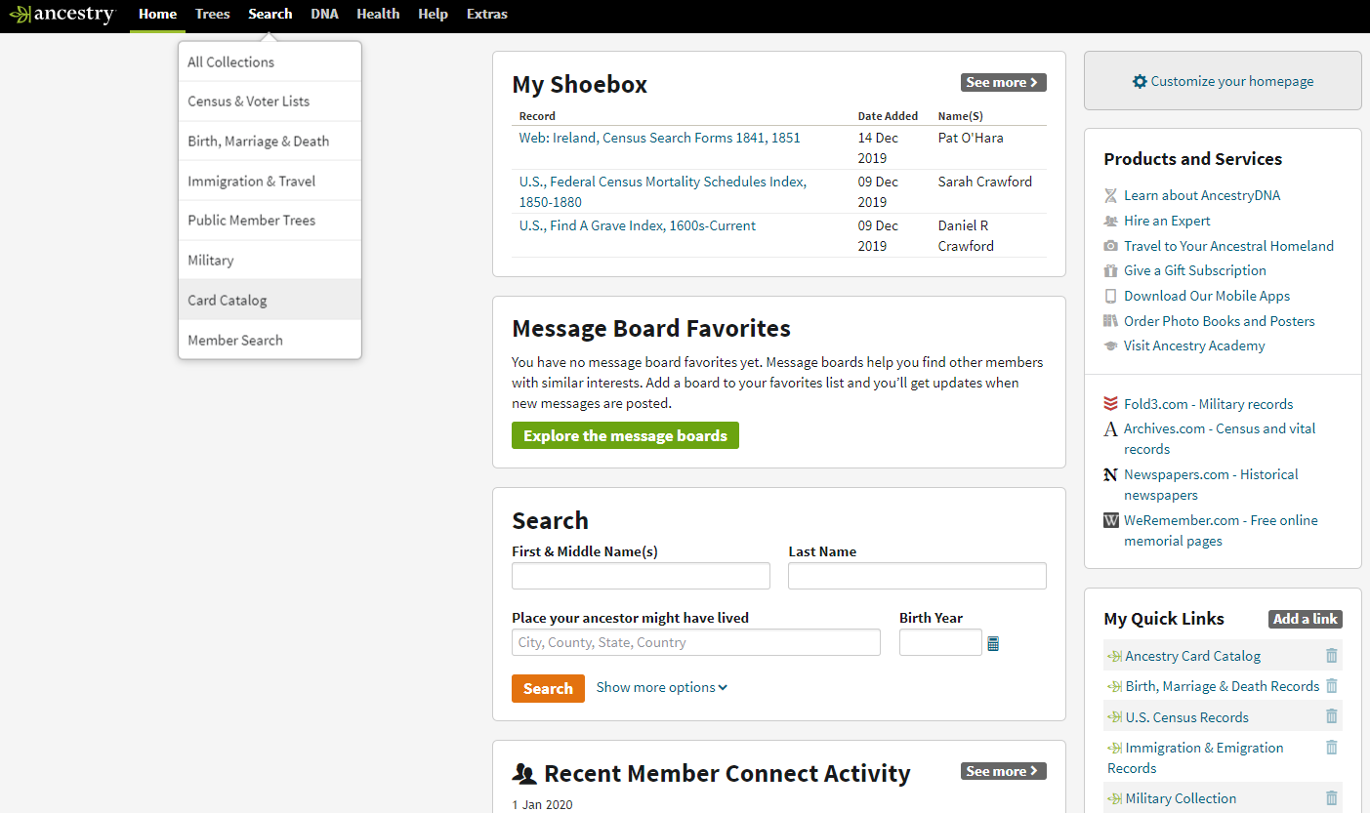
- Click on the Search button on the home screen and a menu will pop up

- In the pop up menu click on the Card Catalog button

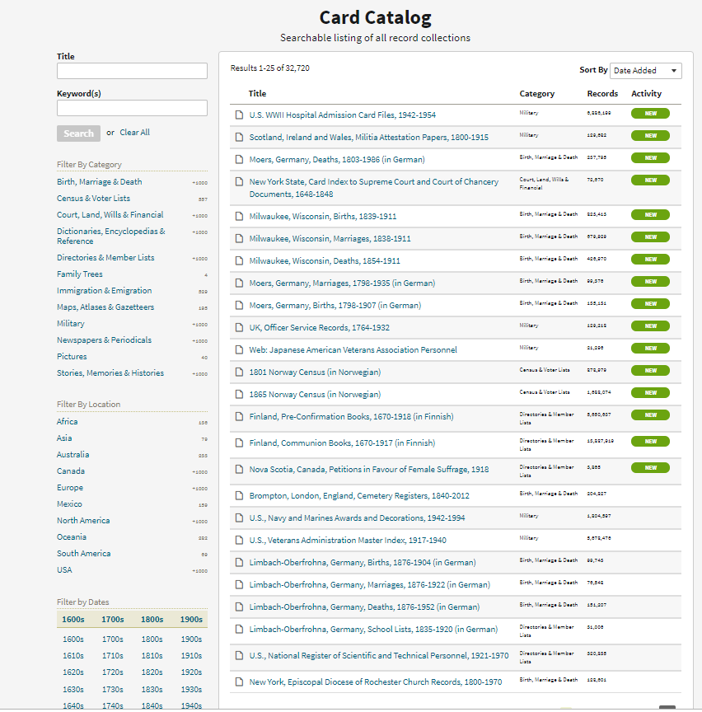
In the new window you have several ways to filter your results:
1
5
- If you happen to know the exact title of the record you are looking for, you can put it here or enter keywords.
2

- Filter by Category

- Filter by Location

- Filter by Date

- Once you have selected your filters, you can then sort the results by:
3
• Date Added
• Collection Title
• Date Updated
• Record Count

4

**note: Once a filter is selected, a new filter options will populate to choose from.
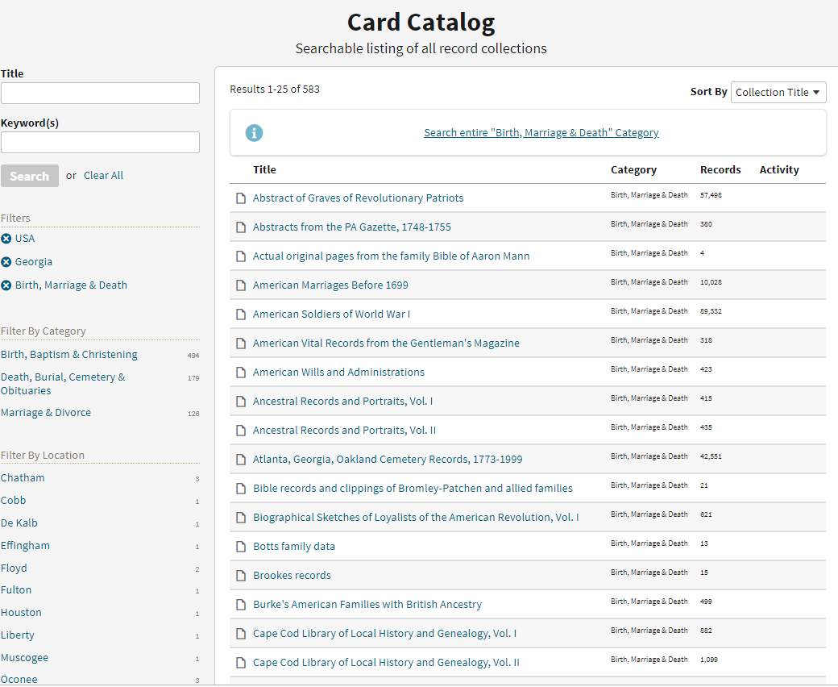
The example below is what happens if filtered USA, Georgia, Birth, Marriage & Death
1
2

- You now have the options to filter by a more specific category or county.

- If you wish to clear any filters, you simply click on the X next the filter and it will remove it.

