How to Access the Catalog collection on FamilySearch:
www.familysearch.org - requires a login (is free and you do not have to be a church member)
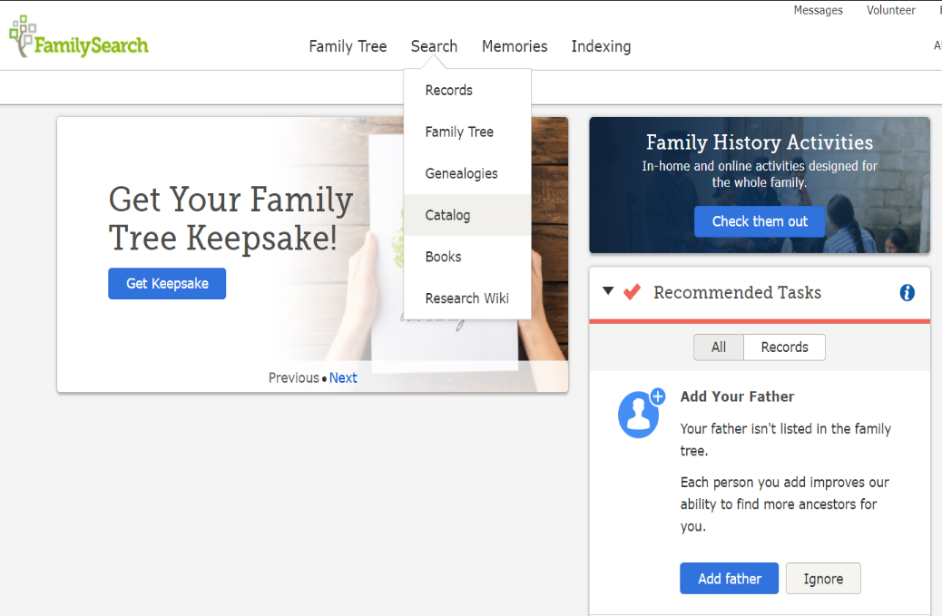
- Hover your mouse over the Search button on the home screen and a menu will pop up

- In the pop up menu click on the Catalog button

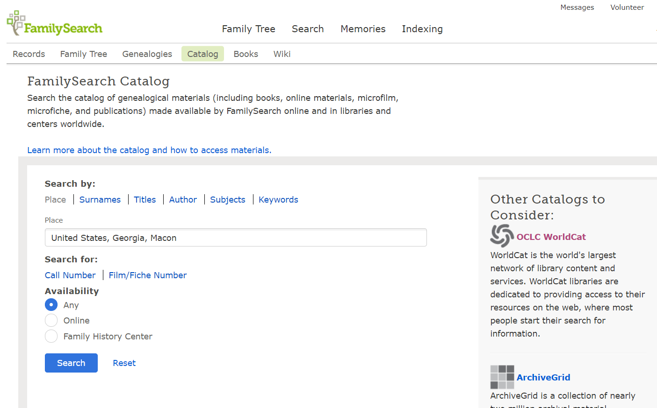
- In the new window you can search by the topics shown

- In the Place field type the format United States, State, County with the desired State and county that you are looking for.

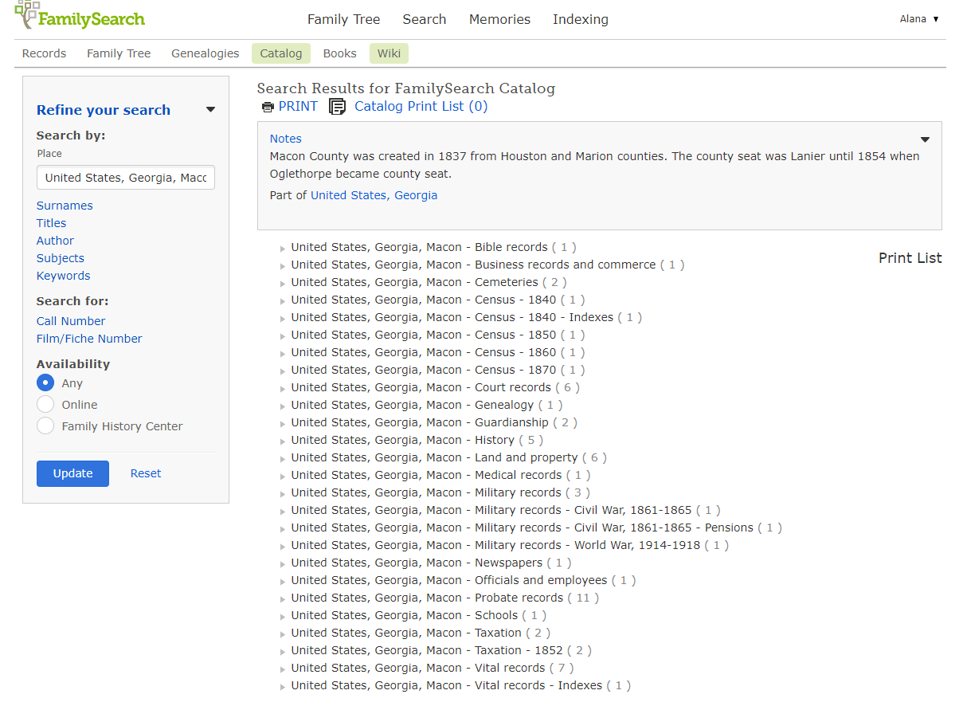
You will now see all of the records that FamilySearch has for the county in their inventory

- you can click on the little arrow next to the topic you want to investigate further

- you can also select where the item is available: anywhere, online, or only in a Family History Center
- if you change the Availability or Refine Your Search, you have to click on the Update button for the new results to populate

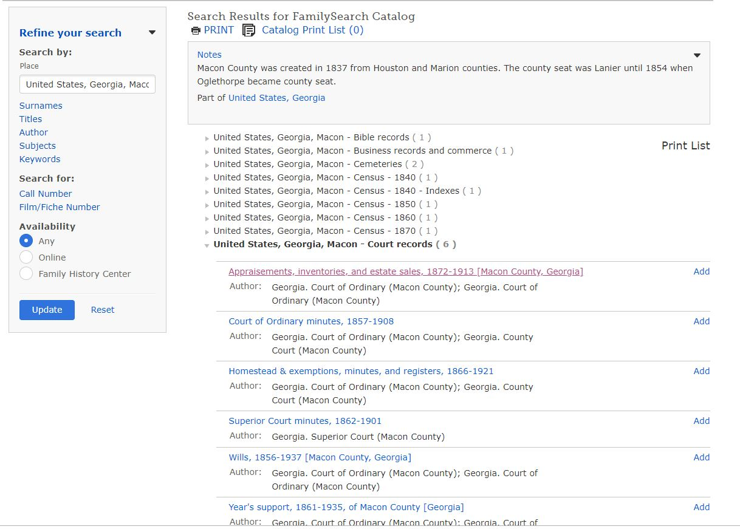
This is an example of the results when the arrow next the collection is selected. Simply click on the desire record to see more information about it and to view the images if they are available.

***Note – FamilySearch is in the process of digitizing all of their records and loading records daily. Check back often if your desired record is not viewable yet. Due to copyright restrictions some records are not viewable online outside of a Family History Center.

Alternate Method
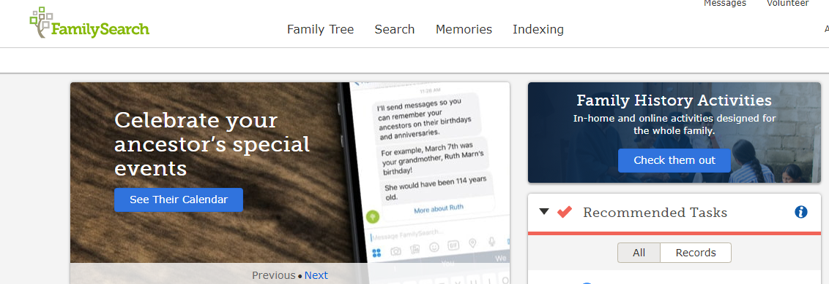
Simply click on the Search button from FamilySearch’s home page and you will be taken to the page shown below.

4
3
2
1
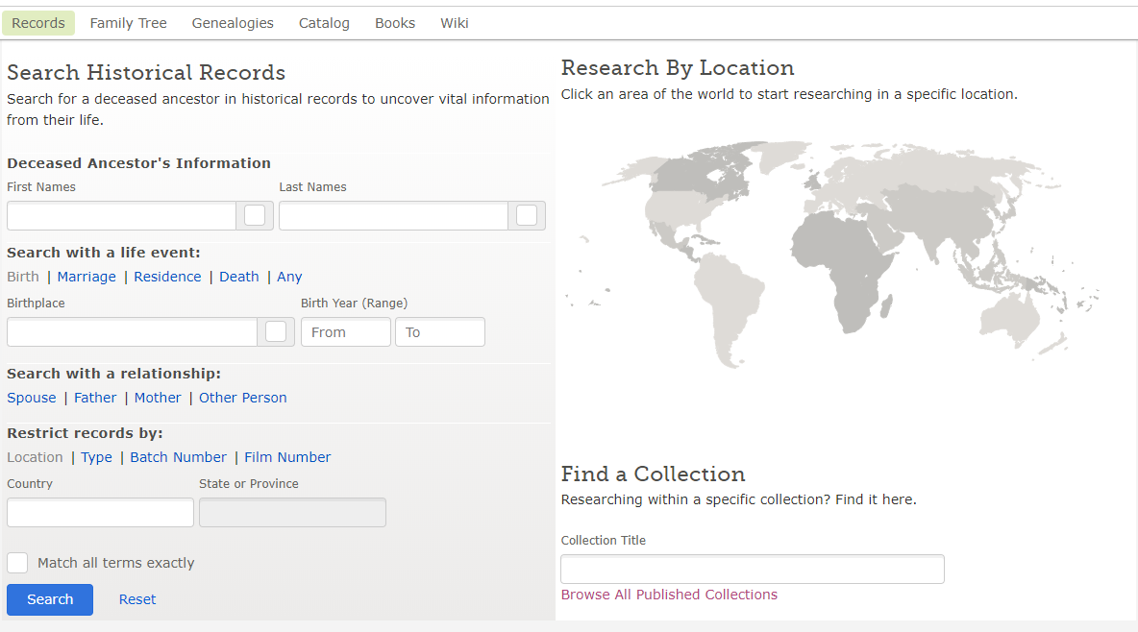
On this page you have several ways you can search:
- Historical records – will give you results from indexed records
- Research By Location – simply click on the desired area on the map and a pop up will allow you to choose the specific area you want to research which will take you to the page specifically for that location which shows all that FamilySearch has to available for it (both indexed and unindexed)
- Find a Collection – helpful if you know which collection you are specifically looking for
- Browse All Published Collections - this link will open a new page that will allow you to filter down by location, date, and collection type

