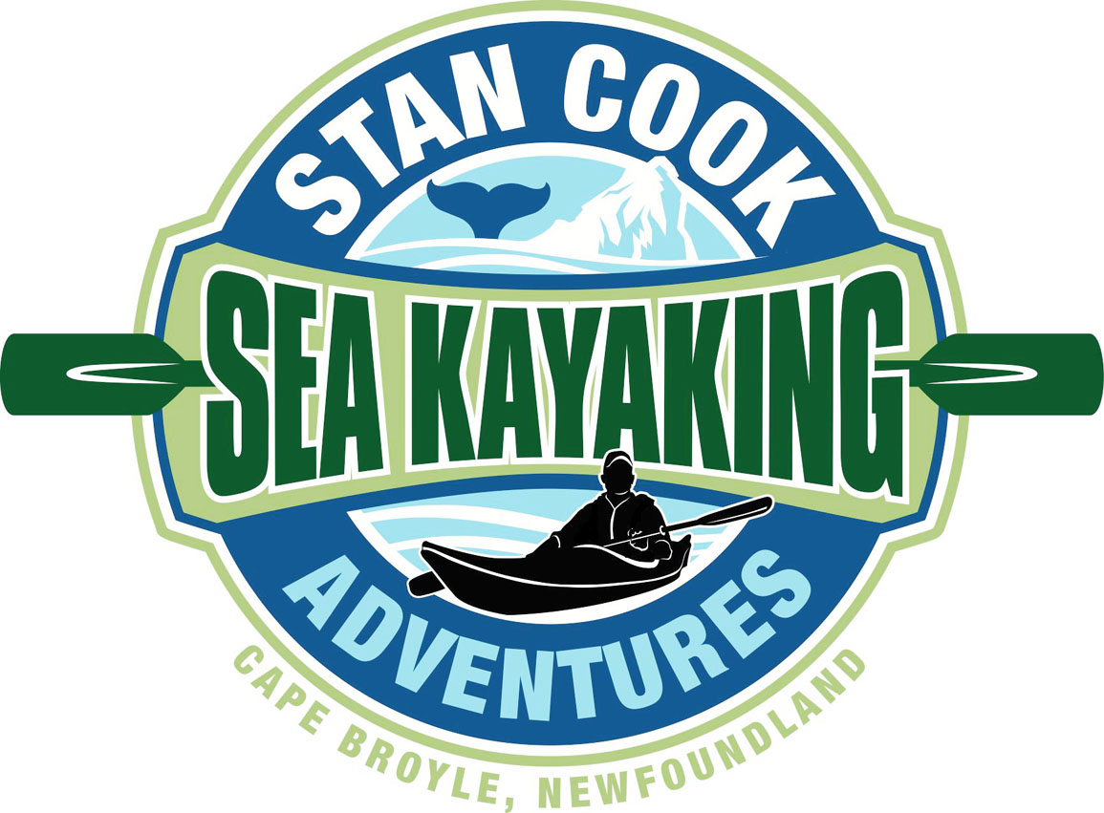
May 14, 2019

Thank you all for those amazing, heart warming, personal comments and memories that you’ve sent to us. We are shocked at the outpouring of emails, texts, phone calls and posts. It has been overwhelming and, to be honest, a little bit emotional.

At this stage of my life I should know better than to dismiss both my wife and sister’s comments, as I did last week prior to posting our closing letter online. They both told me that the post would be a news story, as through the years many people have been involved directly and indirectly with our business. I was viewing the letter as a glorified Family Announcement, just ‘news’ for our family and perhaps the few who were looking to come out this summer. However the ladies were right once again and they’ve spent most of the week reminding me of that!

I realize now that I should have started the ‘goodbye post’ by saying, “None of us are sick and its all good!”, as the majority of calls we received started with, ‘Is something wrong with you or your parents’ health?’
It is all good and there is no reason to worry about our wellbeing.

The personal stories were so touching and humorous that we’ve reminisced every night this week. But the outcry that surprised us the most is folks desiring for us to continue offering tours. Even after many read our closing letter they still talked about their plans to repeat a paddle with us, or how they hope to come out for the first time this summer or asked if could we stay open another season as their Visiting Friends & Relatives are coming to town. We didn’t realize the impact our tours have had on people and the awareness they created of Cape Broyle. The volume of interest has taken us aback.

So I didn’t properly address in that letter what we’re hoping the next stage is (and that post was still 2 pages long).

Rest assured we are happy with our decision to close Stan Cook Sea Kayak Adventures, but we believe it would be a loss for that legacy not to continue with someone else at the helm of an adventure company in Cape Broyle.

As we know very well, this type of seasonal business needs someone as energetic and passionate about showcasing NL as we were. Though it would not be Stan Cook Kayaking Adventures, as Stan Cook wouldn’t be operating it, we feel us passing the torch could impart great and extremely practical operational knowledge to

another entrepreneur. So if you are interested in getting into this province’s tourism industry, please contact us and we can chat.

Originally my thought was to reply to the few sporadic posts that would occur and thank those individuals for thinking of us, but it’s quickly ballooned past my limited posting abilities. So please consider this note the huge THANK YOU to all and long may your big jib draw!

All the Best,

The Cook Family

