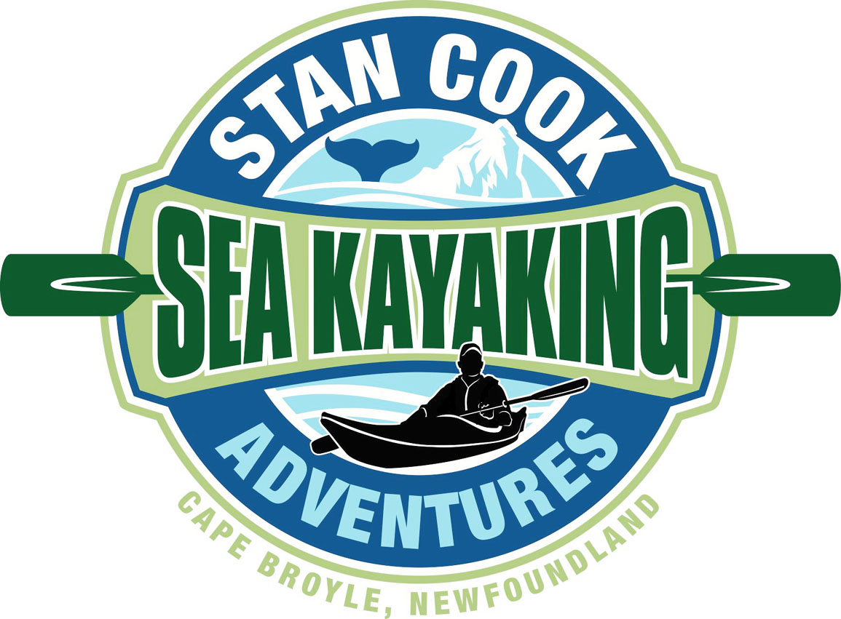
May 1, 2018

How do you announce the end of something great? It’s a bit overwhelming to celebrate almost 50 years of working in a family business through words. However our family has decided the best and practical thing is to let folks know in writing that we will not continue offering coastal kayaking and hiking adventures. I find it particularly challenging because, outside my family and closest friends, our business is what I’ve been involved with for most of my life.

For us it marks the end of an era and the beginning of a new one. My folks are at an age where they wish to have less demands, both physical and mental, and plan to enjoy their ‘retirement’ years in a different way. We are fortunate to be able to make this decision at, what we feel is, the best time. Coming to this conclusion has filled us with gratitude and nostalgia and when it comes down to it, we just don’t feel comfortable that our company can offer the quality that garnered such rave reviews if we all are not ‘paddling together’.

As seasonal business operators know, when your season starts everyone has to pull in the same direction, full tilt, until the season ends. For the last few decades we’ve loved living that intense lifestyle. It’s said that every stage in life is inherently different from the others. The unique aspects of our business have shown us that truth.

I’m so thankful and fortunate to have worked with my parents, my sister (albeit briefly) and many other great folks. The company Dad built was based on team atmosphere and that pillar remained when I joined. Our co-workers have been our summer family and ‘beach team’ for the majority of my adult life. Watching these young men and women, who start with us in their early teens, grow and mature into productive confident adults as they guide their way into their mid twenties, showed us how fortunate we were to have this great company. Working alongside people so interesting and so interested has made our journey amazing.

Being an entrepreneur and pioneer obviously comes with challenges and Stan Sr. faced many when he started in 1970. Numerous people openly voiced that he must be ‘crazy’ and they couldn’t understand why he would bother ‘taking people out on the water in those little boats.’ Stan persevered because he loved teaching and especially enjoyed connecting people with nature.

It was also challenging when we expanded the business in the early 1990’s but once Mom joined the fray, she gave a level of calm that Dad and I definitely needed. It would take weeks to post all the letters and emails she received about how great she was in helping Guests with their vacation plans. Nancy’s level of customer

interaction was so high with those looking to book a tour and she talked to them so often, that many wrote they thought of her as family. Though Dad and I took care of the on-water stuff, Mom truly made everything happen.

Our business also allowed me opportunities to work with people on provincial, regional, national and international levels. The time spent sitting across tables in boardrooms with extremely knowledgeable, successful and insightful businessmen / businesswomen gave me the value of multiple Masters degrees. Their interest and support strengthened my confidence and business acumen. As I left various positions held in the industry, as the Chair of a national body or a regional association, I’ve always looked upon that work with pride. Whether it was HNL, TIAC, CTC, NL Tourism Partnership, NL Adventure Association, The Irish Loop, GMIST or others, achieving common goals brought deep satisfaction. Several of those groups I helped create and was the founding chair, but most of my success came from being allowed to stand on the shoulders of those leaders whose prior contributions were immense. It always gave me solace knowing that I left those positions in better hands than my own.

Our family looks with delight on a generation of business people and enablers who redefined our province through the Tourism Industry. Our success was supported by those vanguards who created the products, experiences and accommodations that were marketed abroad so expertly. The impact those efforts had on our province were wonderous. Such accomplishments has made Canada and many other countries hold up Newfoundland & Labrador as a shining example of how to develop a tourism industry, that not only provides huge economic value to a region, but also makes it’s people proud of where they live and who they are.

We really cannot thank our Guests enough. They’ve been the heart of our business. Their unwavering support has guided our journey. We thank those tens of thousands who have allowed us to share, and hopefully enhance, their precious time spent while on vacation. It has been an honour. Over the years we’ve hosted countless birthday’s, anniversaries, bachelor parties, staggettes, wedding proposals (created a few divorces with those 2 person kayaks as well I’m sure ) and have been honoured on several occasions to help spread ashes of loved ones.

As my parents and I were thrashing around this decision it was impossible not to reminisce (which has caused this letter to go one as long as one of Dad’s stories). We talked about the Tall Tales, the provincial / national awards received, the thousands of media folks that came out paddling whether to write stories, shoot video or both, the interesting people we’ve worked with, and the celebrities that we got to know through our adventures.

It’s impossible to list them all but some ones that stuck in our minds were;
- filming 2 seasons of Beyond your Backyard, a television show with Gordon Pinsent. Getting to hang out on a nightly basis with ‘The Rowdy Man’ was something never to be forgotten.
- hosting would be future Prime Minister, Justin Trudeau’s stag party
- paddling with World Champion, Olympic & Commonwealth Gold Medalist Kayaker Adam van Koeverden
- several HNL events; the book ends include the first board meeting I attended to when I was publically Roasted on my last night on their board; the practical joke involving the industry’s Magazine cover; and the ramifications of explaining on what a ‘free-be’ was while not realizing the extent to which the media would report that anecdote
- how we met and eventually purchased the shop
- helping a terminally ill Guest get her Bucket List Wish of paddling alongside a whale
- Dad receiving just about every accolade possible from the industry over his 48 year run
- saving a drowning dog
- bobbing quietly in a sea cave while a world class musician performed an original piece of music he was preparing to premier at Carnegie Hall

The hard work, sacrifice and contributions made those moments even more enjoyable. We are very proud of what we achieved. They are memories that we’re tremendously grateful to have.

As Mom and Dad unwind they need not worry about; how over the last decade Spring seems to have forgotten Newfoundland; that with the warm sunny days of August and September come the strong Southwest winds; and constantly having to explain to our CFA Guests about the snow and gales still happening in June.

For me it will be difficult to find a pasture greener than the one I’m in, but I plan to work with others who are as excited about their job as I have been about mine. Wherever I land, I look forward to achieve as much as was accomplished over the last 25 years.

I don’t know if there ever is a perfect time for change like this, but it’s definitely the right time for us.

Cheers,

Stan Jr.
Cape Broyle, NL

