Buena Vista c1840
A Beautiful and Historic Place for your Celebration!

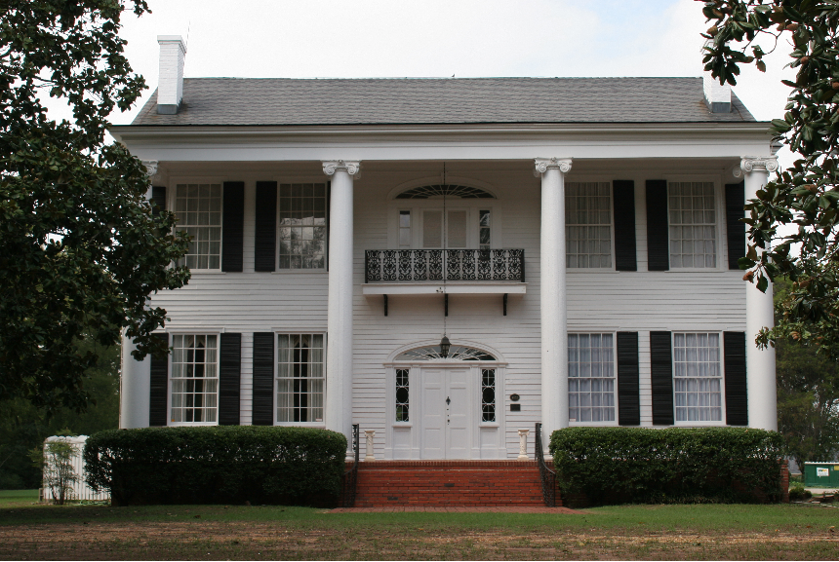

Buena Vista is available for both indoor and outdoor Weddings,
Anniversary and Birthday Parties, Baby Showers, Retirements, Corporate Events, Business Meetings, Bridal Luncheons, Rehearsal Dinners and Photo Shoots.
Nestled alongside large Magnolia trees it is a step back in time!

BUENA VISTA RENTAL PRICES 2018

Wedding, reception, or large event rental
$850 for 8 hours on Saturday OR
$1200 for 3 hours on Friday and 9 hours on Saturday
(Hours begin when the doors are opened and ends when the doors are locked and are to include your set up and clean up.)
Refundable Deposit to hold your date: $250

Small event rental
$200 for 4 hours (Sun. thru Thurs.) OR $300 for 4 hours (Friday or Sat.)
(Hours begin when the doors are opened and ends when the doors are locked and are to include set up and clean up.)
Refundable Deposit to hold your date: $100

Photo Sessions $25/$35 per Hour

Directions from Montgomery

Day Street Exit - Coming on 31 N. (Birmingham highway), go over the Alabama River Bridge, then take a left onto Co. Rd. 4. Buena Vista is located 2.4 miles on Cty. Rd. 4 on the right. We are about 12 minutes from the Day Street Gate of Maxwell Air force Base.

Coming from Montgomery on I-65, take Exit 179 (Prattville), turn left at the top of the ramp, turn left onto 82 (at the Lowe’s store), turn left
onto Hwy. 31 at the 2nd light, go about 3 miles and turn right onto County. Rd. 4. Go 2.4 miles on County. Rd 4, and Buena Vista will be on the right.

The address to put in your GPS is
641 County Road 4 East
Prattville, AL

For more information contact the Buena Vista coordinator
Darlene Leistner
334.365.3690(house) or 334.498.0152 (cell)

Facebook page:
Buena Vista Then and Now
Buena Vista – Prattville (an older page)

May we use, by your permission, pictures from your event
for our Facebook page?
Circle one: Yes or No

Rental Policy

All events are to be scheduled through the Buena Vista Director.
She can be reached at Buena Vista 334. 365. 3690 or 334. 498. 0152.
E-mail: buenavista@autaugahistory.org
Facebook: Buena Vista Then and Now OR Buena Vista - Prattville

Reservations are on a first come, first serve basis.

A deposit must be received at the time of reserving a date for an event.
The contract must be signed by both renter and the Buena Vista Director or an agent of the ACHA for reservation to be considered valid.

Full payment must be paid six weeks prior to your event.

There is a $35.00 charge for all returned checks.

Cancellation of an event will cause the renter to lose all deposits paid.
For functions cancelled less than six weeks prior to the date of the function, the renter will be responsible for the full contracted amount. If the function is cancelled more than six weeks, prior, all fees paid, less the deposit, will be refunded.

After the wedding the Deposit will be refunded within two weeks, provided there is no damage to the House or property. If damage has occurred, the renter will be contacted, and the deposit will be applied towards the cost of the repair. If the cost of repair exceeds the deposit, the renter will be responsible for the balance. The refund check will mail it to you, so please make sure we have an up- to-date address!

Remember it is your responsibility to ensure the attached clean-up tasks are completed. Buena Vista must be left the way it was when you arrived. There is a basic checklist included in this packet that all renters and caterers should adhere to.

If you have read and understand the above policies and agree to follow the guidelines as outlined by the Autauga County Heritage Association, please sign below and return to the ACHA office with your contract:

*Renter:______________________________________________Date:__________

Buena Vista Wedding Rental Contract

Wedding Date ________________________

Renter’s Name __________________________________________________________________ Address:____________________________________________________________________________________________________________________________________________________ Home Phone: _______________ Work Phone: _______________ Cell: _______________________
Email_________________________________________________________________________

Bride’s Name_______________________________________
Phone Number______________________________________

Groom’s Name_______________________________________
Phone number_______________________________________

Tme of your wedding ceremony:________________
Approximate number of guests_________________
Time for your hours to begin and end : Friday__________________________
Saturday_________________________

Will alcohol be served? YES (See note below) NO
ALCOHOL USE: (Please read)
All events serving alcohol require a $160.00 fee that is due with your rental fee.
No Alcohol will be consumed on the premises without prior agreement and the presence of a licensed security guard. Alcohol is only allowed at the reception following the ceremony. No alcohol will be allowed in the dressing rooms or upstairs at any time. Failure to comply with these rules will result in the immediate loss of your deposit and possible dismissal of your event.

(CONTRACT CONTINUED)

RENTAL DEPOSIT: _______ Deposit is due the time of signing the contract.

RENTAL FEE: ___________ The rental fee is due six weeks from your date.

ALCOHOL FEE: __$160____ The alcohol fee is paid along with the rental fee.

You may pay with credit card through Square or by check or cash.

Please make all checks payable to: Autauga County Heritage Association.

All correspondence should be sent to:
Buena Vista Coordinator
Heritage Museum
102 E. Main St.
Prattville, AL 36067

Please read the following and sign:

In consideration of permission to use the premises, the renter agrees that such entry will be at his own risk and neither the ACHA, nor the officers, agents, or employees shall be liable, under any circumstances, for the death or personal injury to, loss or damage to the property of renter occurring on the premises of Buena Vista, or arising out of the exercises of the permission granted. In accepting such permission, the renter does hereby release, indemnify, hold harmless, and covenant not to sue the ACHA, officers, agents, and/or employees for any damage of whatever kind arising with the exercise of the permission granted herein. Should any damage occur to the house, the renter would be responsible for the cost of such damages over and beyond the deposit, which he/she shall forfeit. If any policies or any part of the agreement is broken, the renter agrees to forfeit the deposit.

RENTER: ____________________________________________________

Date: _______________________________________________________

BUENA VISTA COORDINATOR: _____________________________________

Date: ________________________________________________________

Rules and Fire Code Regulations

Please read and initial each of the following rules and Fire Code Regulations.

1.____Outside exits must not be blocked from the inside or outside of the house.
2.____ No smoking inside of the house at any time.
3.____Candles may be used on the first floor and outside only. All surfaces must be protected from wax. Candles must be snuffed out with snuffers provided.
4.____Any kitchen items used must be cleaned and returned to their proper place.
5.____There is no ice maker at Buena Vista. Renters must bring bagged ice, but may store it in our freezer.
6.____The stove may be used for heating foods only.
7.____Telephone use is restricted to local calls only. Renter will be responsible for any long distance or directory assistance calls made during their time.
8.____Small pieces of furniture may be moved under the supervision of the Director, but must be replaced after the function.
9.____No rice, bird seed, confetti (paper or mylar), marshmallows or candy sprinkles to be thrown. No champagne poppers, sparklers, or other fireworks are to be used on the premises. Bubbles are allowed.
10.____No one is allowed in locked areas or on the third floor.
11.____ Children are not allowed upstairs without adult supervision.
12.____All items belonging to renter must be removed from Buena Vista after the event is over.
13.____NOTHING is to be placed on the piano at any time.
14.____No DJ’s, bands, dancing, or loud music INSIDE of the house.
15.____All trash must be placed in the dumpster in the back yard after event.
16.____Autauga County Heritage Association is not responsible for valuables left unattended (such as purses and bags). Please secure your valuables or leave them at home.
17.____All rented items must be outside of the house to be picked up by the rental company
18.____It is the responsibility of the renter to ensure all guests are aware and follow the rules and policies of the house.
19.____ No parking on the grounds directly behind or in front of the house. Do not drive vehicles on the brick patio in front or brick walkway in back.
20. ____The items in the kitchen are not for the use of the renter. Please furnish all of your own containers, serving dishes, utensils etc.
21 ____No alcohol may be brought onto the premises by yourselves or your guests without prior arrangement.

I have read and agree to follow the policies outlined in the agreement. I understand and agree to abide by the rules and codes as set forth by the Autauga County Heritage Association and agree to make these rules known to those assisting with my event including vendors, caterers, florists, and entertainment.

*Renter:___________________________________________Date:________

What is expected at the end of your function.

In contracting with Buena Vista, you are responsible for the following to the completed at the end of your function:
KITCHEN
____Remove all food items, dishes, boxes, etc. Check refrigerators and freezer.
____Wipe down the tables, countertops and appliances used.
____Clean out the sinks and any food scraps left in drains.
____Hang used dish rags and towels on the sink
____Wipe up any spills in the refrigerators.
____Empty all big trashcans. Take trash to the dumpster.
____Sweep the floor.

If you are using a caterer, it is your responsibility to let them know about this list.

THE DOUBLE PARLOR
____Line chairs around the side of the room. Please DO NOT stack them.
____Remove all items from the mantels and other decorations from the room.
____Pick up any trash – cups, napkins, flowers, etc.

THE DINING ROOM
____Remove all floral arrangements, decorations, food and serving dishes.
____Pick up dropped foods and wipe up any spills on table surfaces and floor.
____Throw away all trash.

UPSTAIRS
____Make sure all trash and all personal items are removed and all Buena Vista property is back in its place.

MISCELLANEOUS
____Replace any furniture that was moved back to its original place.
____All rental equipment must be left outside of the house for pick-up. (ACHA
is not responsible for theft of rental properties.)
____All grounds must be free of trash, cans, floral items, etc. before leaving.
Please check front and back porches also.

The house has been inspected and shown to have completed the above list.
Event Hostess: ___________________________________________________________
Renter: _________________________________________________________________
Date of Event ____________________________________________________________

