Instructional Story Design Worksheets and Guides
from Instructional Story Design, (Appendix 1), by Rance Greene

The collection of guides and worksheets you’ve encountered and used throughout the book are compiled in this appendix for quick reference. You can use the worksheets as a space to do iterative work and record the outcomes on the Instructional Story Design Plan in Appendix 2. This is the editable version of the worksheets. Visit needastory.com for upcoming events and workshops to help put the Instructional Story Design into action. If you’d like to schedule a workshop for your team or you just want to share your storytelling successes contact us here!

Story Design Model
The Story Design Model is an easy way to remember what you are looking for as you discover, design, and deliver stories for training.

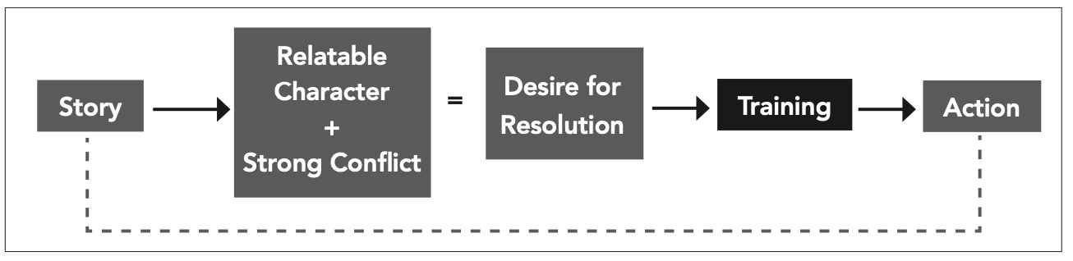

PRIMED for Learning
Use PRIMED Questions to unearth the business outcome, the root problem, and the ideal solution. Record these on the Instructional Story Design Plan.

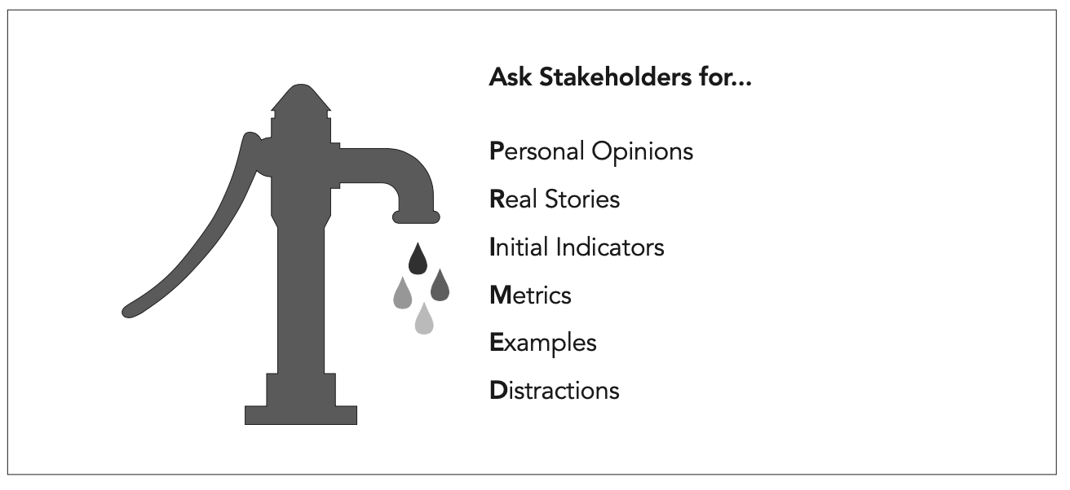

Audience Profile Questionnaire
The information you gather about your audience will provide valuable
intelligence for creating relatable characters. Once you’ve gathered this information,
record a summary on the Instructional Story Design Plan.

Personal Information
Look for interesting details that provide motivation for your characters.

What is their primary language?
What is their education and background?
What is their job or role?
How long have they been with the company?
What industry is the company in?
How long have they been in this field of work?
Where does the learner live?
What types of music do they listen to?
What types of games do they like to play?
What types of movies do they like to see?
What type of humor do they appreciate?
What types of sports do they like?
What forms of entertainment do they enjoy?
What are the demographics of the company?

What They Already Know
Look for opportunities to move the learner up the design continuum from definition to practice, using stories as examples to allow for self-discovery.
What is the learner’s pre-existing knowledge of the material being presented?

Values and Motivation
Look for drivers behind why characters do what they do.
What do they value most about their job?
What do they value most in life?
What motivates them at work?
What do they do in their spare time?
What will motivate them to take the training?
What will motivate them to act on the training?

Circumstances at Work and Reaction to Circumstances
Mirror circumstances in real life within your story. Look for emotional reactions that can accentuate strong conflict.
Describe their current circumstances at work.
How are they currently reacting to circumstances at work?
What challenges them most at work?
Has anything happened recently in the organization that may make them feel vulnerable?
Who or what has influence over them?
Who do they have influence over?
Will this training or message create a shift in power?
How are they likely to respond to this training in light of their circumstances at work?

Fears, Risk, Comfort Zone, and Commitment
Look for sources of internal or external conflict that may prevent learners from taking action on the training. Weave these sources of conflict within the story.
What keeps them up at night?
What fears will keep them from taking action?
What other mental or practical barriers will prevent them from taking action?
Can these fears or other barriers be dispelled? How?
What might they misunderstand about the message?
Why might they believe the change doesn’t make sense for them or their organization?

What would they sacrifice if they acted upon your idea or training?
What is the perceived risk?
What are the physical or emotional risks they will need to take?
How will this stretch them?
Who or what might they have to confront as a result of this training?

What is their tolerance level for change?
How far out of their comfort zone are you asking them to go?
Are you asking them to unlearn something? What?

Are they willing to commit time to take the training?
Are they willing to commit to acting upon the training?
What preconceptions do they have regarding the training?

Benefits
As characters behave in conflict with the action list, look for opportunities to show the fallout (the ways they will miss out on the benefits listed here).
How will they personally benefit from the training and taking action? What’s in it for them?
How will training help their sphere of influence?
How will the company benefit?
How will the client benefit?

Technology and Logistics
What is their experience with e-learning? Mobile learning? Gamification? Social media?
Where will they take the training?
Describe the environment where they will take this training.
Will the learner be able to hear or play audio when taking the training?
What types of mobile devices do they own?

Action List Template
Use the reminders at the bottom of the template to structure the action list.
Record your final action list in the Instructional Story Design Plan.

Main action
Sub action 1
Sub-sub action A
Sub-sub action B
Sub-sub action C
Sub-action 2
Sub-sub action A
Sub-sub action B
Sub-sub action C
Sub-action 3
Sub-sub action A
Sub-sub action B
Sub-sub action C
Sub-action 4
Sub-sub action A
Sub-sub action B
Sub-sub action C

Use Strong, Positive Action Verbs
  - Write the actions as if you are speaking directly to the learner.
  - Write observable actions.
  - Avoid avoid. It’s hard sometimes, but keep verbs focused on performance, rather than non-performance!
  - Dig deeper when verbs like understand or be aware creep up. What actions should take place as a result of understanding or being aware?

Put Actions in a Logical Order
  - If you are building an action list for a process, the main action should appear at the top and the steps to accomplish that action fall underneath it in a logical order from top to bottom. The same is true for sub-actions and sub-sub-actions.
  - If you are building an action list for skills that are not a sequential process, you may choose to order it from easy to difficult, from familiar to not familiar, or from tasks that affect individuals to tasks that affect the entire department.
  - As you share with your stakeholders, ask them to sign off on the action list to validate its completeness and accuracy. Since they already have a familiarity with outlines, it will be easier for them to review using this format.

Character Description Worksheet
Use the guideposts to compile the final character description,
which you can record on the Instructional Story Design.

Guidepost | Character Description
Position
At work, in life
Conflict
Which action are they in conflict with? What nouns and adjectives come to mind?
Peers
How does their personality contrast with other characters in the story?
Appearance
Physical attributes can be helpful in creating the story, even if the final portrayal isn’t an exact match.
Personal information
Look to the audience profile for this information.
Values
Look to the audience profile for this information.
Reaction to current circumstances
Look to the audience profile for this information.
Fears
Look to the audience profile for this information.
Backstory
Details about their history that may affect the action of the story, true to audience profile.
Name
Read through the above description. What name comes to mind?

Show the Action Worksheet
This worksheet will help with the completion of the next worksheet, Build the Story.

Identify the actions and the conflict for your story. Each of the characters for the story you are creating is in conflict with one or more of the actions from the action list. To begin thinking in terms of action and conflict, ask yourself these three questions and complete the worksheet.

- Is the character doing realistic things?
First, imagine the character in conflict with their corresponding action. What are they doing in the scene? Describe some of the actions you might see them do.

Are these actions observable? Are they in keeping with the character description? Weed out any that don’t fit these two requirements.

- Is the action conflict?
Next, narrow the actions down to the ones that are in direct conflict with their corresponding action from the action list, and write that action in the second column next to their name. Is the conflicting action directly related to the action from the action list?

Character name | Conflicting action | Why the character does this

- Is the character motivated to do these actions?
Complete the table by writing some reasons in the last column of why the character might take the conflicting action. Consult their character descriptions and look for external and internal pressures that influence their decisions.
Build the Story Worksheet
After you’ve worked through each of the steps,
record the final story on the Instructional Story Design Plan.

Story Premise
Write the story premise for each character and their corresponding action, using the story premise formula:

A story about [character name and position] who struggles to [an action from the action list].

Map the Plot With Core Actions
Answer the core action questions for the story.

Core questions | Core actions
Where are they in the story?
What are they doing?
What do they encounter that gives them an opportunity to do the action from the story premise?
What do they do that’s in conflict with that action?

String the core actions together in a short paragraph to start the story.

Connect With the Character
From the Show the Action worksheet, integrate at least one motivation for the character into the story. Write your story below.

Refine the Verbs
Look back at your story and look closely at the verbs.
- Are they in present tense? If not, rewrite it in present tense.
- Do they need helping verbs? If so, they might be too weak.
- Could they be strengthened by using a synonym?

Rewrite the story using these three questions as your guide.

Escalate the Conflict With Dialogue
Look for opportunities to insert dialogue. Let us hear the character speak!

Make It Concrete
Go back to your character descriptions and Show the Action exercise. Are there attributes of your character that could be shown by adding detail?

- What small actions or information can reveal more about the characters?
- What meaningful props can the characters interact with to make the setting more real?

Rewrite the story using these questions as your guide.

Eliminate Descriptive Words and Phrases
Rewrite the story eliminating adjectives and adverbs. If the story seems weaker, it’s probably not because it’s missing the adjectives and adverbs. It’s most likely because the action is too weak to carry the story by itself. You need to strengthen the action. Also look for extraneous words and phrases to trim.

Let Your Audience Discover the Story Premise
Your stories should be action-packed now. Do another read-through and make sure you’re not giving the story premise away. If you are, rewrite the story and give the audience room to discover the story themselves.

Assess Your Story
Ask yourself these questions. If you (and the stakeholder) can answer yes to all four, your story is done! Record the final version in the Instructional Story Design Plan.
- Do I know these characters?
- Do I feel for them?
- Can I see the story unfolding in my mind?
- Do I want resolution?

Storyboard Template
On the Instructional Story Design Plan, work through which story form is most suitable, given your audience and the development tools at your disposal. If the story form involves visual or audio components, use a storyboard template to record those elements. Break up the story into scenes by row and imagine the story unfolding. Record what you see and hear in the storyboard.

Audio  Music and sound effects | Visual  Appears on the screen | Dialogue and Narration  Story broken into scenes per row

Story–Reflection–Solving–Feedback Worksheet for Training
Use this worksheet like a design document for instruction.

Story
You’ve developed your story. What actions from the action list are you training on?

Reflection
Give your audience a chance to reflect on the story. Design a reflection question that allows them to relive the story in their minds and feel what the characters were feeling. Your reflection question can be similar to one of these questions:

- How would you feel if . . . ?
- Why do you think . . . ?
- What did you observe . . . ?

Write some possible reflection questions below.

Solving
You’ve presented the problem through story. Now, give the learner an opportunity to solve it. Write a few solving questions and possible options that lead the learner toward practice on the design continuum.

Feedback
Look at your possible questions above. What kind of feedback will you offer for each of the options you’ve provided? Remember, feedback affirms the learner’s action or redirects it.

