

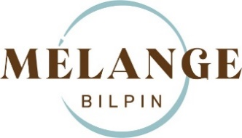
BREAKFAST BEVERAGES
Summer
Coffee | REG | LG |  | Tea
Espresso | $6.00 | - |  | Loose Leaf Tea: |  | $6.00
Macchiato | $6.00 | - |  | Australian Breakfast  Ceylon Orange Pekoe
Piccolo | $6.00 | - |  | Earl Gray Supreme  Darjeeling Himalaya Blend
Cappuccino | $6.00 | $8.75 |  | Peppermint  Jasmine Green
Flat White | $6.00 | $8.75
Latte | $6.00 | $8.75 |  | Soft drinks:
Long Black | $6.00 | $8.75 |  | Coke, Coke Zero, Sprite, Lemon Lime & Bitters |  |  | $5.00
Chai Latte: | $6.00 | $8.75 |  | Fruit Juice:
Ginger OR Cinnamon |  |  |  | Orange or Apple | $5.00
Dirty Chai Latte | $6.00 | $8.75 |  | Beloka Sparkling Mineral Water (750ml) |  |  | $10.00
Mocha | $6.00 | $8.75 |  | Alternative milk (oat, soy, lactose free) |  |  | $1.00
Hot Chocolate | $6.00 | $8.50 |  | Extra shot |  |  | $1.50

