Downtown Optimist Club of Columbia

In Person/ Zoom Meeting

Monday, November 20th, 2023 at Shakespeare’s South (Denver Room)

Meeting began at 12:00 noon

Members in attendance: President Mike Hachett, Mary Dewey, Ken Oster, Steve Winter, Ed Musterman, Rick McKernan, Carl Scott, JimMurphy, Jerry Sullivan, Deb Swanegan, Larry Fick, Tony Parrison, C.O. Schaffer, Barbra West, Pat Brown, and Daryl Stockstill
By zoom Nadia Ryakmyatullov

Special Guests: Rena Winter (Steve’s Wife), Gay Litteken and Verena Wilkerson (1st Chance for Children) and Mike Tillman (Ed’s Friend)
Invocation: Rick McKernan
Pledge of Allegiance: Steve Winter

Birthdays/Anniversaries:
Pay the pig (Money goes to the OIF Children Cancer):
Daryl Stockstill paid $1.00, Jim Murphy paid $.50 for the MU win and KU lost, Carl Scott paid $.25 for KU lose, Mike Tillman and Rick McKernan both paid a $1.00 each for KU

Carl Scott would like to Thank Mary Dewey for bring in the Columbia College Cross County and Track and Field team came to help unload our big truck of trees on Saturday, November 11th. Jim Murphy says all the trees are drilled and to Jerry Sullivan, Ed Musterman, Carl Scott and Daryl Stockstill who help keeping the trees watered. He also thanks Steve and Rena Winter for making there was something to eat at the clubhouse for all the workers who was helping unloading the trees and drilling team.

Steve Winter: – 2nd order is due today and will be here Thursday and everything is bags and ready to be picked up at the Clubhouse. . 3th order is due Monday, November 27th for the gift cards and Tuesday, November 28th for the Koeze Nuts orders. Amish candy is in but, the white chocolate pretzels will be in on Tuesday, November 21. Steve and Becca will set up the south room on Wednesday for we will be ready for opening day on Friday, November 24.
Carl Scott will meet the Electric company to check out all the light poles around the tree lot on Tuesday, November 14th.
C.O. Schaffer says keep signing up to work the tree lot so we don’t have to pay for workers to work the lot. We can save the for the organization who work with kids in the community. We need a lot of help on opening day and this weekend. If you can’t help with loading the trees we will find something us for you to help with, for example, picking up limbs, talking to the customers, and making sure the customers take off only the bottom part of the tree tag.
Carl Scott reminded us that November 21st is Food Bank food drive.
Reminder is you want to got to the Kids 1st Optimist Club Christmas Party by November 30, 2023 to me. So, I can let Tizzy know so, they know how much food to get for the Party on December 6th and Cost is $25.00 person.
Speaker for the Day: Gay Litteken and Verena Wilkerson information is attached to this email.
Optimist Creed was recited and meeting adjourned at 1:00 pm
Mike Hachett, President
Please look at the update calendar for where the club meeting will be at, and other important dates.

◄ Oct 2023 | November 2023 |  |  |  |  | Dec 2023 ►
Sun | Mon | Tue | Wed | Thu | Fri | Sat
 |  |  | 1  Barbara West Birthday | 2  Sunrise Optimist Club  Fundraiser  4 to 8 pm at South of Town  Panera Bread | 3 | 4  Fulton Breakfast Optimist Turkey Shoot at 11:00 am at Sy-Go Farms
5 | 6  Noon Meeting at Boone Electric Community Room (Watt room) Jenny Priest, Director  MO Girls Town | 7 | 8 | 9 | 10 | 11  First set of  Christmas Tree Arrival need help unloading  8 am
12 | 13  Noon Meeting at Boone Electric Community Room (Watt room)  Kip Kendrick  Presiding Commissioner, Boone County | 14 | 15 | 16 | 17  Santa and Mrs Claus visiting Orr Street Studio from 4 to 8 pm  Hosted by Junior Achievement | 18
19 | 20  Noon Meeting at Shakeoeares (South)  Gay Litteken  Executive Direct 1st Chance for Children | 21  Partnership Against Hunger Food & Fund Drive  6:00 am to 6:00 pm  HyVee, Schnucks, Eat Well | 22 | 23  This Photo by Unknown Author is licensed under CC BY-NC-ND | 24  Christmas Tree Lot Opens up  for the season | 25
26 | 27  Noon Meeting at Shakeoeares (South)  Steven Keller  MO Scholars Academy | 28 | 29 | 30  Deadline to sign up for the Kids 1st Christmas Party for December 9th from 5:30 to 9:00 at Vineyard Clubhouse $25.00

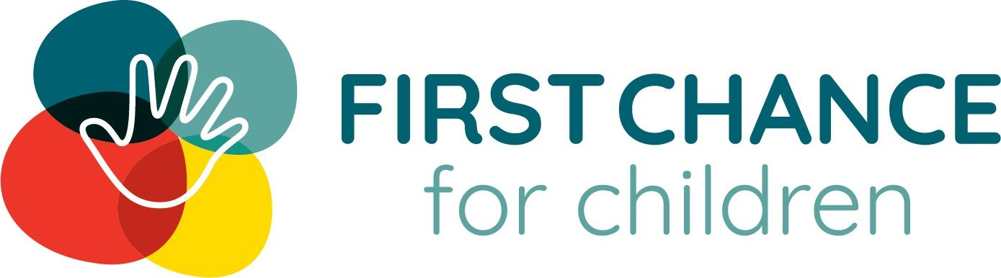

Mission Statement
First Chance for Children provides early childhood programs and family resources to foster healthy outcomes for children and families in mid-Missouri.

Vision Statement
All children will arrive at school ready to learn and succeed in school and in life.

Fundamental Values

Commitment
- to provide families with best practices and services to support and empower their growth
- to partner with our community to provide wrap-around services and connect families
- to demonstrate to our funders that we facilitate measurable improvements in wellbeing and development for children and families

Advocacy
- on every level for the best interests of children and families too often left out and left behind

Respect
- for the worth of all children, families, and communities, acknowledging that each person is the expert on their own experience and has a right to self determination

Empathy
- in all our interactions, especially when it applies to the diverse experiences of families in a challenging world

1998-2001

Child Care Consortium is Born
In 1998, Heart of Missouri United Way and The City of Columbia made an initial investment in a community childcare initiative called Community Child Care Consortium. The Consortium conducted a comprehensive planning study on child care and early childhood outcomes in Boone County. They used the information to partner with several agencies and develop services to support at-risk children.

2002-2005

Kindergarten Readiness Becomes the Vision
In 2002, the Community Child Care Consortium crafts its vision around kindergarten readiness and organizes into a 501(c)3 nonprofit called Boone Early Childhood Partners. The mission was to coordinate services and build resources to improve school readiness in Boone County. Working with the community, they identified key indicators of kindergarten readiness and conducted a county wide assessment. They found 16% of children entered school without the necessary skills to succeed. The Partners received several federal grants to improve the social and emotional skills of high-risk children using a parent and teacher approach. After several years of implementing the grants, the board shifted the focus to direct services that benefit children who face an increased risk of not succeeding in school.

2006-2010

Direct Services to Support At-Risk Families
In 2006, Boone Early Childhood Partners changes its name to First Chance for Children to reflect its mission of supporting underserved children and families. They receive two federal grants to improve the social, emotional, literacy, and language skills of at-risk children. They also launched a public relations campaign, Read Play Hug, to increase the awareness of the importance of child/caregiver relationships.

2010- Today

Strong Roots with a Bright Future
First Chance for Children has continued to utilize braided funding to support early childhood initiatives. We have expanded into 13 counties across mid-Missouri contracting with school districts, health departments and community agencies to provide additional services for at-risk families including cribs and diapers through our CRIBS and Baby Bags Diaper Bank. We utilize the Parents as Teachers and Nurturing Parenting models of home visitation along with the Strengthening Families Framework to best support families with their specific needs. We advocate at the state and local level for quality early childhood experiences so that all children can be ready for school, ready for life. y to learn and parents learn to play

Lend and Learn

Lend & Learn is a free & fun program of First Chance for Children that supports children ages 0-5 and their families to grow essential skills through play.
There are two indoor locations with regular play time hours in Columbia and Centralia. Families may borrow toys to extend their play and learning at home. The Columbia location has an outdoor playground.
Additionally, we offer a variety of play events and activities. Check our Facebook page for updates.
Come and go as you please during our open hours.

Am I eligible for this program?
Residence
- Lend & Learn is open to all families regardless of residence.
Ages
- Designed for children ages 0-5 and their caregivers.
Income
- Lend & Learn is open to all families regardless of incomes.

Baby Bags
The Baby Bags program acts as a diaper bank and so much more. Diapers, wipes, hygiene items, and other supplies needed to provide care and comfort to children delivered along with child development and safety information. Items are available at the First Chance office or through one of our partner programs.

Baby Bags Details
Families can get supplies from the Baby Bags diaper bank program by coming by the First Chance for Children office during drop in hours or by calling to schedule an appointment. During the visit families can expect to fill out a brief enrollment form, gain new child health and safety information, receive needed supplies and referrals to community agencies. Items are also available through partner agencies below. Items are available at most, once a month.
First Chance for Children Baby Bags hours:
Monday-Friday 9am-3:30pm
Distributing partner hours vary by organization.

Am I eligible for this program?
Residence
- Boone, Howard, Cooper, Audrain, Callaway, Cole, Marion, Moniteau, Monroe, Osage, Ralls and Randolph counties
Ages
- Supplies for children ages 0-5.
Income
- For families at or below 200% of the poverty line or those who need help.

Items Available
Below are the wide range of supplies that can be obtained by families. Specific items available through the Baby Bags diaper bank program vary by the county the family resides in.
Diapers: one package of approximately 25 diapers and wipes per age eligible child.
- Home and health items: two items per family. Typical items in stock include: baby shampoo, diaper cream, dish soap, and baby lotion.
- Smart Start Kit: A kit including diapers, wipes, healthcare kit, home childproofing kit, bathwater thermometer infant onesie, community resources, and child safety information. Designed to provide the safety necessities and education for young children.

SAFE CRIBS (Community Resources Infant Beds and Support)

Overview
Babies are at greatest risk of child abuse and death because of sleep issues during their first year of life. First Chance for Children’s Safe C.R.I.B.S. program provides a safe crib and the information families needs to safely put their child to bed and deal with sleep related issues. The crib is delivered to the family home and is followed by five additional home visits that focus on child abuse and neglect prevention and child development information.

Program Details
Families can sign up for the cribs program by coming by the First Chance for Children office or by calling to schedule an appointment. Visits can begin prenatally, however the crib will be delivered the day the infant comes home from the hospital, or a child under the age of one no longer has a safe space to sleep. During the first visit families can expect to fill out a brief enrollment form, gain new child health and safety information, receive needed supplies and referrals to community agencies. On follow up visits, home visitors will check the safety of the crib, discuss child safety and development information, and connect to community resources. Items and visits are also available through partner agencies below.

Am I eligible for this program?
Residence
- Cribs Available for families in Audrain, Boone, Callaway, Cole, Cooper, Howard, Moniteau, Osage, and Randolph counties.
Ages
- Cribs designed for children ages 0-1.
Income
- For families at or below 200% of the poverty line.

Baby U Details
Baby U is designed to help families strengthen protective factors that help them navigate the issues of raising children. It is a home visitation program that serves families with children prenatally up to the age of 5. It utilizes a blended home visitation model of Parents As Teachers and Nurturing Parenting. Both are evidence based early childhood home visitation service delivery models. The model used, and information given, is tailored for the specific family’s need. Parents as Teachers has three main components; parent-child interaction, child development information, and family well-being. The Nurturing Parenting model focuses on self-nurturing, parent-child bonding, and parenting skills. In both programs, parents learn about crucial child development and how to create positive learning opportunities at every stage. To ensure overall family well-being, family and child screenings are utilized. For the children, the Ages and Stages 3 and the Ages and Stages Social Emotional screenings are used to monitor both physical and social-emotional development at regular intervals in the program. For recent postpartum families, the parents are screened using the Edinburgh postnatal depression screening. Additionally, the Everyday Stressors Index is used to identify family strengths and set goals for the future. Various incentives for participating are provided at each visit including; diapers, wipes, home & health items, and board books.
All First Chance for Children home visitation services are designed to foster these outcomes:
- Support and encourage care that promotes positive brain development and overall early childhood development for children prenatal to five.
- Provide services that lead to school readiness.
- Provide families with information and support to prevent child abuse and neglect.
- Ensure that low-income households and children with special needs have equal access to services

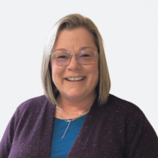

Gay Litteken, BS

Executive Director
(573) 777-1815 x 203
Gay is our Chief Problem Solver, Big Picture Thinker, and Community Cheerleader. She has a background in early childhood education and has been with First Chance since 2022.
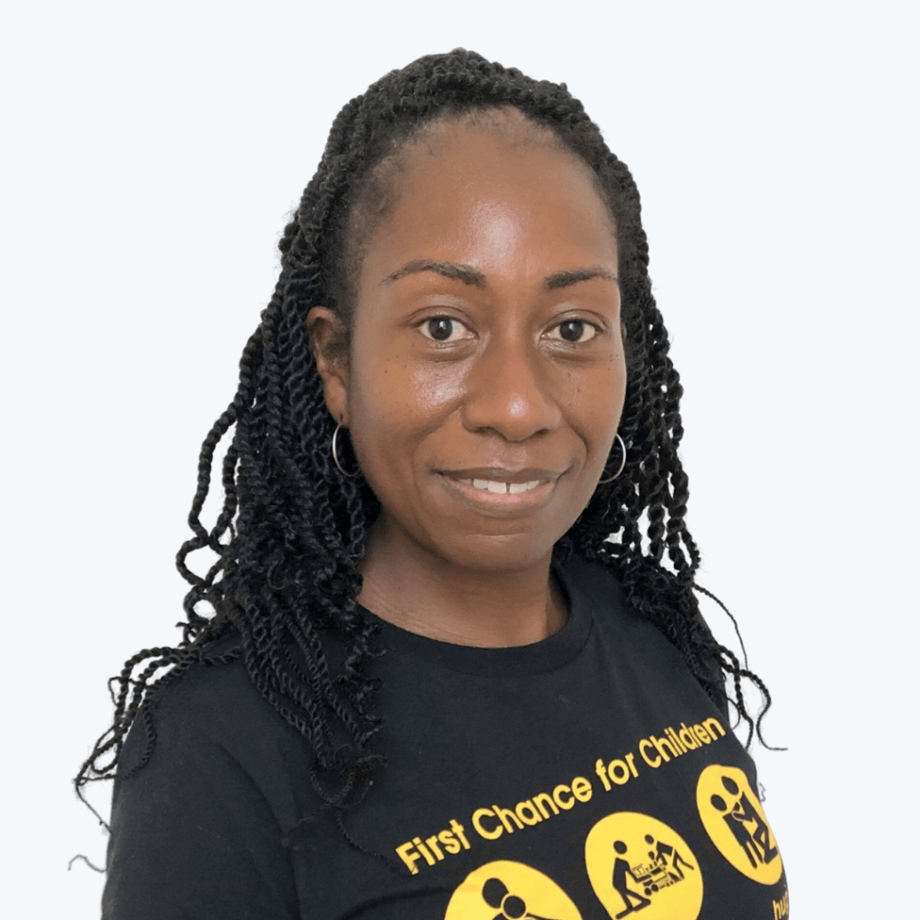

Verena Wilkerson, BS

Baby Bags Diaper Bank Coordinator
- (573) 777-1815 x 208
- Verena supports the operation of our diaper bank program by working directly with families and raising funds, everything in-between! With an extensive background in early childhood education, she knows what families need & how to secure resources that bridge gaps and improve lives. She has been educating families with us since 2021.

