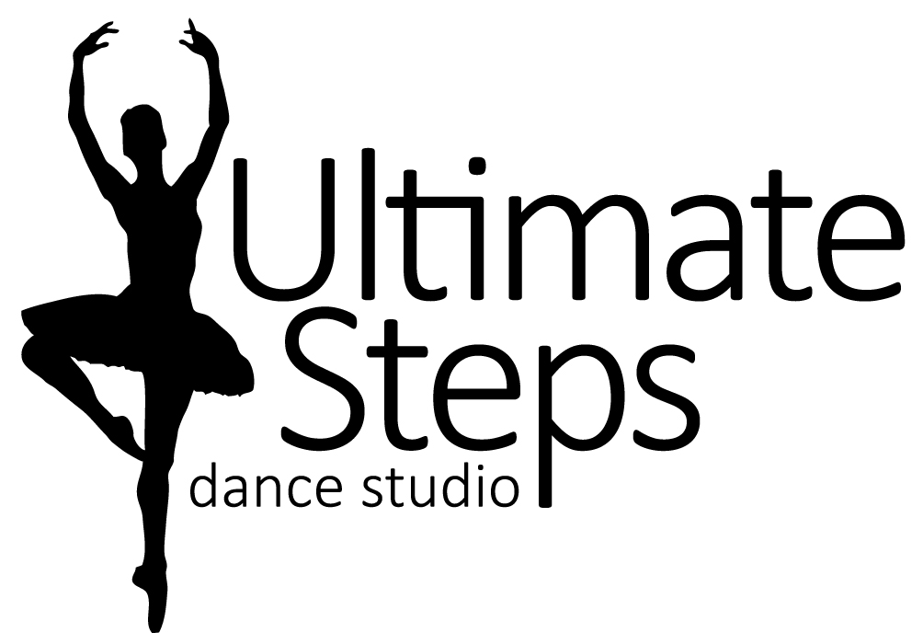PRINCESS PARTY SUMMER CAMP
INFORMATION

Princess Party Camp will have your little princesses twirling and dancing around. During the camp dancers will get to try many different styles of dance such as ballet, jazz, acro, etc. There will also be fun crafts and games. On the last day they will meet and perform with an ACTUAL PRINCESS!!

Session 1 = July 15th to 19th from 9:30am to 11:30am For 3 to 6 year olds
Session 2 = August 12th to 16th from 9:30am to 11:30am
On the last day of camp the show will start at 11:30am.

CAMP PRICE $99.99 + HST Early Bird Special Save $10 by April 30th

WHAT TO WEAR:

Please have your child in dance appropriate clothing for example, Body Suit, tights and skirt or yoga style shorts/capris/leggings with a body fitting tank-top or t-shirt.
For foot wear dance shoes such as ballet shoes, jazz shoes, or gymnastic slippers.
Hair should be pulled back in a ponytail, bun, braid etc.

On the last day of camp please have your little princess dress up in their favourite princess outfit.

WHAT TO BRING:

Pack a small healthy snack (peanut free) as well as a labeled water bottle.
Don’t forget your SMILE!
On the last day, parents don’t forget your camera! You won’t want to miss your chance for a picture with a princess.

Liability Statement
I agree to the registration information, policies, and principles of Ultimate Steps Dance Studio. I release Ultimate Steps Dance Studio, Lauren Tasker, all teachers, staff, employees, assistants and volunteers from all liability action, negligence or lawsuits arising from any activity while in the studio, while using facilities or in studio vicinity and/or in the relation to any travels conducted by Ultimate Steps Dance Studio, including dance competitions and/or recital. I hereby allow Ultimate Steps Dance Studio to use photos and/or videos of my child for promotional use at any time.
Insurance Policy
Ultimate Steps Dance Studio does not carry insurance for its students. It is required that all dance students be covered by their own family insurance policies and if injury occurs it is understood that the student family’s policy is your only source of reimbursement. Ultimate Steps Dance Studio or its teachers are not responsible for injury.
“If you keep believing, the dream that you wish will come true.” Cinderella.

