PRINCESS PARTY CAMP
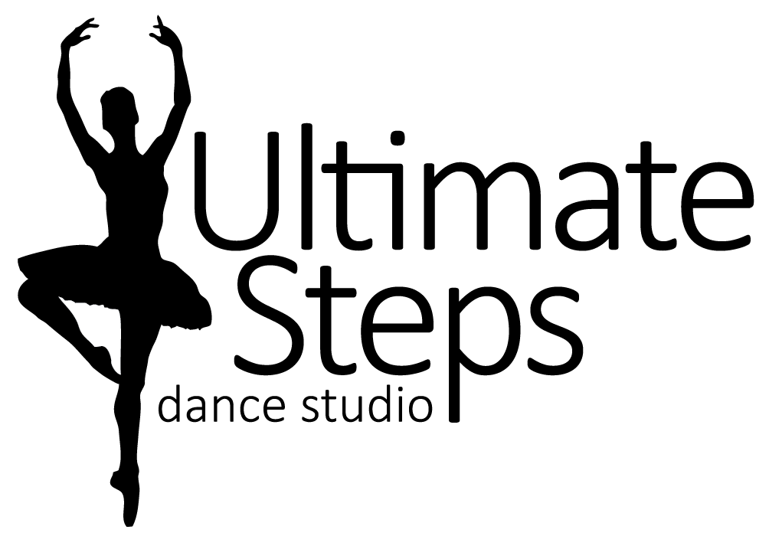
Registration Form

Student Name: _________________________________
Birth Date: month________/ day________/ year________ Age________
Parent/Guardian Name: ______________________________ Cell #______________________
Email Address: ____________________________________________________________
Medical Concerns: (allergies, injuries, and medical conditions) ___________________________________________________
PRINCESS PARTY for 3-6 year olds from 9:30am to 11:30am
Princess Party Camp will have your little princesses twirling and dancing around. During the camp dancers will get to try many different styles of dance such as ballet, jazz, acro, etc. There will also be fun crafts and games. On the last day they will meet and perform with an ACTUAL PRINCESS!!

I agree to the registration information, policies, and principles of Ultimate Steps Dance Studio. I release Ultimate Steps Dance Studio, Lauren Tasker, all teachers, staff, employees, assistants and volunteers from all liability action, negligence or lawsuits arising from any activity while in the studio, while using facilities or in studio vicinity and/or in the relation to any travels conducted by Ultimate Steps Dance Studio, including dance competitions and/or recital. I hereby allow Ultimate Steps Dance Studio to use photos and/or videos of my child for promotional use at any time.
Parent/Guardian Signature: ___________________________ Date: _____________________

Session 1 = July 15th to 19th 2019 Session 2 = August 12th to 16th 2019

For Office Use Only Prices Include HST
Paid by: CHEQUE, CASH, E-Transfer TOTAL AMOUNT $_______________
Early Bird Price(Until April 30th) $__103.00__
Regular Price $_113.00_____

