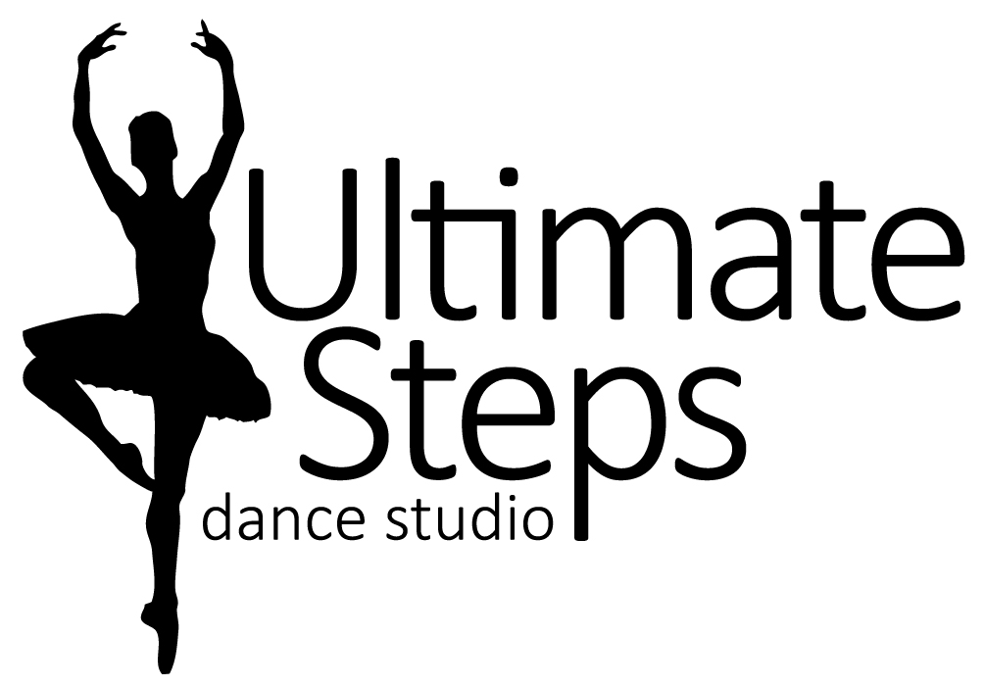 SUPERSTAR DANCE CAMP

This is a full day camp for the dancers who love to DANCE! No experience required. Every day we will be learning different styles of dance such as Acro, Jazz, Hip Hop, Musical Theatre, etc. Our stars will also have fun with crafts, a pizza party and costumes. At the end of camp, our dancing stars will show how they shine with a fun performance for our adoring fans!

For 7 to 12 year olds
July 22nd to July 26th from 9:30am to 3:30pm
On the last day of camp the show will start at 3:00pm.

Price $225.00 + HST Early Bird Special Save $25 by April 30th
*Before and after care available upon request @ $10/hr
WHAT TO WEAR:

Please have your child in dance appropriate clothing for example, yoga style shorts/capris/leggings with a body suit, body fitting tank-top or t-shirt.
For foot wear dance shoes such as ballet shoes, jazz shoes, foot paws or indoor running shoes.
Hair should be pulled back in a ponytail, bun, braid etc.

WHAT TO BRING:

Pack a healthy lunch and snacks (peanut free) as well as a labeled water bottle.
On Friday, Ultimate Steps will provide a Pizza lunch for our hard working stars.
Don’t forget your SMILE!
On the last day, parents don’t forget your camera!

Liability Statement
I agree to the registration information, policies, and principles of Ultimate Steps Dance Studio. I release Ultimate Steps Dance Studio, Lauren Tasker, all teachers, staff, employees, assistants and volunteers from all liability action, negligence or lawsuits arising from any activity while in the studio, while using facilities or in studio vicinity and/or in the relation to any travels conducted by Ultimate Steps Dance Studio, including dance competitions and/or recital. I hereby allow Ultimate Steps Dance Studio to use photos and/or videos of my child for promotional use at any time.
Insurance Policy
Ultimate Steps Dance Studio does not carry insurance for its students. It is required that all dance students be covered by their own family insurance policies and if injury occurs it is understood that the student family’s policy is your only source of reimbursement. Ultimate Steps Dance Studio or its teachers are not responsible for injury.

“DANCE IS LIKE DREAMING WITH YOUR FEET”

