SUPERSTAR DANCE CAMP
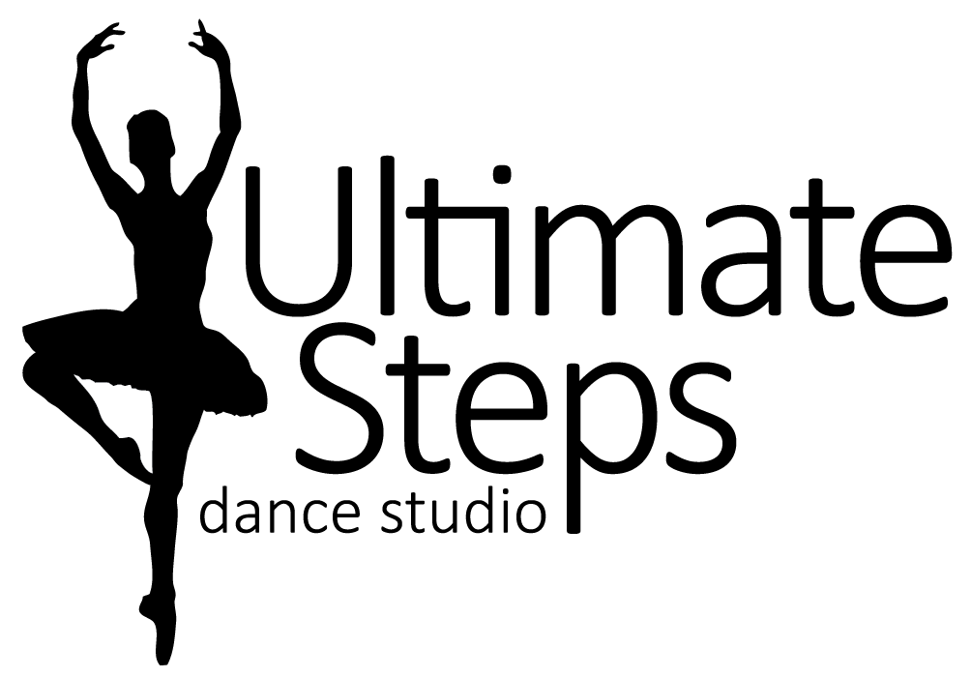
Registration Form

Student Name: _________________________________
Birth Date: month________/ day________/ year________ Age________
Parent/Guardian Name: ______________________________ Cell #______________________
Email Address: ____________________________________________________________
Medical Concerns: (allergies, injuries, and medical conditions) ___________________________________________________
SUPERSTAR DANCE CAMP
7-12 year olds Monday, July 22nd to Friday, July 26th from 9:30am to 3:30pm
This is a full day camp for the dancers who love to DANCE! Every day we will be learning different styles of dance such as Acro, Jazz, Hip Hop, Musical Theatre, etc. Our stars will also have fun with crafts, a pizza party and costumes. At the end of camp, our dancing stars will show how they shine with a fun performance for our adoring fans!

I agree to the registration information, policies, and principles of Ultimate Steps Dance Studio. I release Ultimate Steps Dance Studio, Lauren Tasker, all teachers, staff, employees, assistants and volunteers from all liability action, negligence or lawsuits arising from any activity while in the studio, while using facilities or in studio vicinity and/or in the relation to any travels conducted by Ultimate Steps Dance Studio, including dance competitions and/or recital. I hereby allow Ultimate Steps Dance Studio to use photos and/or videos of my child for promotional use at any time.
Parent/Guardian Signature: ___________________________ Date: _____________________

For Office Use Only Prices Include HST
Paid by: CHEQUE, CASH, E-Transfer TOTAL AMOUNT $_______________
Early Bird Price (By April 30th) $_229.00___
Regular Price $__254.00____
Before /After care_______

