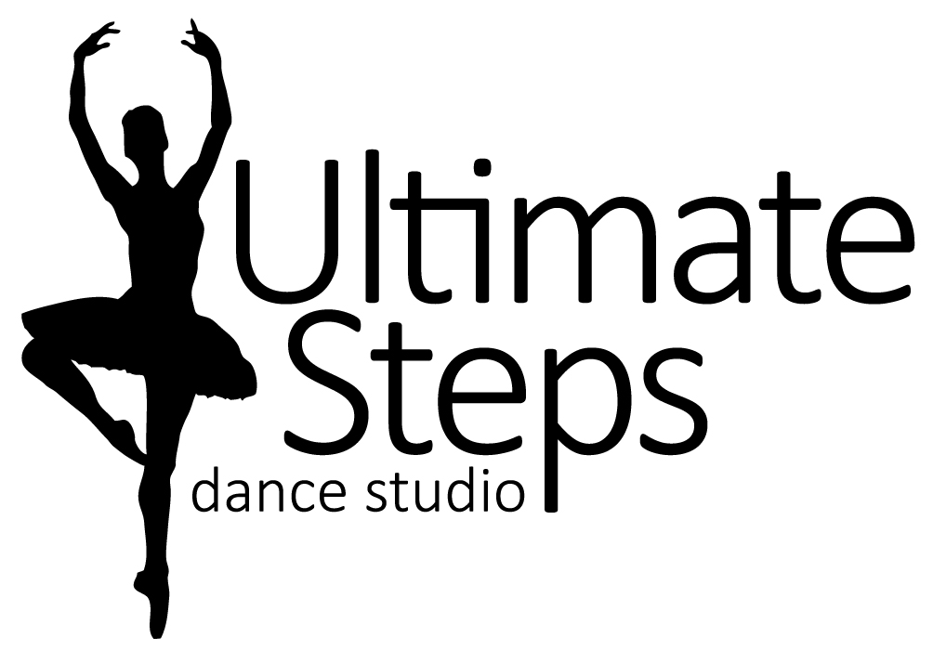**ULTIMATE INTENSIVE DANCE CAMP**

**INFORMATION**

This is a full day camp for the competitive team and dancers with experience. It is a fun filled week of dance taught by the hottest choreographers we can find plus our studio favourites. Dancers will be learning new technique and fresh exciting moves! It will leave you ready to take on the 2019/2020 dance season.

For 7 and Up

August 19th to 23rd from 9:30am to 3:30pm

On the last day of camp the show will start at 3:00pm.

Price $225.00 + HST Early Bird Special Save $25 Before April 30th

*before and after care $10 per hour

**WHAT TO WEAR:**

Please have your child in dance appropriate clothing for example, yoga style shorts/capris/leggings with a body fitting tank-top or t-shirt.

For foot wear dance shoes such as ballet shoes, jazz shoes, foot paws or indoor running shoes.

Hair should be pulled back in a ponytail, bun, braid etc.

**WHAT TO BRING:**

Pack a healthy lunch and snacks (peanut free) as well as a labeled water bottle.

On Friday, Ultimate Steps will provide a Pizza lunch for our hard working dancers.

Don’t forget your SMILE!

On the last day, parents don’t forget your camera!

**Liability Statement**

I agree to the registration information, policies, and principles of Ultimate Steps Dance Studio. I release Ultimate Steps Dance Studio, Lauren Tasker, all teachers, staff, employees, assistants and volunteers from all liability action, negligence or lawsuits arising from any activity while in the studio, while using facilities or in studio vicinity and/or in the relation to any travels conducted by Ultimate Steps Dance Studio, including dance competitions and/or recital. I hereby allow Ultimate Steps Dance Studio to use photos and/or videos of my child for promotional use at any time.

**Insurance Policy**

Ultimate Steps Dance Studio does not carry insurance for its students. It is required that all dance students be covered by their own family insurance policies and if injury occurs it is understood that the student family’s policy is your only source of reimbursement. Ultimate Steps Dance Studio or its teachers are not responsible for injury.

“Never Miss A Chance To Dance!”