ULTIMATE INTENSIVE DANCE CAMP
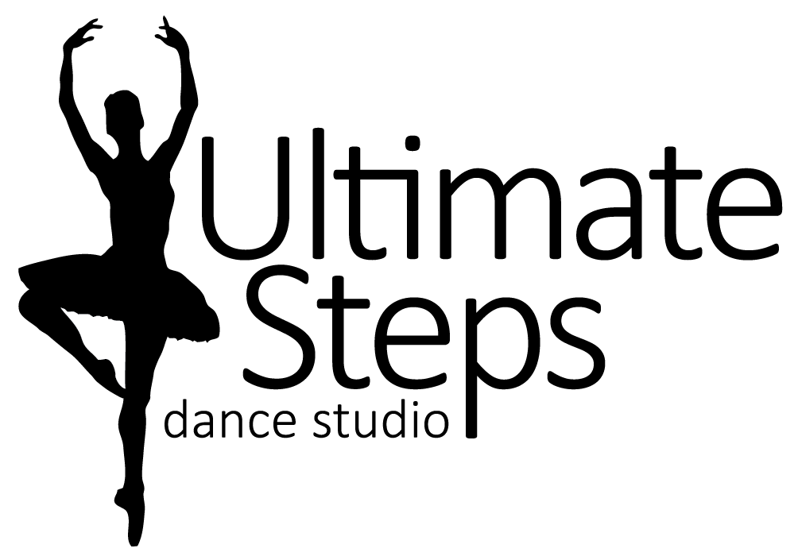
Registration Form

Dancers Name: _________________________________
Birth Date: month________/ day________/ year________ Age________
Parent/Guardian Name: ______________________________ Cell #______________________
Email Address: ____________________________________________________________
Medical Concerns: (allergies, injuries, and medical conditions) ___________________________________________________

ULTIMATE INTENSIVE DANCE CAMP
7 and Up August 19th to August 23rd from 9:30am to 3:30pm
This is a full day camp for the competitive team and dancers with experience. It is a fun filled week of dance taught by the hottest choreographers we can find plus our studio favourites. Dancers will be learning new technique and fresh exciting moves! It will leave you ready to take on the 2019/2020 dance season.
I agree to the registration information, policies, and principles of Ultimate Steps Dance Studio. I release Ultimate Steps Dance Studio, Lauren Tasker, all teachers, staff, employees, assistants and volunteers from all liability action, negligence or lawsuits arising from any activity while in the studio, while using facilities or in studio vicinity and/or in the relation to any travels conducted by Ultimate Steps Dance Studio, including dance competitions and/or recital. I hereby allow Ultimate Steps Dance Studio to use photos and/or videos of my child for promotional use at any time.
Parent/Guardian Signature: ___________________________ Date: _____________________

For Office Use Only Prices Include HST
Paid by: CHEQUE, CASH, E-Transfer TOTAL AMOUNT $_______________
Early Bird Price (By April 30th) $__229.00__
Regular Price $_254.00_____
Before and After Care
*10 per hour

