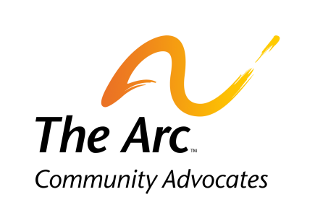
INCLUSION CONFERENCE - EXHIBITOR FORM
March 15, 2023 - Fetzer Center, WMU

Organization Name:
Contact Name:
Contact Email:
Organization Description/Mission:

Please put an “X” by your lunch choice:
Yes, I would like the complimentary lunch. No, I will not be in attendance for lunch.
If yes, please specify any dietary restrictions:

Please return form to: lconant@communityadvocates.org, or you can mail it to:
The Arc Community Advocates, 814 S Westnedge Ave, Kalamazoo, MI 49008
Please send a business logo to lconant@communityadvocates in a .jpg or .eps file format so we can promote your participation in this event. Please contact LaTaynia Conant at (269) 342-9801, or lconant@communityadvocates.com with any questions.
Thank you very much for your participation.
