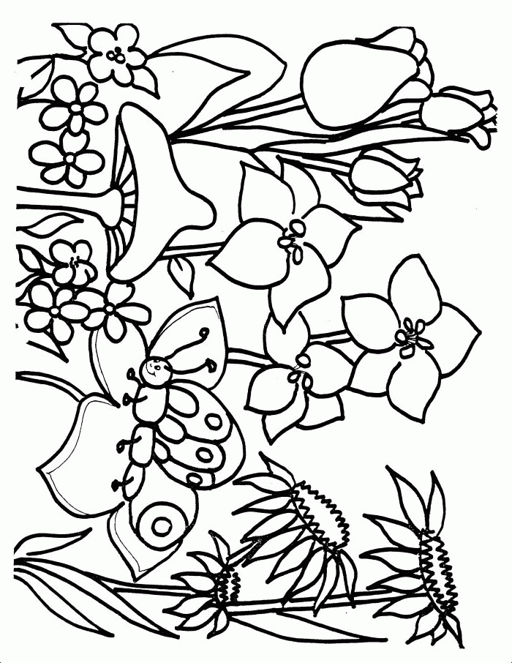
PRS Kids Menu $5
Ages 12 and under

Breakfast
Served until 11:00 am M-F + 2:00 pm Sat & Sun
Pancake + Bacon or Sausage
Egg + Bacon or Sausage + Toast
Biscuit + Gravy

Lunch + Dinner
Grilled Cheese with fries
Two Chicken strips with fries
Half Cold Turkey or Ham Sandwich with fries
Kids Burger with fries $7

