ADVANTAGES OF METAL ROOFS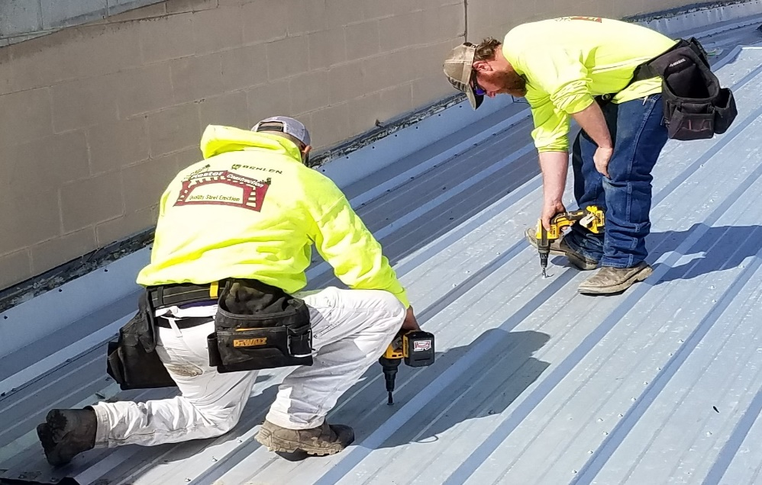

Whether you're putting a roof on a new home, or your existing roof requires a total makeover, there are many materials available. But no matter what roof style you have, metal roofs can be an attractive option because of their longevity, minimal maintenance, and energy efficiency.
Metal roofs offer many benefits, including:
- Longevity. The traditional asphalt roofing material can be expected to last 12-20 years. Metal roofs have a life expectancy of 40-70 years.
- Durability. Metal roofs can sustain wind gusts up to 140 miles per hour depending on the metal roof selected. Metal roofs will not corrode or crack, and may be impact-resistant (depending on which metal you choose).
- Maintenance. In addition, metal roofs don't need the periodic costly maintenance that other roofing materials often require. However, they should be inspected periodically to make sure no repairs are required.
- Safety. Metal roofs are more fire resistant, will not spark and ignite into flames during a wildfire or lightning strike.
- Energy efficiency. Metal roofs reflect solar radiant heat, which can reduce cooling costs by 10-25%.
- Environmentally friendly (Go Green). Metal roofs not only have 25-95% recycled content, depending on the material used, but are also 100% recyclable at the end of their life as a roof. In contrast, most shingle tear-off waste ends up as part of the building-related waste stream — up to 20 billion pounds per year.
- Metal roof insurance discount. Being fire resistant, impact resistant, EnergyStar rated can qualify for insurance discounts. So, if you have a metal roof you should contact your insurance provider to see what kind of discount you qualify for. Discounts will vary between providers but could be as high as 30% based on the providers factors such as location etc..

Metal roofs Disadvantages:
Despite their many advantages, metal roofs have some potential drawbacks. Most can be eliminated by using an experienced, qualified contractor that specializes in metal roofs/buildings who cares about quality. Many other potential drawbacks can be eliminated by using quality material.
- Affordability. Metal roofs can be as much as two or three times more expensive than other roofing materials. While the life of a metal roof is much longer, investing in a metal roof only makes sense if you plan to stay in your home long enough to enjoy the cost benefits.
- Noisiness. Metal roofs can be noisy, especially during a heavy rain or hailstorm. Adding more insulation during installation usually solves this problem, but that may increase costs.
- Expansion and contraction. Metal roofing materials that are attached as large panels tend to expand and contract. If they are not properly installed with fasteners that allow the metal to 'breathe,' the panels may loosen. This can be prevented by hiring a contractor that specializes in metal buildings and roofs.
- Performance.
  - Metal roofing materials that are attached as large panels tend to expand and contract. If they are not properly installed with fasteners that allow the metal to 'breathe,' the panels may loosen. This can be prevented by hiring a contractor that specializes in metal buildings and roofs.
  - If water accumulates anywhere on the roof because of poor-quality installation or repair, it can eventually cause serious damage. Always use a contractor that specializes in metal buildings when repairing your metal roof.
  - Low-grade metals may also be thinner and less durable. Some metals dent more easily than others during hailstorms or installation.

