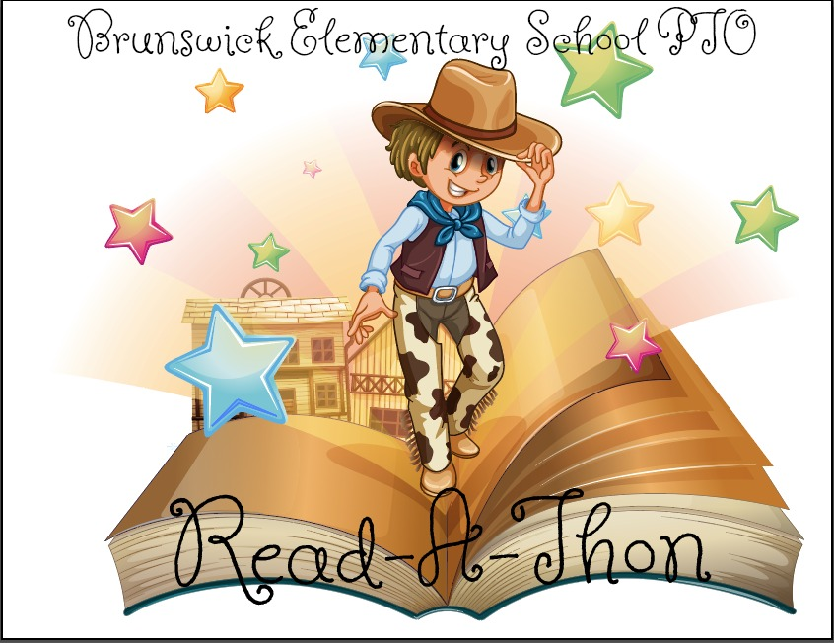

**Brunswick Elementary PTO READ‐A‐THON**

*“The more that you read, the more things you will know. The more that you learn, the more places you’ll go.” ‐Dr. Seuss*

Dear BES Families,

Brunswick Elementary School PTO is very pleased to announce our first Read‐A‐Thon for our students! We all want our kids to share a love of reading and this Read‐A‐Thon supports that goal as well as raises money for the PTO without your child having to sell anything or the school having to split the profits with another organization. Will you please join us in asking friends and family to sponsor your child as he/she pledges to read from October 1st-October 20th? We are even offering an option to pay online to make collecting money even easier!

The PTO has tried to make the Read‐A‐Thon easy and fun and we’re hoping that everyone will participate to make it a huge success for our school. The best part of the Read‐A‐Thon is that 100% of the money raised will stay at Brunswick Elementary School and directly benefit our kids to fund technology improvement, school field trip transportation and, much more!! And there’s nothing to buy; just family and friends encouraging our kids to read! Let’s work together to make it super successful!!

**Here’s how it works.**

This packet contains the Read‐A‐Thon rules, an overview of the prizes, a sponsorship form, and a calendar to record minutes read each night. The first week of the Read‐A‐Thon (beginning Sunday, October 1st) is when your child sets his/her reading goals and should begin asking people to sponsor them by pledging to pay a certain amount per minute that your child reads or is read to or sponsors can also pledge a flat amount to encourage your child to meet his/her reading goal. Remind your child that relatives, neighbors, family friends, coaches make GREAT sponsors! All donations are tax deductible. Your child can continue collecting sponsors throughout the Read‐A‐Thon. Please remember not to go door to door to solicit donations.

Your child will track the minutes they read outside of school each day from Sunday, October 1st– Friday, October 20th. Please initial your child’s recording calendar each day. The classes will compete against each other for the most minutes read to make the Read‐A‐Thon even more fun! Forms and any money collected are due back by **Wednesday, October 25th**. Please use the Read‐A‐Thon packet envelope to return your child’s sponsorship form and minutes recording form along with any money collected by **October 25th** so that your child will be eligible for the prize drawings to reward our hard-working readers!! Sponsors can also pay online through the fundraiser website <https://99pledges.com/fund/brunswickpto>. Family across the world can help support our children’s reading.

**Prizes, Prizes and More Prizes!!**

There are lots of prizes students can earn for participating in the Read‐A‐Thon, whether he/she raises money or not. There will be prizes for the top readers and fundraiser as well as fun prizes for the whole school as we reach our fundraising goals. See the overview of prizes for more information.

Thank you so very much for your support. Please feel free to contact BES PTO (brunswickpto@gmail.com) if you have any questions about this fundraiser.

Amelia Heck, Kelli Dick, Hope Bonanno, Libby Taylor, Cam Jacobson, Emily Porter