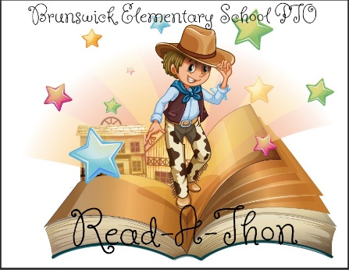

**Prizes, prizes, and more prizes**

**Prizes can be earned by logging minutes read and raising money!**

All students will receive a bookmark with their Read-A-Thon packet.

Earn prizes for the amount of money raised:

* $10- “I Love Reading” bracelet
* $25- “I Love Reading” lanyard
* $50-$5 Book Fair Credit*
* $100 and over-$10 Book Fair Credit*

*Book Fair credit can be used at our fall book fair, October 31st-Nov 8th. Not redeemable for cash

**Raise $100 or more and be entered in a drawing to win a Kindle Fire.**

One winner from grades Pre-K-2nd and one winner from 3rd-5th will be chosen.

The student from Pre-K-2nd and 3rd-5th reading the most minutes and the student from Pre-K-2nd and 3rd-5th raising the most money will win the opportunity to go to lunch at Kings Pizza with Mr. McConnaughey and Mrs. Putnam. **Parent permission will be required.**

The class from Pre-K-2nd and 3rd-5th reading the most minutes and the class from Pre-K-2nd and 3rd-5th raising the most money will have Mr. McConnaughey or Mrs. Putnam as a guest teacher for half of a day (date TBD).

**Prizes for reaching school wide goals:**

* $2500- The students will have a fun filled PE class learning some western dancing.
* $5000-The students participating in the Read-A-Thon will get to duct tape Mr. McConnaughey and Mrs. Putnam to the wall.
* $7500-Mr. McConnaughey and Mrs. Putnam will dress up as cowboys for a day.
* $10,000-Mr. McConnaughey and Mrs. Putnam will work from the roof of the school for a day!