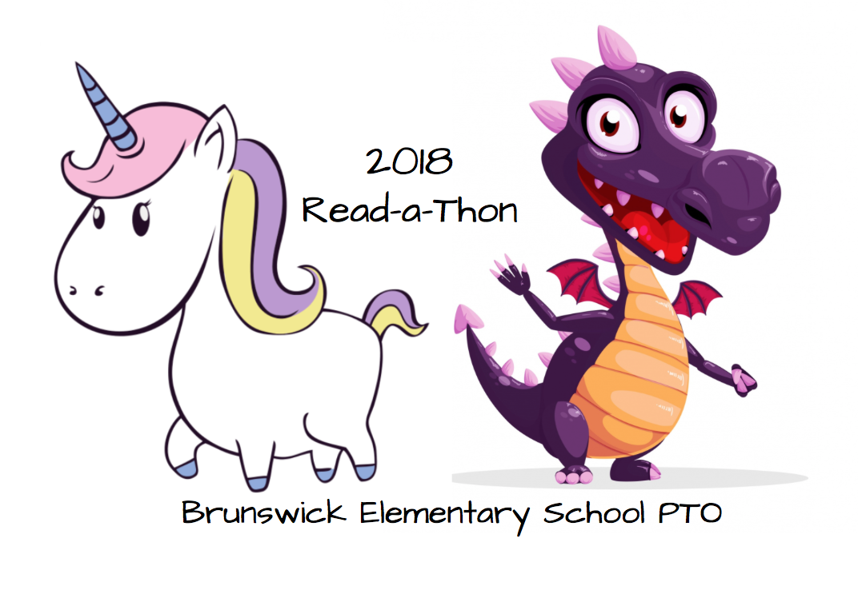

*You can find magic wherever you look. Sit back and relax, all you need is a book. -Dr. Seuss*

**Brunswick Elementary PTO READ‐A‐THON**

Dear BES Families,

Brunswick Elementary School PTO is very pleased to announce the return of our Read‐A‐Thon! This is our largest fundraiser of the year! We are hoping to raise $15,000.00. Last year we raised $6287.07 and the students that participated read 37,163 minutes! Let’s see if we can beat those number this year!

We all want our kids to share a love of reading and this Read‐A‐Thon supports that goal as well as raises money for the PTO without your child having to sell anything or the school having to split the profits with another organization. 100% of the money raised will stay at Brunswick Elementary School and directly benefit our kids to fund technology improvement, school improvements, and much more!! Will you please join us in asking friends and family to sponsor your child as he/she pledges to read from October 1st-October 14th? We are even offering an option to pay online to make collecting money even easier! The PTO has tried to make the Read‐A‐Thon easy and fun and we’re hoping that everyone will participate to make it a huge success for our school! Let’s work together to make it super successful!!

**Here’s how it works.**

This packet contains the Read‐A‐Thon rules, an overview of the prizes, a sponsorship form, and a calendar to record minutes read each night. Remind your child that relatives, neighbors, family friends, coaches make GREAT sponsors! All donations are tax deductible. Your child can continue collecting sponsors throughout the Read‐A‐Thon. Please remember not to go door to door to solicit donations.

Your child will track the minutes they read outside of school each day from Monday, October 1st–Sunday, October 14th. Please initial your child’s recording calendar each day. The classes will compete against each other for the most minutes read to make the Read‐A‐Thon even more fun! Forms and any money collected are due back by **October 15th**. Please use the Read‐A‐Thon packet envelope to return your child’s sponsorship form and minutes recording form along with any money collected by **October 15th** so that your child will be eligible for the prize drawings to reward our hard-working readers!!

**Family across the world can help support our children’s reading.** In order to help increase online pledges you can use the website <https://99pledges.com/fund/bespto2018>. Using this link, you can add your child/children as a participant, creating your child's “page” only takes 2 minutes. By adding your child, you get a personalized link allowing people to donate in your child's name any time that link is clicked. You will get a confirmation email which includes the personalized link, it also includes the ability to send a personalized message to friends and family. This link can also be shared easily on social media, via email or any way you choose.

If you choose not to sign up for a personalized page **please make sure your child's name is put in the memo field** so all of their hard work can be rewarded. **None of your child's information is made public using this site.**

**LOTS OF PRIZES TO BE EARNED!!! SEE OUR PRIZE SHEET!!**

Thank you so very much for your support. Please feel free to contact BES PTO (brunswickpto@gmail.com) if you have any questions about this fundraiser.