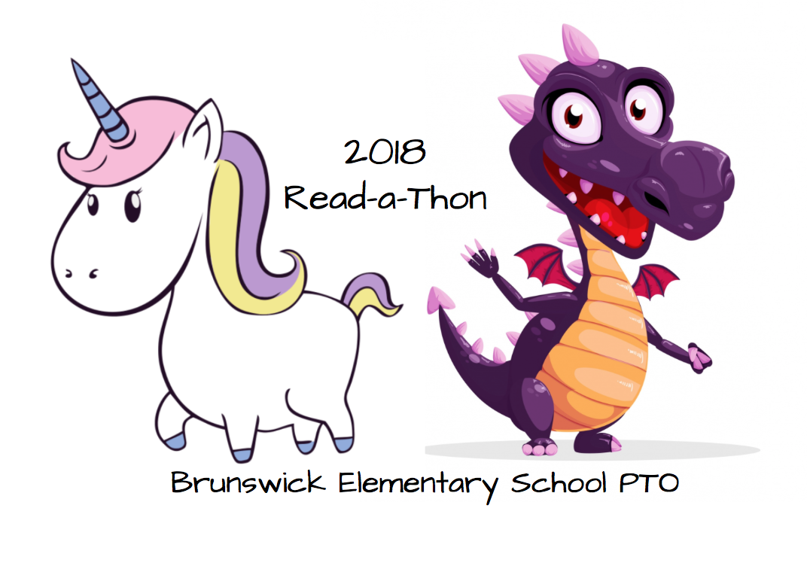
Use your Minutes Recording Form to keep track of how many minutes you read (or are read to)
1. Reading before the official beginning of the READ‐A‐THON on October 1st does not count. 2.Reading during class time does not count. 3. Being read to by other people counts. 4. Reading aloud to other people counts. If you read to someone who is also participating in the Read‐A‐Thon, it counts for both of you! 5. Reading assigned homework (including assigned books, chapters, etc) does count.

BES READ-A-THON Minute Recording Sheet
Name___________________________________ Grade___________ Teacher__________________________
October 2018
My goal is to read________________ minutes in 20 days.
Start Reading on Monday, October 1st

Sunday | Monday | Tuesday | Wednesday | Thursday | Friday | Saturday
 | 1 Minutes read: Initials: | 2 Minutes read: Initials: | 3 Minutes read: Initials: | 4 Minutes read: Initials: | 5 Minutes read: Initials: | 6 Minutes read: Initials:
7 Minutes read: Initials: | 8 Minutes read: Initials: | 9 Minutes read: Initials: | 10 Minutes read: Initials: | 11 Minutes read: Initials: | 12 Minutes read: Initials: | 13 Minutes read: Initials:
14 Minutes read: Initials:
No guessing or rounding off minutes. Please look at the clock or use a timer to keep track of your minutes. Please remember that CHARACTER COUNTS – be honest with your minutes so that it will be fair and fun for everyone. Remember that an adult needs to initial your minutes every day on your Minute Recording Sheet.
Parents/ Guardians Please make sure you initial your students reading minutes.
October 15th: Return your Minute Recording Sheet, Sponsorship Form, and Money Collected in the Read-A-Thon envelope to school by this date in order to be entered into the prize drawings.
TOTAL MINUTES READ:__________________ PARENT’S SIGNATURE:__________________________________

