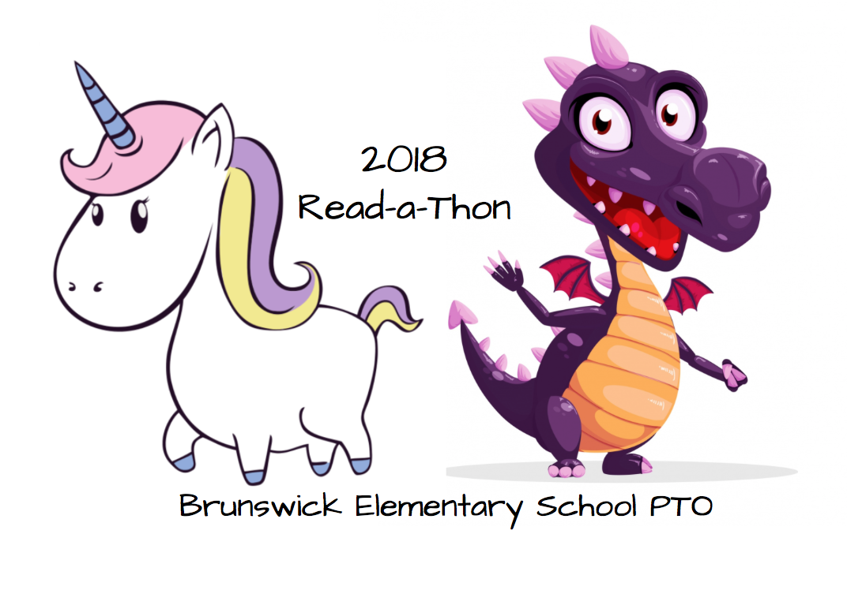

**Brunswick Elementary School**

**Read- A-Thon**

**Sponsor Pledge Sheet**

**MY GOAL IS TO READ­­­­­­­­­­­­-­­­­­___________ MINUTES IN 14 DAYS!!!**

**Name:________________________________________________________ Grade: ___________Teacher: _________________________________**

Dear Sponsor:

I am participating in a school-wide Read-A-Thon at Brunswick Elementary School from **October 1st- October 14th, 2018**. The Read- A-Thon is sponsored by our PTO and encourages kids like me to enjoy reading and improve our reading skills while raising money for my school. 100% of the money raised will directly benefit our students to fund technology improvement, school facilities improvements and, much more!! There’s nothing to buy; just family and friends encouraging our kids to read!

Will you please sponsor me by making a pledge? You can make a flat rate donation or pledge an amount per minute I read. All donations are tax deductible and sponsors can even pay online at https://99pledges.com/fund/bespto2018. Thank you for your support!!

|  |  |  |  |  |  |
| --- | --- | --- | --- | --- | --- |
| **Sponsor Name** | **Sponsor Phone #** | **Pledge Amount** | **Minutes Read** | **Total Due** | **Collected?** |
| **1)** |  |  |  |  |  |
| 2) |  |  |  |  |  |
| 3) |  |  |  |  |  |
| 4) |  |  |  |  |  |
| 5) |  |  |  |  |  |
| 6) |  |  |  |  |  |
| 7) |  |  |  |  |  |
| 8) |  |  |  |  |  |
| 9) |  |  |  |  |  |
| 10) |  |  |  |  |  |

Some example pledges per minute: ($.05 x 250 minutes = $12.50) ($.10 x 250 min = $25.00) ($.25 x 250 min = $62.50)

Make checks payable to Brunswick Elementary School PTO. Return this form, your minute recording calendar and money collected in the Read-A-Thon envelope to school Monday, October 15th to be entered into PRIZE DRAWINGS!!!!