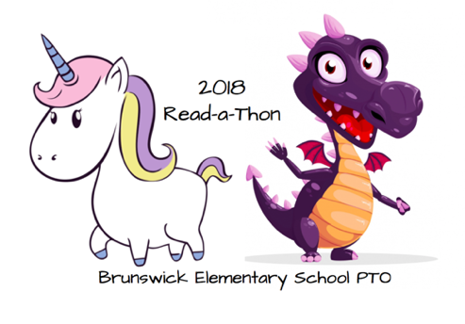

**Prizes, prizes, and more prizes**

**Prizes can be earned by logging minutes read and raising money!**

All students will receive a fun bookmark with their Read-A-Thon packet.

Earn prizes for the amount of money raised:

* $10- Enchanted Forest Figurines
* $25- Get invited to a special after school movie night, with snack included.
* $50- $5 Book Fair Credit*
* $100 and over-$10 Book Fair Credit*

*Book Fair credit must be used at our fall Enchanted Forest book fair, October 29th-Nov 9th. Not redeemable for cash

**The student with the most minutes read in each classroom will be entered in a drawing to win a Kindle Echo Dot.** One winner from grades Pre-K-2nd and one winner from 3rd-5th will be chosen.

**Raise $100 or more and be entered to win a Kindle Fire HD 8, up to 3 winners.**

The student from Pre-K-2nd and 3rd-5th reading the most minutes and the student from Pre-K-2nd and 3rd-5th raising the most money will win the opportunity to go to lunch at Kings Pizza with Mr. McConnaughey, Mrs. Putnam, and/ or Mrs. Routzhan. **Parent permission will be required.**

The class from Pre-K-2nd and 3rd-5th reading the most minutes and the class from Pre-K-2nd and 3rd-5th raising the most money will have Mr. McConnaughey, Mrs. Putnam, and Mrs. Routzhan as a guest teacher for half of a day (date TBD).

**Prizes for reaching school wide goals:**

* $2500- The students will have a fun filled dance during school hours.
* $5000- Mr. McConnaughey, Mrs. Putnam, and Mrs. Routzhan will dress up in an enchanted forest theme for a day.
* $7500- Mr. McConnaughey will work from the roof of the school for a day!
* $10,000- Invited author assembly for the entire school

**Stretch GOALS**

If on average each student raises $25 we would raise more than $17,000, that money would go **direct** to our school to add shade structures on the playgrounds and many other important updates!

* $12,500- Fun filled assembly for the whole school voted on by BES Staff and students.