“Cathedral Window Pillow Class” – 5 hour class
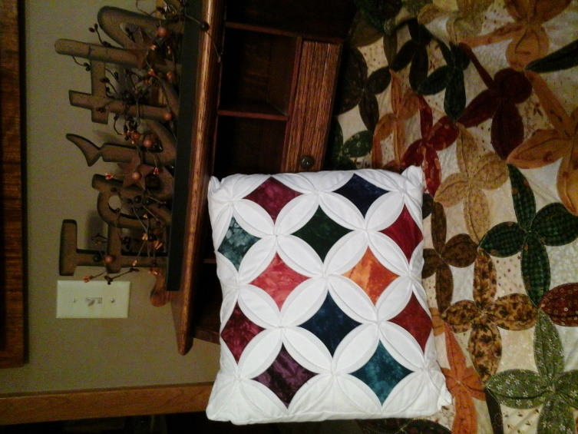
Supply List:
1 1/2 yard Muslin (Or ‘background’ fabric of your choice) Cut (9) 10” squares – please bring the remaining fabric to class for the backing of the pillow.

(12) 2 1/2” Squares – Fabric of your choice (for the center of each window section)

9” Seam Pressing Template – Unseen Hands

Large Iron (no small irons, please) – everyone needs one Pressing surface for your area. The harder the pressing surface, the better outcome you will get with the end result.

Sewing machine

Thread that will match the background fabric of your choice

Pins - Seam ripper - 14” Pillow Form

Class Fee:
$35 per person, plus the purchase of the 9” Seam Pressing Template for $14

