“Color/Embroidery Class” – 4 hour class

Supply List - Students need to bring in:
8” Embroidery Hoop
Colored Pencils
Small pair of scissors

I Provide Kits for each student (included in the kits are below):
Pattern
Working Fabric with the design already traced onto the fabric
Embroidery Floss
Embroidery Needle
Fabric Medium to seal the color
Cost: $45 per person
Finished size of the wall hanging is 11” x 11”, I used a (26) 1 ¾” Yo-Yo’s to create a Yo-Yo Border. Students can add any border they desire. My ‘hanger’ is a 12” hanger… hanger Yo – Yo’s are not included.

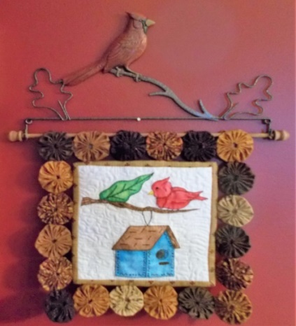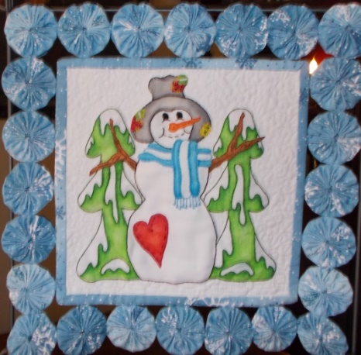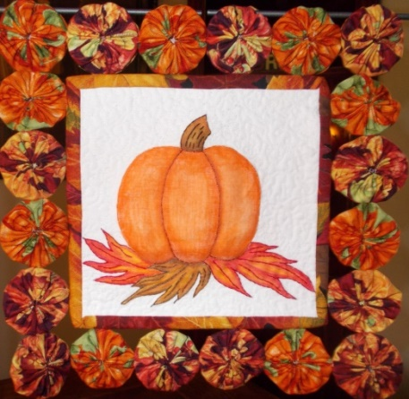
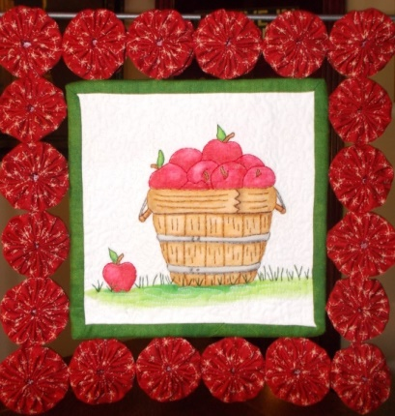
The first part of this class involves coloring… technique, shading, sealing and colors.
The second half of this class, I teach them how to do 3 embroidery stitches. The Backstitch, French knot and Satin Stitch. I also teach them how to “Twill”…. This is an old embroidery knot that has come back and is very popular right now.

