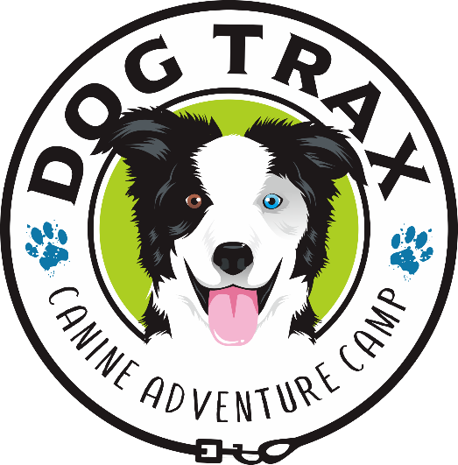

SLEEP-OVER SERVICE AGREEMENT and INFORMATION
REV: 02/2026
MY COMMITMENT AND INCLUSION OF SERVICES TO YOU:
I agree to provide personal sleep over at my home which will include:
- Pickup and Delivery back to your home between the hours of 7am-4pm,
- Daily Sniff Spot and associated fees, for at least an hour, are included,
- Nightly Zen walk before bed (weather permitting),
- Enjoying the parkour yard, canine comradery in a family atmosphere,
- Cozy and clean beds and facilities,
- Filtered water fountains,
- Fine dining and wholesome, organic, homemade treats and rewards,
- Nightly turn-down treat,
- Kong/bone time/Snuffle mat time are included,
- Medicines and raw diet are included,
- Classes or sport opportunities (Scentwork, Barn Hunt, agility, Fastcat) are included,
- Morning and evening reports with video and photos,
- Bathes and minor grooming is included,
- Ongoing coaching, referrals and support,
- Emergency care, transport and veterinary support,
- 8 hours of free care. Your day starts at 8am and goes to 4pm the next day. When you choose to start your dog is up to you.
….and, as always, my heart-felt commitment to you, your family and your dog.
.

Page 2 of 4
YOUR TIMELY PAYMENT COMMITMENT TO ME:
 FEE SCHEDULE
- Sleep Overs are $75.00/day/dog
- Medical Stay is $120/day
- Puppy Stay (under a year) is $100/day
- Day Stays are $50 (after 4pm checkout)
- Late Arrival are $20 (after 8pm on the day of check in)
Damage to property: Unless there is severe damage (ie. tearing apart infrastructure), there is no additional cost. Severe damage will be assessed at a reasonable rate to make whole.
Payment for Services: You agree to pay Ann “River” Raines dba DogTrax for the Services provided to you and your dog at the start of each visit. This is in the event something (God forbid) catastrophic were to happen to you. I would, at least, be paid for the initial time. There is so much involved returning a pet to an agent or making additional arrangements which can include, time, space, additional food, care, and money that I may never be reimbursed.
I accept cash, check, Venmo(@River-frouws), Zelle or Pay Pal (Ann Raines).
Late charges will be paid upon check out. I cannot, nor would I want to, withhold your dog for services not rendered. But, I reserve the right to collect and you are liable for all charges including any veterinary services incurred.
If you have not contacted me and made other arrangements by 6pm on your check out day, a fee consisting of the daily rate ($50), an overnight charge if applicable (20$) and an additional $10 late charge will be applied to your bill each day for each dog. I will not take and leave your dog at your home because you have failed to make arrangements for his/her return. I will keep them with me to provide a safe environment until your return. In the event you are not able to return, your dog will be relinquished to your agent immediately.

 TRANSPORT
Transport to and from your home is included within these areas which include: South Folsom, El Dorado Hills, Orangevale, Citrus Heights, Granite Bay. Pick up at Bradshaw for our Sacramento guests is included.
*Additional cost may apply to those areas outside of these areas.

Page 3 of 4
PET PROFILE, HEALTH, PERSONAL STUFF AND BEHAVIOR
PET PROFILE: Please commit to providing complete, truthful, and accurate information on the pet profile as I can only render service that is catered to your specific dog(s) according to your information. Each dog must have a separate Profile. Your dog(s) will be part of my family. They will be going where we go and taken care like the precious partner(s) that they are.
Care, Custody and Control: I will only release dogs back to the owner who have signed this agreement or are additionally authorized to pick up your dog(s). I will not get into a custody battle.
HEALTH:
Medications: Please provide all medication and supplements and a list of what they are, how much, how to administer and how often. If convenient, use the medical chart included on the client portal.
Vaccination requirements:
Your dog must have a current:
- DHPP, Bordatella and Rabies,
- A fecal test for parasites within 2 weeks (14 days) of the sleep over.
Titers are ok.
I do not require Canine Influenza, Leptospirosis or rattlesnake vaccinations.
I highly recommend Rattlesnake aversion training as we will be outdoors.
Fleas and Ticks: All dogs must be free of fleas and on a tick prevention. What are you using?
________________________
Medical Cap: What is your medical cap (the amount you are willing to pay for veterinary services?)
_____________________
PERSONAL STUFF: Please don’t bring personal items except for a collar AND harness. Despite my best efforts, they can get lost or damaged.
BEHAVIOR: IF FOR ANY REASON, your dog, becomes aggressive and bites my dogs, me or my family members, I reserve the right to separate your dog to restore order, peace and make safe anyone and anything involved. You will be notified immediately.
Contact with my dogs: Please understand that your dog will be comingling with my three border collies and my service collie (Gus). Every effort will be made to make this a trouble-free experience. If you do not want him or her to be with any other dogs you must tell me BEFORE, check in.

Page 4 of 4
LIABILITY WAIVER:
I agree to release and hold harmless Ann “River” Raines dba DogTrax, the family of Ann “River” Raines or employee/subcontractor or volunteer from all liability, should my pet become lost or injured not due to any negligence on Ann “River” Raines’s or above listed person’s part. All dogs that stay with me for any length of time will have an additional collar with a tag that states my name and phone number in the unlikely event they become separated.
YOUR AGENT:
You must provide an adult over the age of 18, as a contact for DogTrax, if you are unable to be reached in case of an emergency. They must be someone other than the primary care parent and not traveling with you. You agree that the agent is in full and complete authority to make decisions, including those that have to do with the health, welfare, medications, treatment, life and death and finances of your dog. If you are unable to find someone to fulfill that requirement, I am able to fill in for you (See Payment for Services regarding late fees). By signing this you are guaranteeing that an agent on your behalf has been contacted and they agree to provide treatment consent in the case of any emergency. You also are consenting that if you are not able to be rejoined with your dog for whatever reason, your agent will gain possession of your dog as soon as possible.
Agent’s Name:__________________________________ Agent’s Cell #: ______________________________

Agent’s Address:___________________________________________________________________________

Agent’s Email: _____________________________________________________________________________

Relationship to you: ________________________________________AGE: _________

Owner’s Signature: _________________________________ Date: _______________________

YOU HAVE READ THIS ENTIRE AGREEMENT.
YOU HAVE HAD THE OPPORTUNITY TO DISCUSS IT WITH US TO YOUR SATISFACTION.
YOU AGREE TO ITS TERMS.

OWNERS’ SIGNATURE DATE

