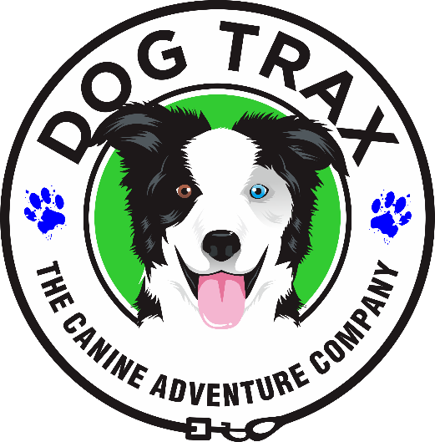

**Transport Authorization**

**Dog(s) Name: _____________________________________**

I authorize transport of my dog with Ann “River” Raines, dba DogTrax or her employee or subcontractor to and from my residence or any other venue in her vehicle. I understand that my dog will be appropriately restrained to avoid injury to them, other passengers or the driver. In the event of no fault of Ann “River” Frouws, I will not hold her liable and waive the right of legal action.

_______________________________________

Owner

_______________________________________

Date