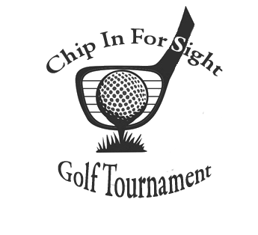


Organization/ Contact Name: _____________________________________________________________
Email: _______________________________________________________
Phone: ______________________________________________________
Sponsor Amount: ______________________________________________
Will donate Raffle Item (Minimum value $25)
Item _____________________________ Value ________________
Please email all logos in a jpeg, gif or pdf format and any other info for signage to Josi at accounting@theblindassociation.org
VISA/MC/Discover # ____________________________________________
Three Digit Code _____ Exp. _____ /______ Zip Code _______________
Name on Account _______________________________________
Total Due ____________
Check # ________________ (attached) Mail with registration

All checks made payable to The Blind Assoc. – Credit Card payments may be made by contacting 724-287-4059.
www.theblindassociation.org
322 N. Cedar St Butler, PA 16001
Sponsorship Information:
Sponsorship Packages
Saturday, August 22, 2026

Please go to www.theblindassociation.org or visit our Facebook page for more details on this event!

Our vision is clear:
Prevent, Prepare for, and Manage Blindness and Visual Impairments

HILAND GOLF course
106 Saint Wendelin Rd. butler, PA 16002

SPONSORSHIPS
Premier Sponsor $2,000 (Exclusive sponsor with a sign on all golf carts, special recognition, and complimentary foursome)
Lunch Feed Sponsor $1,000 (Complimentary foursome, Lunch Sponsor Sign, special recognition)
Continental Breakfast (2) $500 (Sign at Continental Breakfast and Tee Sign)
Turn Sponsor (2) $500 (Sign at the Turn Food Station and Tee Sign)
Tee Sponsor $150 (Tee sign with your company name)
Submit by July 31, 2026

Proceeds benefit services provided for individuals who are blind or visually impaired.

Registration begins at 8:00 am
Shotgun starts at 9:00 am
Lunch Feed 3:00 pm

