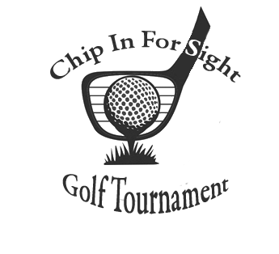



Organization/ Contact Name: _____________________________________________________________

Email: _______________________________________________________

Phone: ______________________________________________________

Sponsor Amount: ______________________________________________

🗖Will donate Raffle Item (Minimum value $25)

Item _____________________________ Value ________________

Please email all logos in a jpeg, gif or pdf format and any other info for signage to Josi at [accounting@theblindassociation.org](mailto:accounting@theblindassociation.org)

VISA/MC/Discover # ____________________________________________

Three Digit Code _____ Exp. _____ /______ Zip Code _______________

Name on Account _______________________________________

Total Due ____________

Check # ________________ (attached) Mail with registration

All checks made payable to The Blind Assoc. – Credit Card payments may be made by contacting 724-287-4059.

[www.theblindassociation.org](http://www.theblindassociation.org)

322 N. Cedar St Butler, PA 16001

***Sponsorship Information:***

Sponsorship Packages

Saturday, August 26, 2023

Please go to [www.theblindassociation.org](http://www.theblindassociation.org) or visit our Facebook page for more details on this event!

Our vision is clear:

Prevent, Prepare for, and Manage Blindness and Visual Impairments

**HILAND GOLF course**

**106 Saint Wendelin Rd. butler, PA 16002**

**SPONSORSHIPS**

🗖Premier Sponsor $2,000 (Exclusive sponsor with a sign on all golf carts, special recognition, and complimentary foursome)

🗖Lunch Sponsor $1,000 (Complimentary foursome, Lunch Sponsor Sign, special recognition)

🗖Beverage Cart Sponsor (2) $500 (Travel the course offering complimentary nonalcoholic beverages. Company name on cart)

🗖Hole Sponsor $150 (hole sign with your company name)

🗖 Tee Sponsor $150 (Tee sign with your company name)

Submit by July 31, 2023

**Proceeds benefit services provided for individuals who are blind or visually impaired.**

Registration begins at 9:00 am

Shotgun starts at 10:00 am

Dinner Reception 3:30 pm