Golfer Registration Form
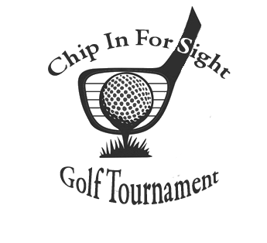


Registration begins at 8:00 am
Shotgun starts at 9:00am
Lunch Feed at 3:00 pm
Also available Raffles and Skill Prizes
Mulligans
50/50 Raffle

Entry Fee Includes:
Continental Breakfast
18 Holes of Golf with Cart
Hot Dog and Chips at the Turn
Lunch Feed & Dinner
Longest Drive and Closest to Pin
For Men and Women
1st place team wins $400.00
2nd place team wins $200.00

Fees:
Single Golfer: $100.00
Foursome: $400.00
LUNCH FEED Only: $30.00
Reservation Deadline – AUGUST 10, 2026

All Proceeds Benefit
saturday, August 22, 2026
Hiland golf course
106 Saint Wendelin Rd. butler, PA 16002

All checks made payable to The Blind Assoc. – Credit Card payments may be made by contacting 724-287-4059.
www.theblindassociation.org
322 N. Cedar St Butler, PA 16001
Please go to www.theblindassociation.org or visit our Facebook page for more details on this event!
Sponsored by
Captain and Crew Format
Captain: _______________________________________
Phone _________________________________________
Email _________________________________________
Golfer 2 _______________________________________
Email _________________________________________
Golfer 3 _______________________________________
Email_________________________________________
Golfer 4 _______________________________________
Email _________________________________________
Lunch only option:
Name ______________________________________
Phone ______________________________________
Email ______________________________________

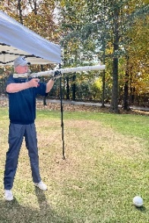
AIR CANNON HOLE

