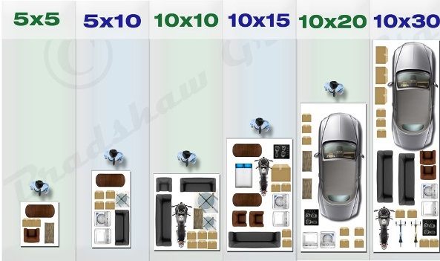

5x5: small furniture, boxes, twin mattress,
seasonal items, bicycles, business merchandise

5x10: one bedroom, queen size mattress,
major appliances, furniture, boxes

10x10: two bedroom, king size mattress,
major appliances, furniture, boxes

10x15: three bedroom, king size mattress,
major appliances, furniture, boxes

10x20: four bedroom, vehicle, king size mattress,
major appliances, furniture, boxes

10x30: four bedroom or larger, king size mattress,
vehicle, boat, major appliances, furniture, boxes

