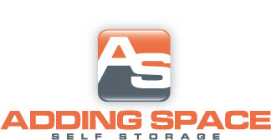
256-378-3131
Standard
Size | Auto Pay |  | Regular
5X10 | $23.75 |  | $25.00
10X10 | $38.00 |  | $40.00
10X15 | $52.25 |  | $55.00
10X20 | $61.75 |  | $65.00
10x30 | $90.25 |  | $95.00
12X30 | $104.50 | $110.00
20X20 | $109.25 | $115.00
Climate Controlled Units
Size | Auto Pay | Regular
5X5 | $23.75 | $25.00
5X10 | $33.25 | $35.00
10X10 | $57.00 | $60.00
10X15 | $76.00 | $80.00
10X20 | $90.25 | $95.00

$10.00 DEPOSIT ON ALL UNITS

