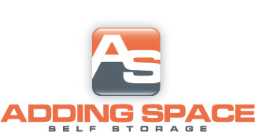

**Harpersville**

*Standard*

|  |  |  |
| --- | --- | --- |
| **Size** | **Auto Pay** | **Regular** |
| **5X10** | **$28.50** | **$30.00** |
| **10X10** | **$48.00** | **$50.00** |
| **10X15** | **$57.00** | **$60.00** |
| **10X20** | **$71.25** | **$75.00** |
| **10X25** | **$90.25** | **$95.00** |
| **10x30** | **$109.25** | **$115.00** |

**$10.00 DEPOSIT ON ALL UNITS**