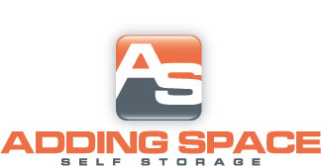
Fayetteville
256-378-3131
Standard
Size | Auto Pay | Regular
5X10 | $23.75 | $25.00
10X10 | $38.00 | $40.00
10X15 | $52.50 | $55.00
$10.00 DEPOSIT ON ALL UNITS

