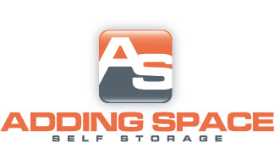
256-234-7922
Standard
Size | Auto Pay | Regular
5X10 | $23.75 | $25.00
10X10 | $38.00 | $40.00
10X15 | $52.25 | $55.00
10X20 | $61.75 | $65.00
20X20 | $109.25 | $115.00
12x30 | $118.75 | $125.00
Climate Controlled
Size | Auto Pay | Regular
5X10 | $33.25 | $35.00
10X10 | $57.00 | $60.00
10X15 | $76.00 | $80.00
10x20 | $90.25 | $95.00
Parking
Outdoor | $47.50 | $50.00
Indoor | $95.00 | $100.00
$10.00 DEPOSIT ON ALL UNITS

