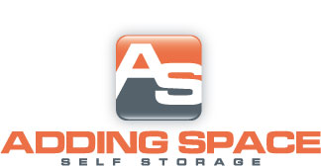

Standard
Size | AutoPay | Regular
5x10 | $33.25 | $35.00
10x10 | $47.50 | $50.00
10x15 | $66.50 | $70.00
10x20 | $85.50 | $90.00
10x30 | $114.00 | $120.00
12x30 | $118.75 | $125.00
20x20 | $142.50 | $150.00

Climate Controlled Units
5x5 | $28.50 | $30.00
5x10 | $47.50 | $50.00
10x10 | $71.25 | $75.00
10x15 | $95.00 | $100.00
10x20 | $114.00 | $120.00

$10.00 DEPOSIT ON ALL UNITS

