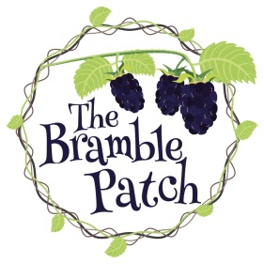

The Pumpkin Patch Halloween special booking form

**Name of Adult:** ………………………………………………………

**Name of child/ren:** …………………………………………………………………

**Age/s:** ………………………………………

**Address:** …………………………………………………………………………………………………………………………………………………………………………………………………………………………

**2 contact phone numbers:** …………………………………………….......................

**Allergies/ medical conditions:** …………………………………………………………………………………………………………………………………………………………………………………………………………………………

I DO /DO NOT give consent for photos to be used for marketing purposes and on social media

**Please select which session you would like to sign your child up to:**

Morning session: 9am – 12pm

Afternoon session 1pm – 4pm

Thank you for filling in the booking form. Libby will let you know if the requested session is available.

Book with confidence; please be aware if the government bring in any new restrictions or lockdown laws you will be fully refunded!

Now please email back to: [info@the-bramble-patch.co.uk](mailto:info@the-bramble-patch.co.uk)

You will then be sent payment information; once payment has been made you will receive confirmation of your booking.

Thank you