***THE 1ST ANNUAL INDIAN SPRINGS***

***2 PERSON GOLF S***

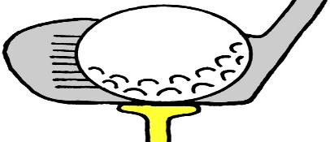

[This Photo](http://blog.dnevnik.hr/kamaci/2009/08/1626613241/free-clip-art-golfer.html) by Unknown Author is licensed under [CC BY-SA](https://creativecommons.org/licenses/by-sa/2.5/)

**SHOTGUN START 8:30 AM**

**18 HOLES**

**100% PAYOUT AFTER $30 GREEN FEES**

**$75/MAN $150 A TEAM**

**217-538-2392**

**PRICE INCLUDES:** PRIZE PURSE FOR 1ST SECOND AND 3RD IN EVERY FLIGHT, WITH FLIGHTS EVERY 10 TEAMS , CASH PAYOUT FOR SKINS IN EVERY FLIGHT AND 6 CLOSEST TO THE PIN.

NAME__________________________________PHONE____________

NAME__________________________________PHONE____________

100% PAY OUT!