
HOA Board January 2026

HOA fees are due this month. Remember, the new fee is $185.77. Payment booklets were sent to every homeowner, so you can use yours as a reminder. The HOA accepts checks mailed to the address below, and you can use our web site for credit card payments. The web link is below.
Asking residents to not use visitor parking for parking their third cars isn’t working. The board has agreed to start fining visitor parking violations at $100.00 for each offense. Starting February 1, 2026, the cars pictured on the back of this letter will be towed. Should you see a violation, please take a photo of the car, send it to the board, with the house number if you know it, and a fine will be issued. Keep in mind, college students home for the holiday are not visitors. Also, parking in one visitor space for 24 hours then moving to another visitor space for another 24 hours is a violation. You will have to find parking after 24 hours, but not another visitor space.
Should we get snow this winter, there are a few things to remember: Please clear your sidewalk within 24 hours of the end of snowfall. If you clear your parking space, please DON’T put the snow in the street. That will delay the clearing of our street. DON’T put snow in a neighbor’s parking space without their permission. This goes for leaves and trash too. Yes, residents are doing this. Sweeping leaves to the other side of the street on city or HOA property is wrong. Put your leaves in bags and set out the bags for trash pickup. Again, don’t make your trash or snow someone else’s issue.
White trash bags have appeared again. Don’t set white trash bags out for pickup. They must be in a can, not next to it.
We are looking into grants to pay for some trees to put around our entrance to help reduce street noise and wind in the community.
Again, I want to thank the board members for their hard work in keeping Dorsey Estates a home where everyone wants to live.

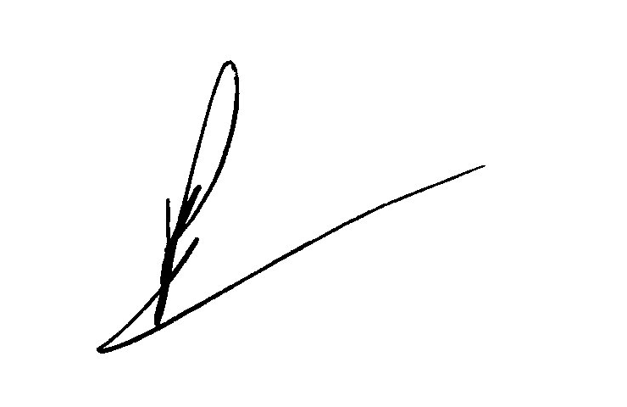

Robert Utley
President of Dorsey Estates HOA Board

Board Contact Information:
Dorsey Estates Board website: www.dorseyestates.org
23 Firstfield Rd. Unit 3092 email: debod@dorseyestates.org
Gaithersburg MD 20885-7504

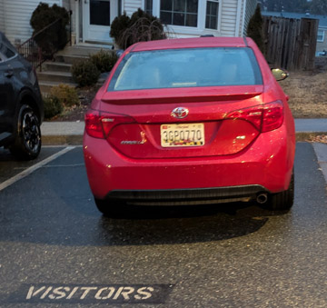
Starting February 1, 2026, these cars will be towed if
found in visitor parking spaces. If you know the
address of these cars please let the board know.

Car #1 plate number 3GP0770

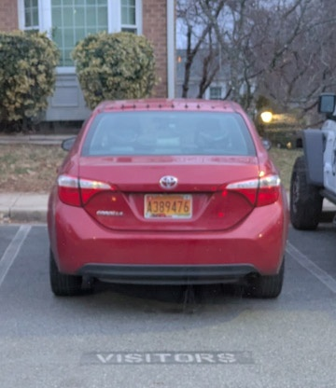

Car #2 plate number A389476

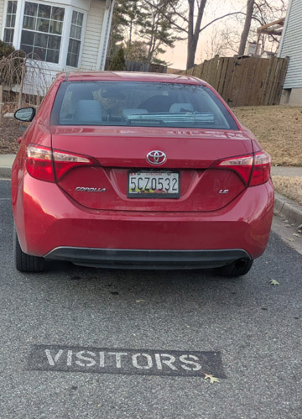

Car #3 plate number 5CZ0532

