

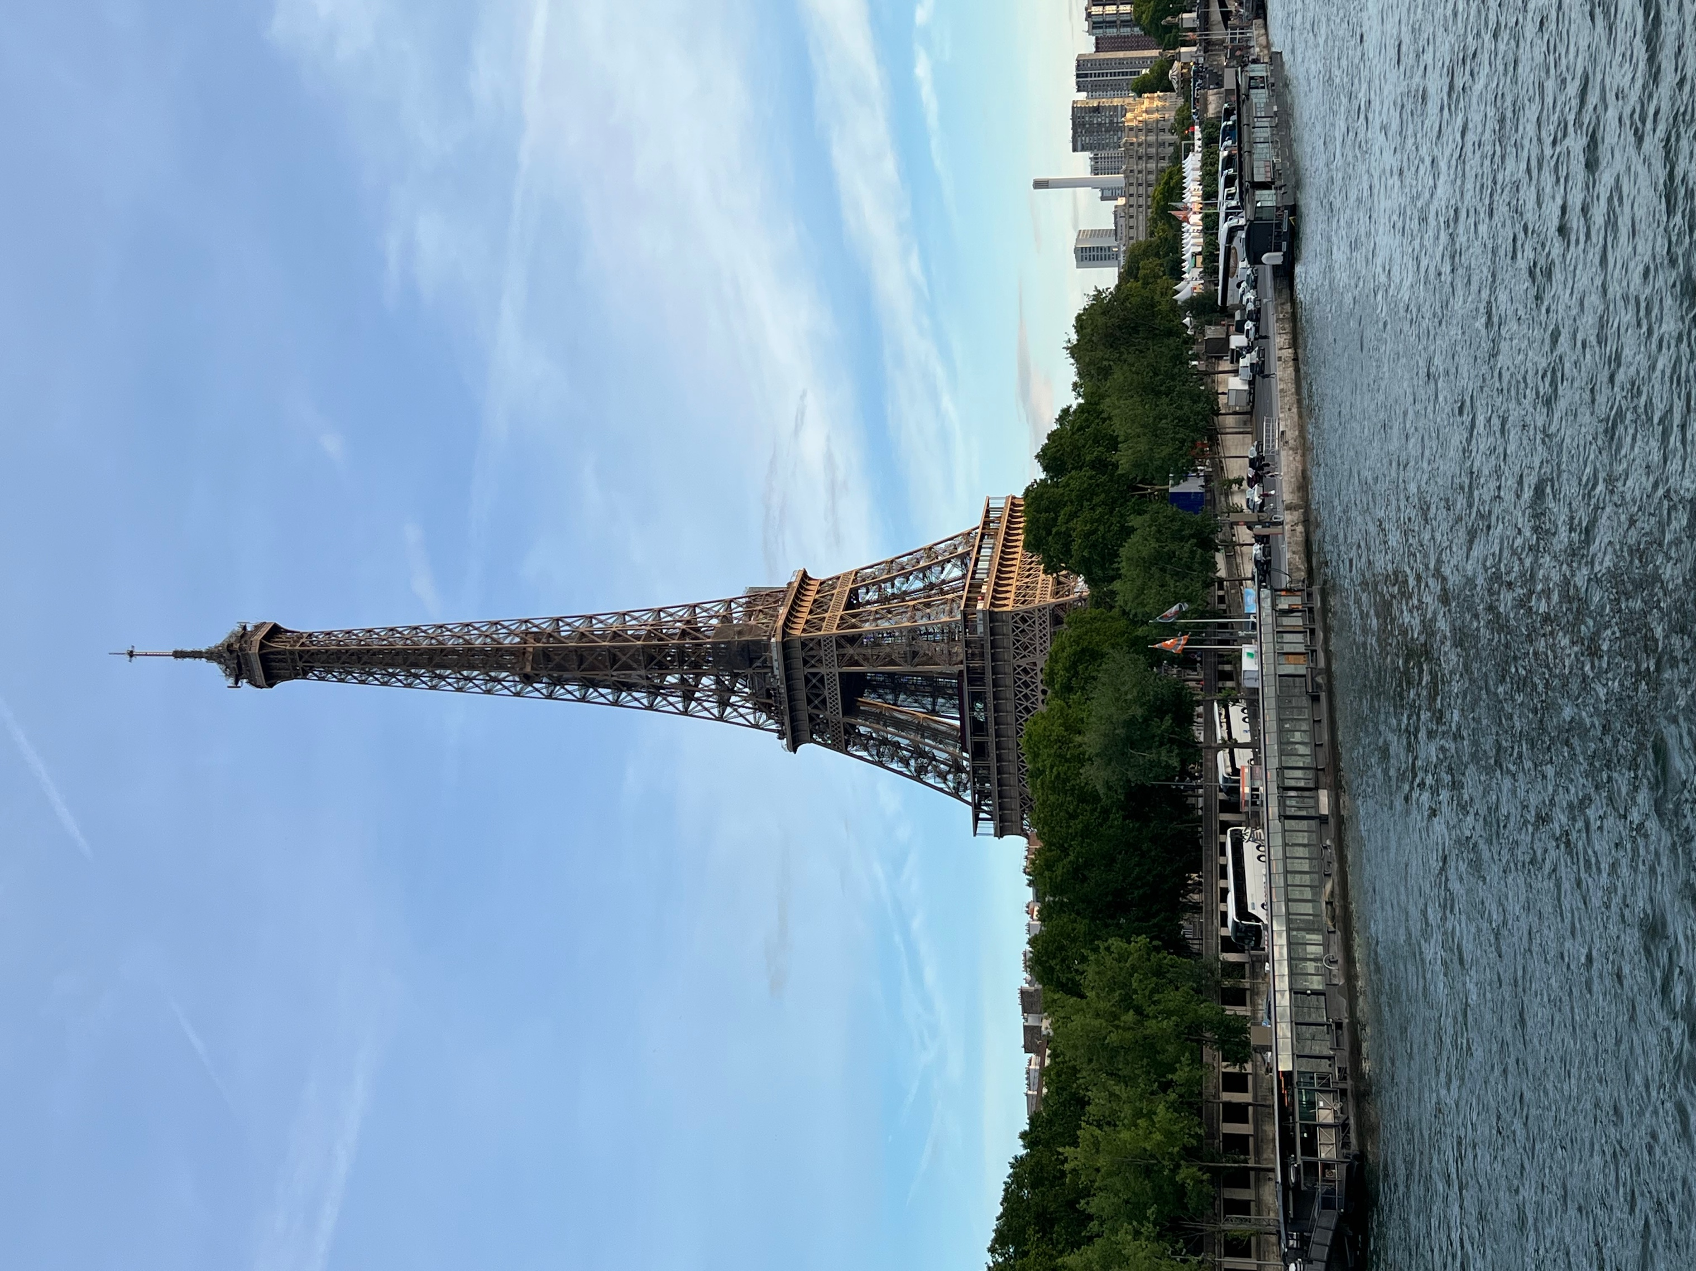
October 2025

Dear Travel Friends,

Join us in Paris, on the historic beaches of Normandy and along the beautiful coast of Brittany in our Travel Friends adventure to France in late May 2026. Our nine-night program starts with arrival in Paris on Saturday, May 23. We'll spend three nights in the French capital, the "City of Light," and walk through the historic districts and parks on either side of the Seine River--the Latin Quarter, the Marais, Montmartre, the Tuileries and the Champs de Mars. We'll tour the Notre Dame Cathedral, recently reopened to the public, go up the Eiffel Tower and walk through the Louvre Museum--the world's largest and most visited museum.

While in Paris and for a very unique experience, join us on Monday evening, May 25, for the "Fêtes Galantes," the annual costume ball held at the Versailles Palace, just outside the city. With our coats, dresses, hats, wigs and shoes in the style of the 17th and 18th centuries, we'll wander through the Hall of Mirrors and other venues where royalty and nobility dressed to see and be seen at the time of King Louis XIV. The evening features music and dance from the period and a fireworks display at midnight. The ball is optional and tickets are limited. Take a look here for a preview.

From Paris we'll take a train to the coast of Normandy, to the beaches where American and British forces landed in Nazi-occupied France in 1944. We'll take a guided tour to understand how the invasion unfolded and see the excellent Memorial Museum at nearby Caen. Then we'll travel by train to the town of St.-Malo, in Brittany, for three nights in this lovely, historic port on the English Channel, with a boat tour to the village of Dinan, and a trip to nearby Mont St.-Michel, a tidal island topped with a medieval monastery and one of France's most recognizable destinations. We'll take the train back into Paris for a last night's stay in a hotel near the airport, allowing for easy departure for home the next day.

Cost of the nine-night program is $3500 per person in a double occupancy room. The price includes nine nights of tourist or superior-tourist class lodging in Paris, Caen and St.-Malo, all ground transportation, including in and out transfers from and to the airport at the start and end of the program, Metro and public transportation passes, train tickets, Normandy Landing tour, museum and site entrances as indicated in the program, boat trips on the Seine and Rance rivers and continental breakfasts each morning in the hotels. International airfare, meals and travel insurance are not included.

Paris, Normandy and Brittany offer outstanding opportunities for sightseeing and exploring the culture, history and cuisine of Europe. Our small group allows us the flexibility to wander, learn and enjoy each other's company at a relaxed pace. We hope you'll join us next spring!

Mark McMeley
Karl Atkinson
e-mail: travelfriends@icloud.com
web: https://travelfriends.info/

Paris, Normandy and Brittany, Spring 2026
May 23-June 1, 2026

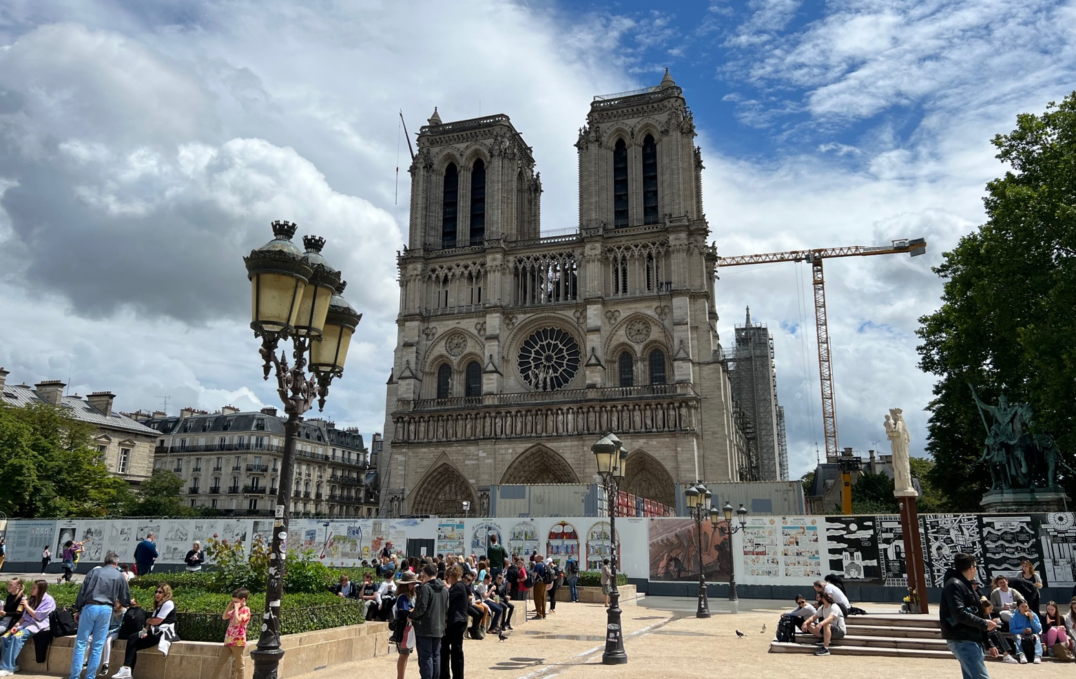

Friday, May 22

Program participants depart the U.S. for Paris. There is no group flight, but we can put you in contact with other travel members if you'd rather not fly alone.

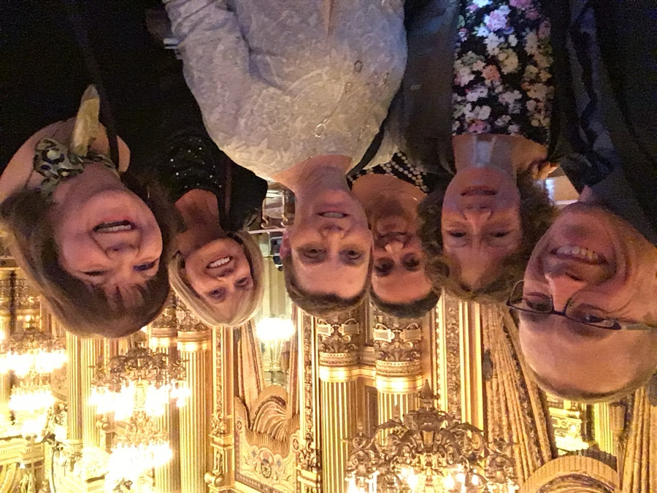
Saturday, May 23

Participants will arrive at Paris's Charles de Gaulle or Orly airports. The program conductor will meet everyone outside Customs at either airport and take everyone to the hotel. Transportation to the hotel is included in the program price. France is six hours ahead of U.S. Eastern Time.

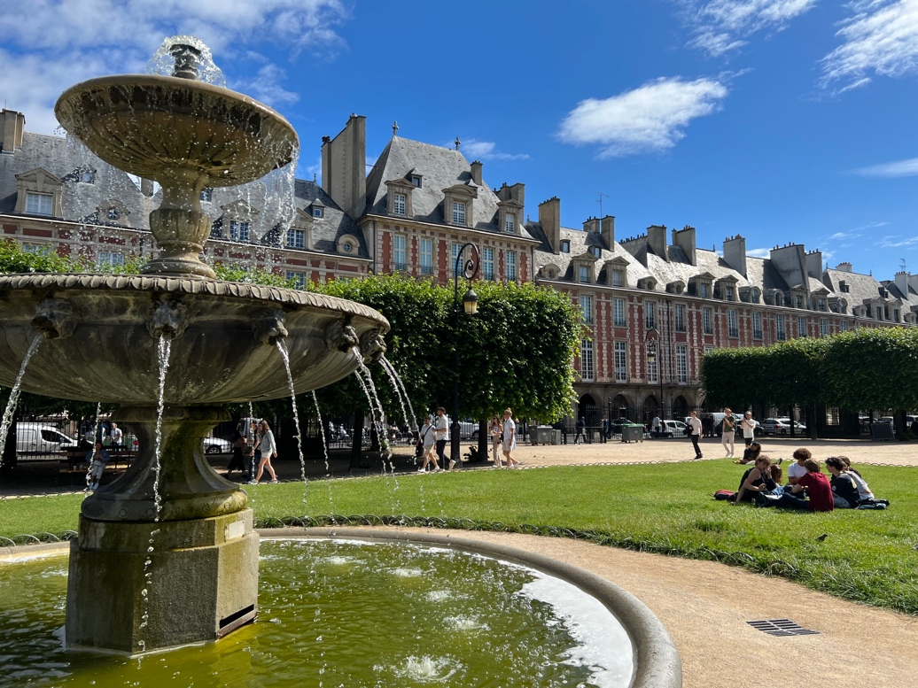
Sunday, May 24

After breakfast at the hotel (included with each night of our stay), we'll strike out to explore Paris. We'll use transit passes for our first two full days in the city, allowing us to hop on and off the Metro and city buses whenever we wish, or we'll use taxis when more convenient. We'll start with a visit to the newly reopened Notre Dame Cathedral, the medieval jewel in the heart of the city. Choose between attending a morning mass (with the advantage of hearing the Great Organ), or later in the day with a free visitor pass. We'll sit for lunch in a café on the Left Bank (of the Seine River), and then head to the Louvre Museum for a leisurely afternoon visit of the world's largest and most popular museum and home to Leonardo da Vinci's Mona Lisa (La Joconde), the Winged Victory of Samothrace and other outstanding examples of world art. We'll head back to the hotel in the afternoon. Later we'll enjoy an hour-long evening cruise on the Seine River, seeing the Eiffel Tower, Notre Dame and the city's beautiful bridges lit up at night.

Monday, May 25
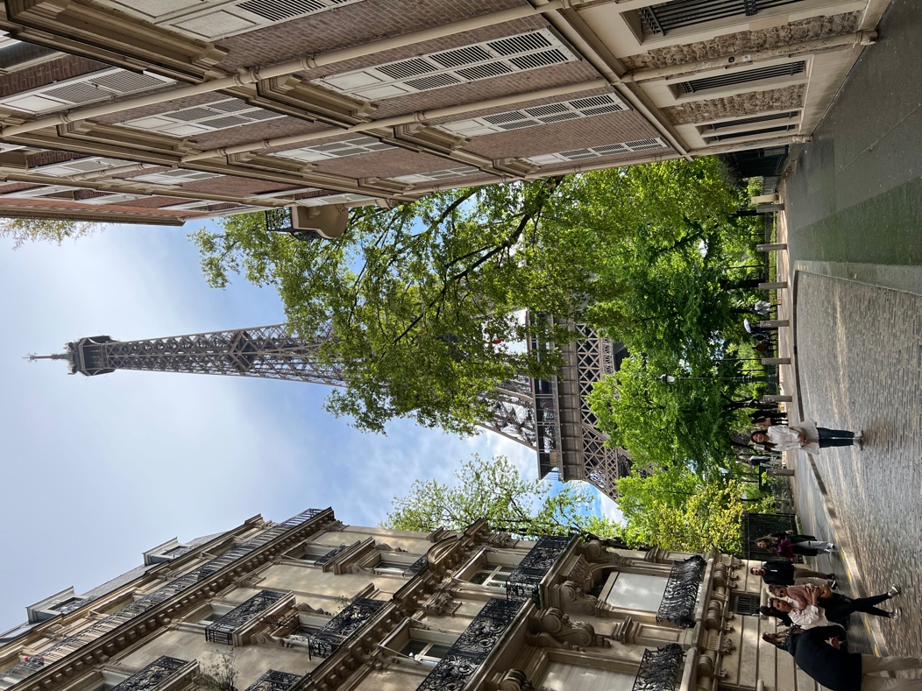
After breakfast, we'll head to the colorful Montmartre neighborhood for a visit to the Sacré-Coeur (Sacred Heart) Basilica, one of Paris's most iconic buildings, and enjoy a panoramic view of the city. We'll take a break to get a warm crepe from one of the many small cafés just below. Then we'll take the Metro for a trip to the Eiffel Tower, perhaps the world's most recognizable construction, and use the elevators to the second level for another unforgettable view. After lunch, we'll stroll down the city's most elegant boulevard, the Champs Elysées, with a view of Napoleon's Arc de Triomphe before heading back to the hotel. Those who purchased tickets to the Fêtes Galantes (the masked ball) at Versailles will have time to get ready before we head to the palace in the early evening.

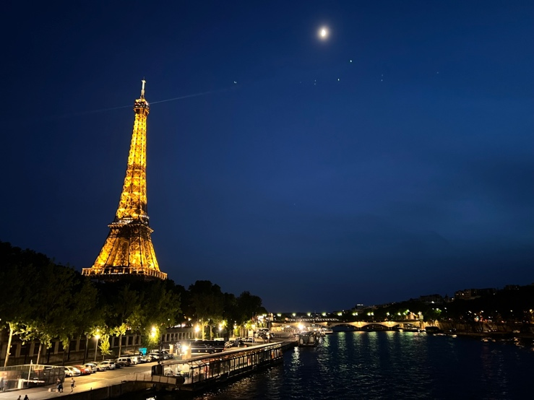
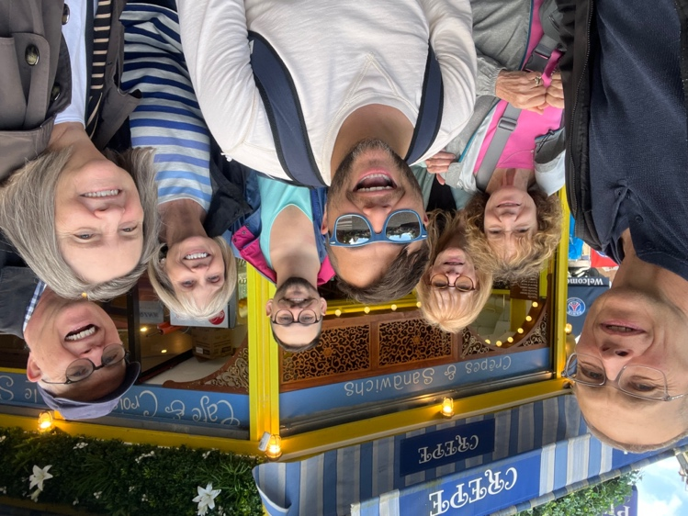

Tuesday, May 26

We'll check out of the Paris hotel and depart mid-morning for Paris's Saint-Lazare train station. We'll take a two-hour trip by train to Normandy, to historic Caen (resting place of the conquering King William of Normandy), and near the beaches where amphibious forces from the U.S. and the U.K. landed in June 1944. We'll check into our hotel and visit the Caen Memorial Museum, an outstanding museum dedicated to the D-Day Invasion and overall history of World War II. Dinner near the hotel.

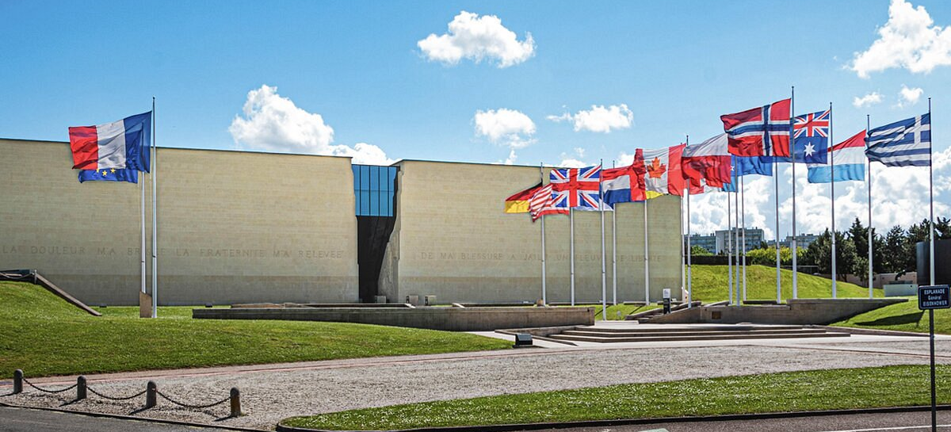

Wednesday, May 27

After breakfast, we'll take a guided tour to nearby Utah Beach and Omaha Beach, the site of the amphibious landing that marked the beginning of the end of World War II on the Western Front. We'll also walk through the beautiful, somber American Cemetery at Colleville-sur-Mer. We'll enjoy the rest of the afternoon on the beaches before heading back to Caen. Dinner near the hotel.

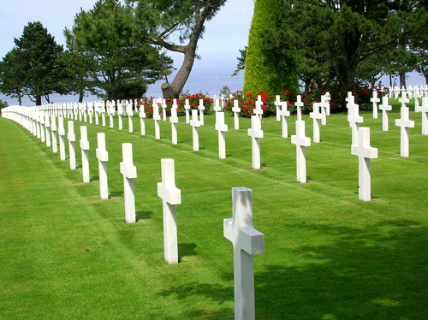
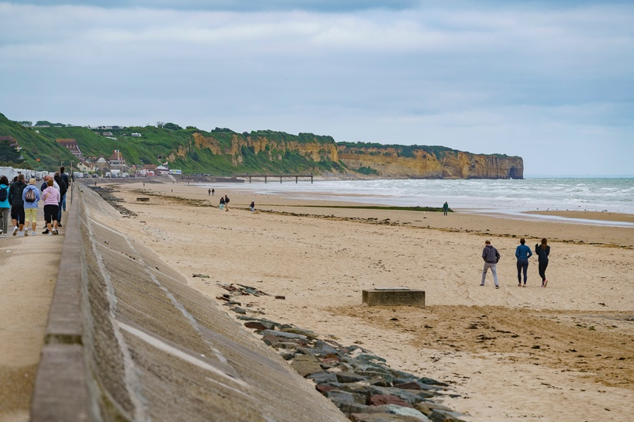

Thursday, May 28

We'll depart Caen mid-morning for Brittany and the town of Saint-Malo, the historic "pirate city" of France on the English Channel. We'll check into the hotel and have time to walk around the historic walls of the city, through its old quarter and along the coast. Dinner near the hotel this evening.

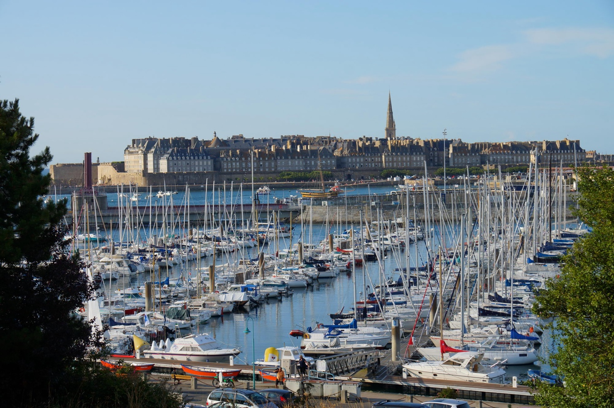

Friday, May 29

We'll enjoy a boat ride this morning up the Rance River to Dinan, a beautiful little village that preserves its medieval architecture through narrow streets and alleys. We'll have time to explore the town ramparts and the castle, to sit, relax and enjoy the scenery before returning by bus or train to St.-Malo in mid-afternoon.

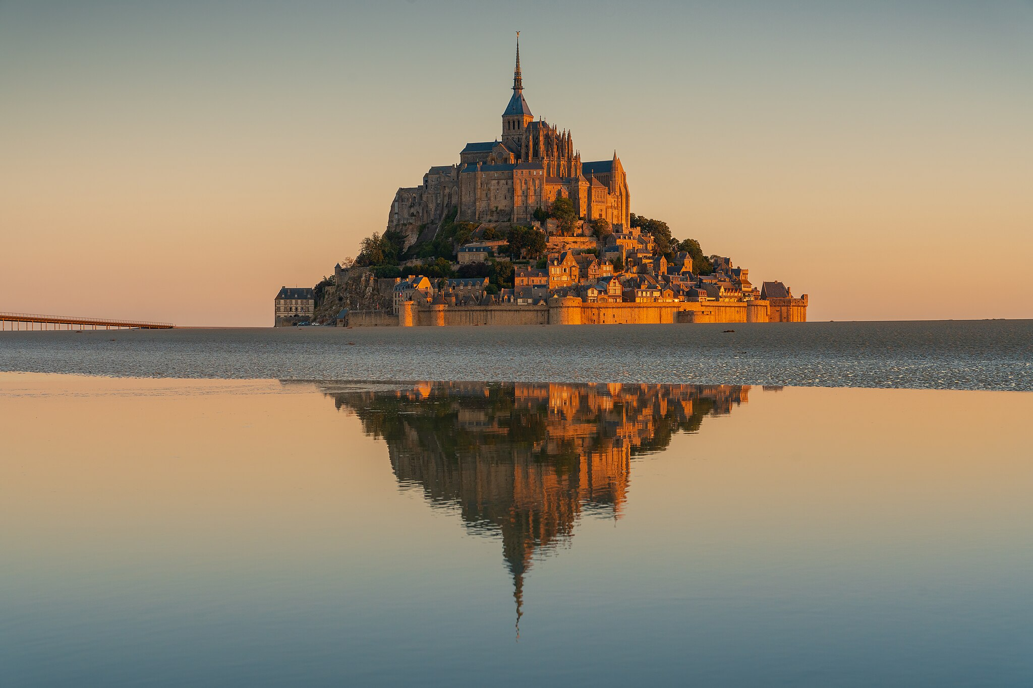

Saturday, May 30

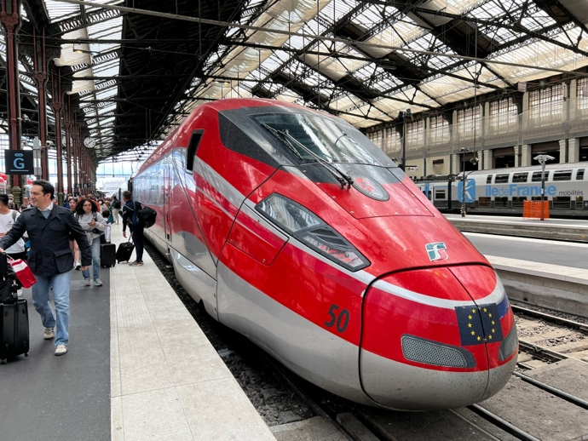
After breakfast, we'll take a bus tour to Mont St.-Michel, the famous monastery built on a tidal island in the English Channel, one of the most beautiful settings anywhere for a religious shrine. The tides turn St.-Michel into an island each day, but the causeway finished in 2014 allows us to walk the one mile (or take a shuttle) across the bay to the shore of the island whenever we wish. The passages on the island itself are steep. Those who wish may take the stairs up to the monastery (entrances are included in the program fee). We'll return by bus to St.-Malo in the afternoon. Dinner near the hotel. This evening we'll recount our adventures in France over a farewell dinner, in a restaurant near the water.

Sunday, May 31

After breakfast, we'll take a late morning train from St.-Malo back to Paris. We'll transfer to a hotel near Charles de Gaulle Airport (CDG), to allow easy departure the next morning for the return flight home or to continue your adventures elsewhere in Europe.

Monday, June 1

The program coordinator will accompany you to the airport. Most flights land in the U.S. in time to connect the same day to your home airport.

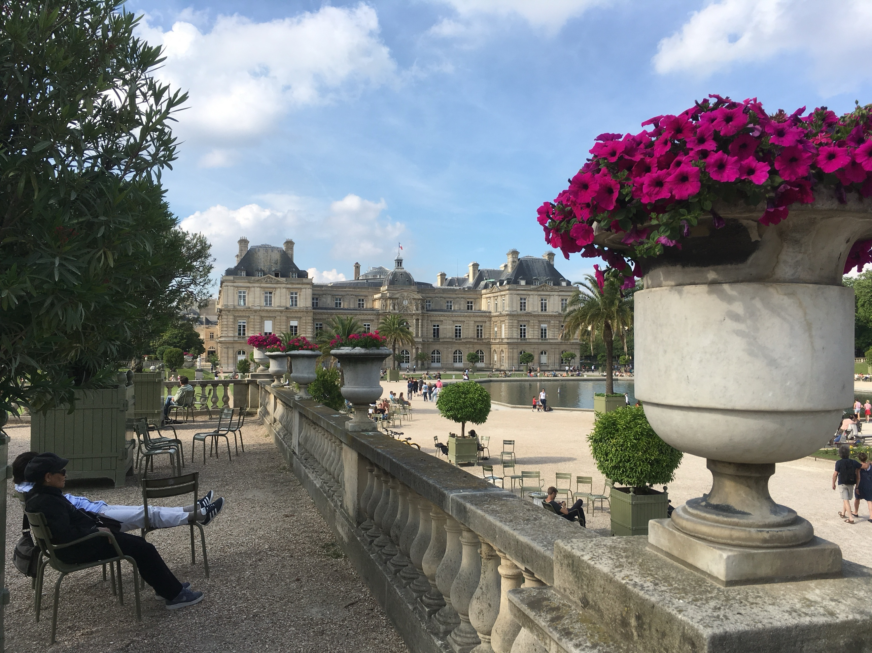

Fees and payments

Fee for the nine-night Paris, Normandy and Brittany program is $3500.00 per person, in a double-occupancy room. The fee includes:

--Nine nights tourist-class, double-occupancy lodging in Paris, Caen and St.-Malo, France, with buffet-style continental breakfast each morning.

--All local land transportation, including incoming and outgoing transportation from and to Paris's Charles de Gaulle (CDG) and Orly (ORY) airports, Paris public transportation passes, intercity train tickets and river cruises in Paris and St.-Malo, and the day trip to Mont St.-Michel, except where specified as not included.

--Entrances for the Notre Dame cathedral, Sacré-Coeur Basilica, elevator to the second level of the Eiffel Tower, Louvre Museum, Caen Memorial Museum, guided tour of the Normandy Beach Landing sites, and the abbey at Mont St.-Michel.

--Gratuities to drivers and hotel staff.

Fee does not include international airfare from the United States, lunches or dinners, entrances not specified in the program, travel insurance or visa.

Supplement for a single room is $1200.00.

This fee is based on a minimum of six paying passengers.

Payments are due on the following schedule:

January 31, 2026: $ 500.00 due
February 28, 2026: $3000.00 due (plus $1200 single-room supplement if applicable)

Payments should be made to River Plate Seminars by check at this address: Mark McMeley, 1001 Brynlor Lane, Orlando, Florida 32818, or though Venmo at Mark-McMeley-1, or through Zelle at phone number 321-977-1389, or by wire transfer to the following account:


Chase Bank
7674 Dr. Phillips Blvd., Orlando, Florida 32819
account: 105 987 770
routing number: 021000021
attn: Mark McMeley



