
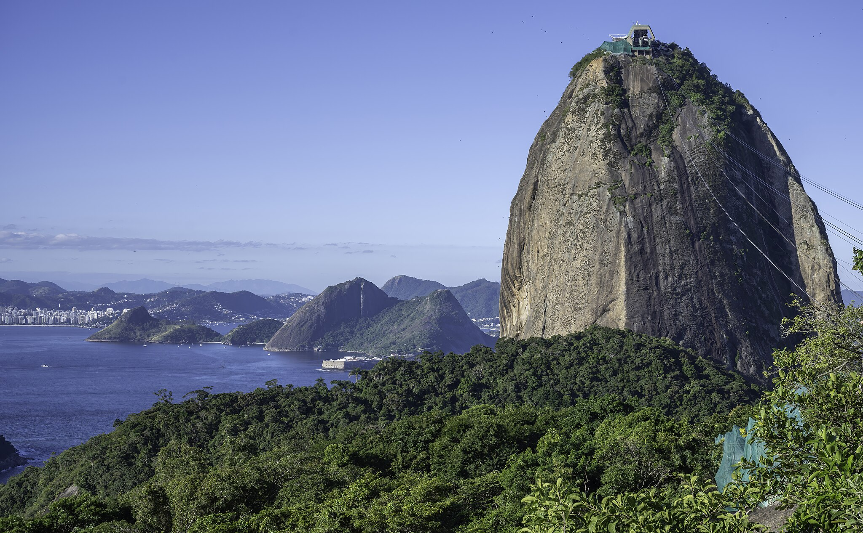
January 2026

Dear Travel Friends,

There's no party like the world-renowned Carnaval in fabulous Rio de Janeiro. The "Cidade Maravilhosa" (the "Marvelous City") will show off in an annual explosion of music, parades and dance in early February 2027 (mid-summer in the Southern Hemisphere), just before the Lenten season in the Christian calendar. Our Travel Friends group will meet in Rio for the culmination of this weeks-long festival, then fly south to Iguaçu Falls, on the border with Argentina, and spend two days exploring one of the world's greatest natural wonders. Join us early next year to see two highlights of South America in our small, friendly group of adventurers.

In Rio, we'll see the giant celebrations in the Sambadrome, the half-mile long stadium where samba "schools," each comprised of thousands of brightly costumed dancers, musicians and singers, parade over three consecutive nights. We'll enjoy the famous beaches at Ipanema and Copacabana and have a chance to visit historic and cultural sites of what was once the capital of the Portuguese-Brazilian Empire. We'll take an aerial car to the top of Sugarloaf Mountain and a narrow-gauge train up the Corcovado (site of the Christ the Redeemer statue) to enjoy the view of mountains, forests, the Atlantic Ocean and perhaps the most stunning cityscape anywhere.

After Rio, we'll take a two-hour flight to Iguaçu Falls, on Brazil's southern border, to see one of the world's largest and probably its most beautiful waterfalls, set in a sub-tropical jungle and spread over two miles with some 275 individual cascades. Iguaçu is a World Heritage Site, protected in two national parks on both sides of the border with neighboring Argentina. We'll explore the trails that weave among the falls and take an exciting powerboat ride on the Argentinian side. We're likely to see monkeys, toucans, the always-curious coatis, and with luck a jaguar, the largest cat in the Americas. A highlight will be the trail to the Devil's Throat, the deepest, biggest part of the falls, where we'll watch swallows dart in and out of nests perched behind the thundering cascades. Travelers may fly back to Rio in time for a nighttime return to the United States or may continue with us to Buenos Aires and the Travel Friends excursion to Patagonia.

Cost for the eight-night program is $3950 per person for a double-occupancy room, or $4900 for a single-occupancy room, with a deposit of $500 due on July 31. Fees include all local transportation and entrances as described in the attached itinerary, such as subway and city transport passes and transportation to the hotel at the start of the trip and back to the airport at the end, and the round-trip flight between Rio de Janeiro and Iguaçu. International airfare from the United States, the Brazilian tourist visa and meals are not included. There is no one flight that our group will take heading to Brazil, but we'll put folks in touch with one another if someone prefers not to travel alone. As always, our group will be small, with no more than 15 people, allowing us to move around easily and to stop whenever we wish to take a break and enjoy the city and the natural areas around us.

Karl and I look forward to you joining us in February 2027. Please let us know if you have any questions about the program.

Mark McMeley
Karl Atkinson
www.TravelFriends.info
e-mail: travelfriends@icloud.com
Carnaval in Brazil
with Iguaçu Falls

February 6 – 14, 2027

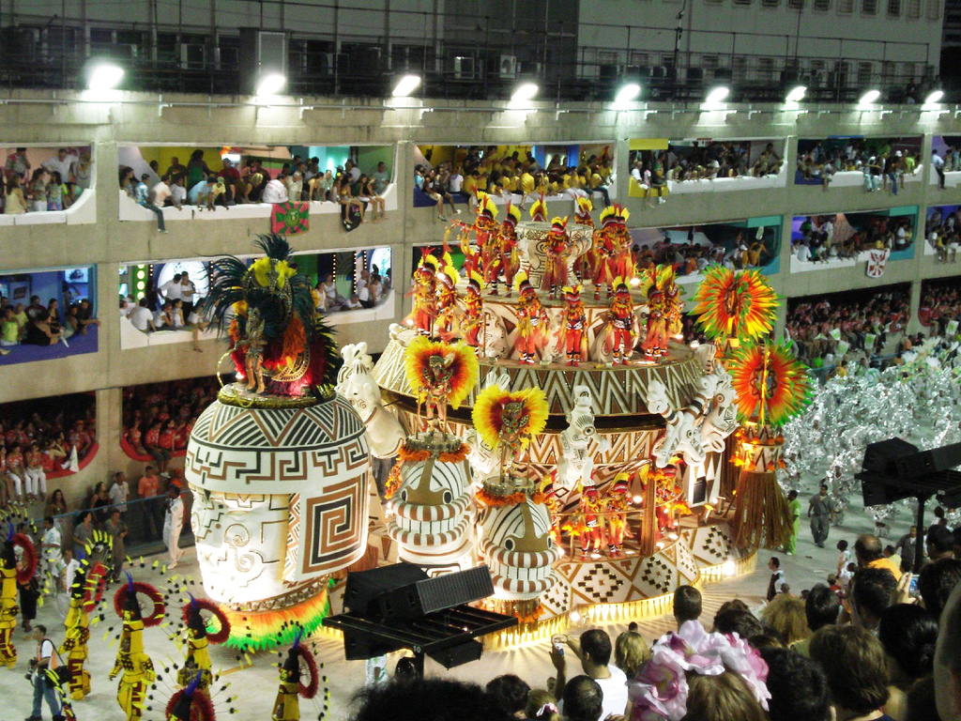

Friday, February 5

Program participants depart the United States today.

Saturday, February 6

Flights arrive at Rio de Janeiro's Galeão airport (GIG). The program conductor will meet participants as they arrive at the airport and escort everyone to the hotel in central Rio. Transportation to the hotel is included. Brazil is two hours ahead of U.S. Eastern Time.

We’ll spend the rest of the day relaxing and walking along the nearby Flamengo and Botafogo beaches and taking in the sights, including nearby Sugarloaf Mountain. Shorts, sandals and t-shirts are welcome! Dinner this evening will be in a nearby restaurant.

Hotel: Rio de Janeiro, Brazil
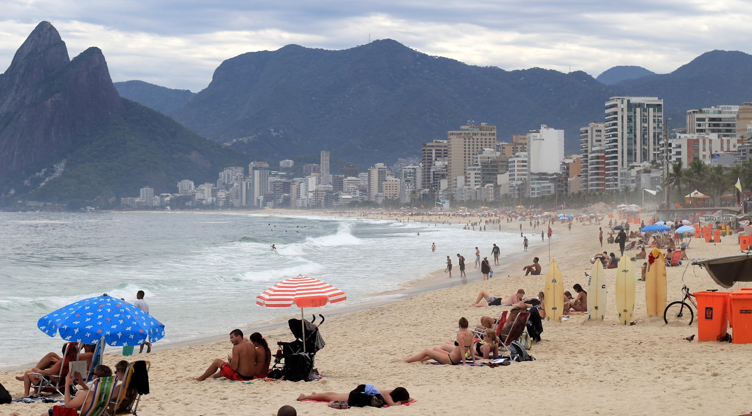

Sunday, February 7

Breakfast is included today and each day of our stay in Brazil. We’ll meet downstairs at 10 a.m. and take a half-day walking tour to get an overview of the places to visit this week. We'll use our public transport passes for Rio's modern, efficient subway and public bus systems, taking advantage of the subway stop located near the hotel. We'll stop for lunch in one of the many small diners offering inexpensive dishes of meat, poultry, fish, rice, tapioca and vegetables that are a part of everyday life here. Of special interest, if you choose, are visits to the Fine Arts Museum and the Municipal Theatre, the grand opera house built in the era of the coffee and sugar barons. There's plenty of time this afternoon for a swim in the warm Atlantic beaches a few blocks from the hotel or at the beaches of Ipanema and Copacabana. In the evening, join us for a sunset dinner.

Hotel: Rio de Janeiro, Brazil

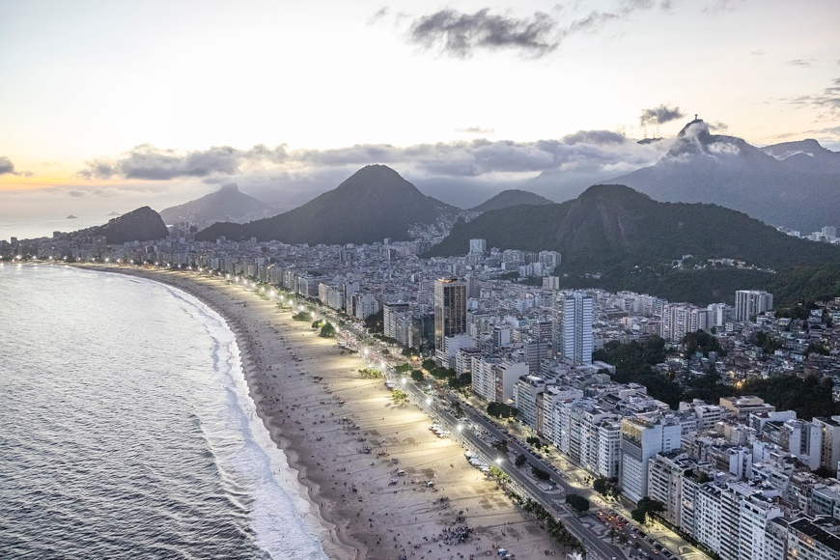
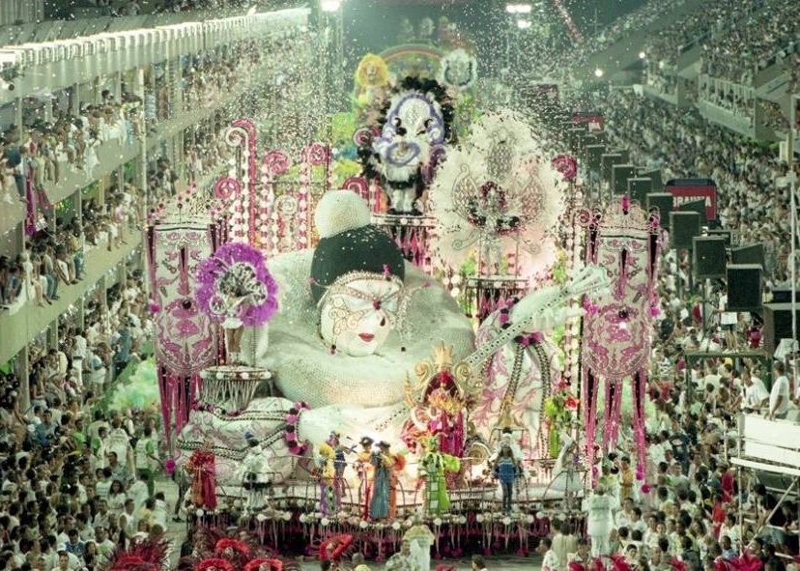

Monday, February 8

This morning we’ll visit Sugarloaf Mountain, the iconic stone hill towering above the Botafogo neighborhood, taking the aerial tram to the top for a beautiful view of the bay and the city. We'll have lunch nearby, then relax in the hotel, at the small hotel pool or at the beach. We'll leave the hotel in the early evening and board the nearby metro, which will take us close to the Sambadrome, for the second of the three nights of the samba parades. We'll have reserved seats in the stadium. Be sure to take your phone, fully charged, to take pictures of tonight's big, loud and colorful spectacle, the culminating event of Rio's Carnaval. Secure your phone with a strap. (We can provide examples). The parade starts about 7 p.m. and continues to the next morning, but we'll leave when we wish to return to the hotel, using the metro, which runs all night.

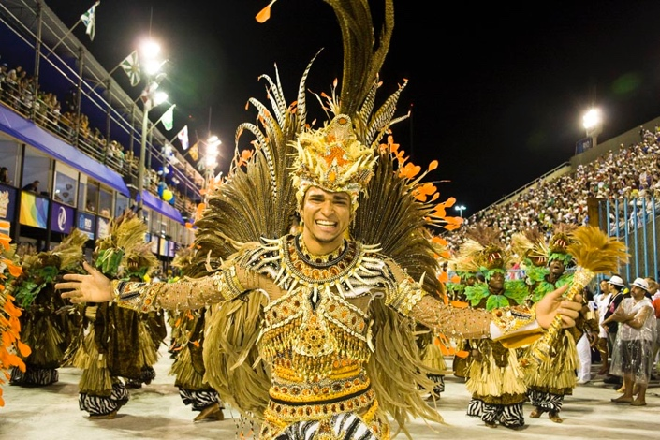
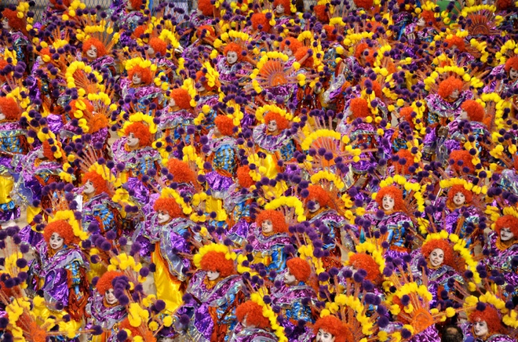
Hotel: Rio de Janeiro, Brazil
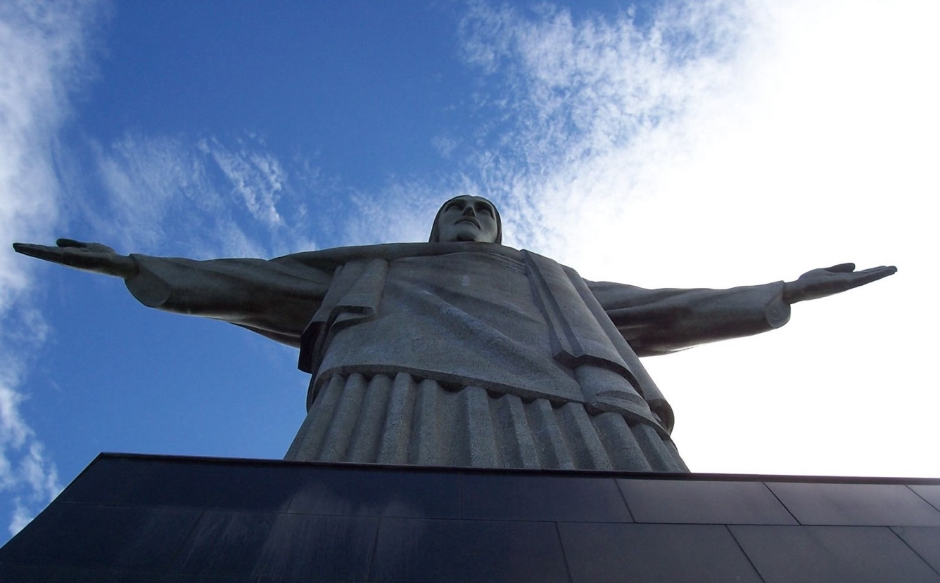

Tuesday, February 9

After a leisurely breakfast, we'll have a late start and explore other sights in the city, including the historic Botanical Garden. We'll have time to explore residential areas and beaches and enjoy a drink in a sidewalk café in the Ipanema and Copacabana neighborhoods.

Hotel: Rio de Janeiro, Brazil

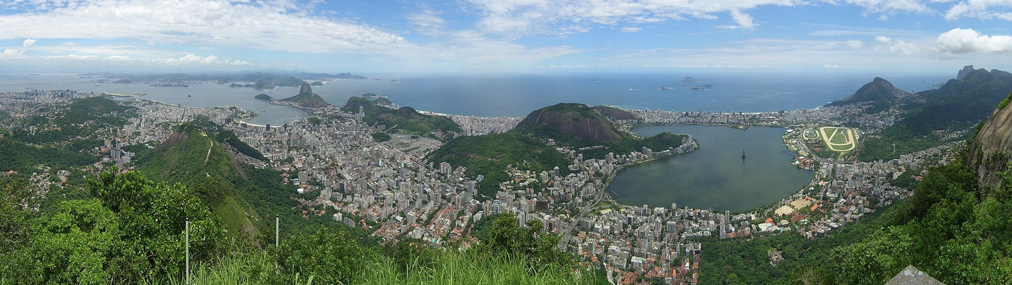

Wednesday, February 10

After breakfast we'll take city transport or an Uber to the Corcovado, the sharp, rocky hill that is topped by the dramatic Christ the Redeemer statue, the 100-foot high Art Deco-style statue that overlooks Rio and is the most iconic image of the city. We'll enjoy some time seeing the tropical forest and waterfalls in the surrounding Tijuca National Park. The afternoon is free to return to one of the beaches, relax in the hotel or do some last-minute shopping for souvenirs at one of the nearby commercial centers. Dinner near the hotel.

Hotel: Rio de Janeiro, Brazil
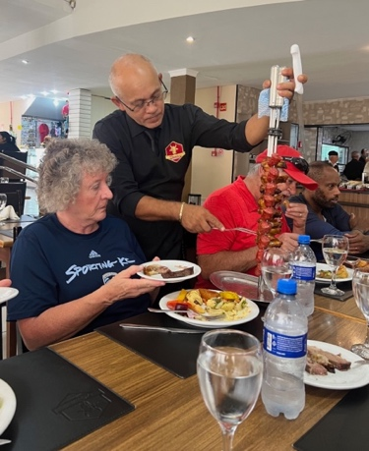
Thursday, February 11

We'll pack our bags this morning and head to the airport for a flight to Foz do Iguaçu, two hours to the south, a city of about 250,000 close to Iguaçu Falls. We'll check into the hotel and have some time to explore the city. Dinner this evening at an espeto corrido, the Brazilian steakhouses where the waiters circle by with skewers of meats and sausages.

Hotel: Foz do Iguaçu, Brazil

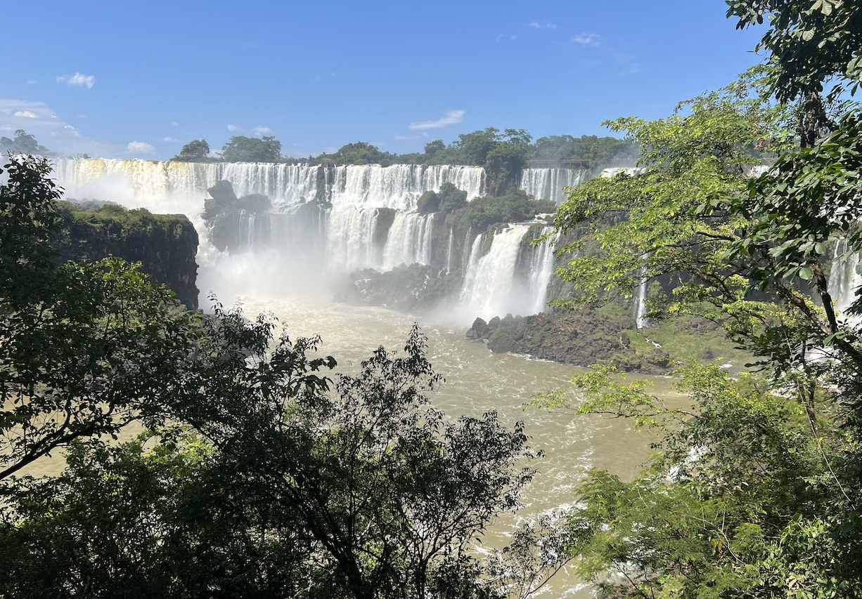

Friday, February 12

After breakfast we'll take a private van into Argentina to see Iguazú Falls and the surrounding jungle. ("Iguaçu" in Portuguese and "Iguazú" in Spanish refer to the same river and the same complex of waterfalls. The name comes from the local Guaraní indigenous language, meaning "big water.") We're crossing an international border, so be sure to take your passport. We'll walk trails that weave through individual falls of the two-mile complex of cascading water of Iguazú River. Afterwards we'll eat lunch at the park's dining hall. Those who wish will walk down with us to the river and take one of the powerboats that cruise to the base (and the spray) of San Martín Falls. The boat trip (included in the program) is a thrill ride that will leave you wet, even with the raincoats provided. We'll walk the elevated trail to the Devil's Throat, the tallest and biggest part of the falls, and spend some time at the observation platform, taking in the power of the river that cascades in front of us. We'll depart for the hotel in Brazil around 4 p.m. Dinner near the hotel.

Hotel: Foz do Iguaçu, Brazil

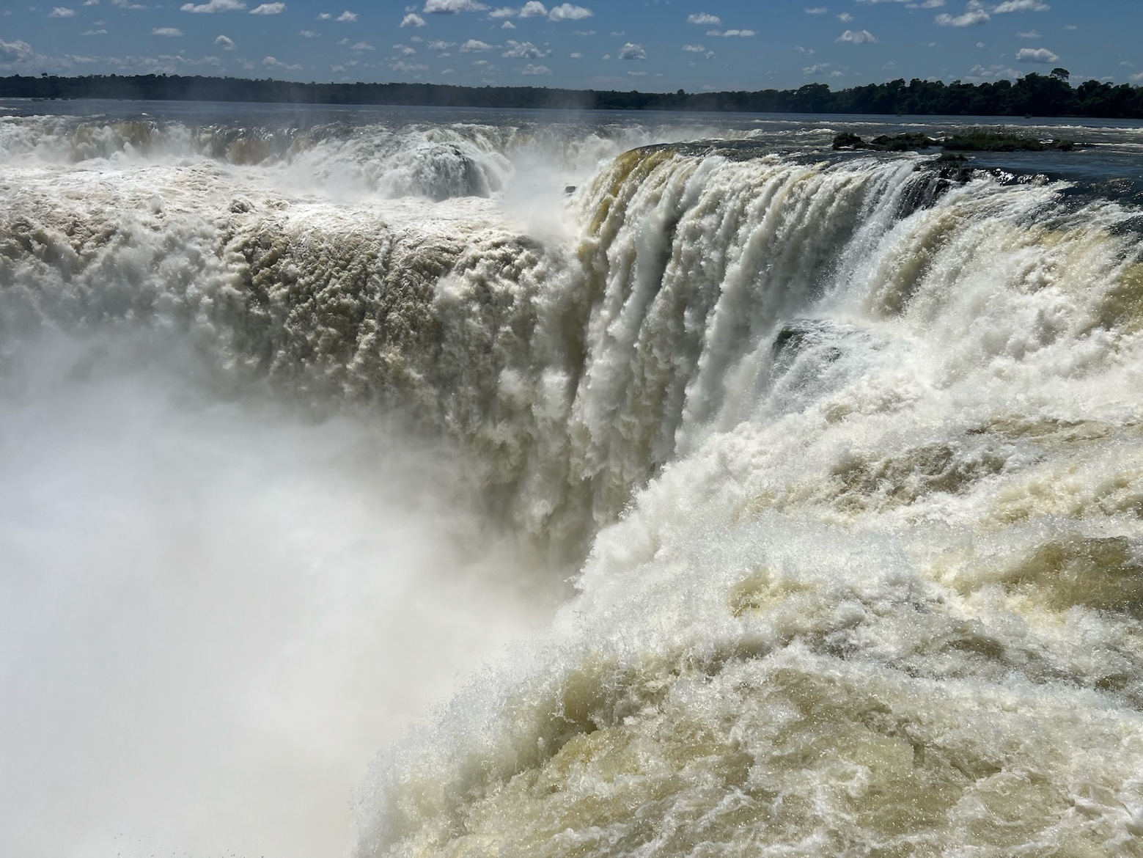

Saturday, February 13
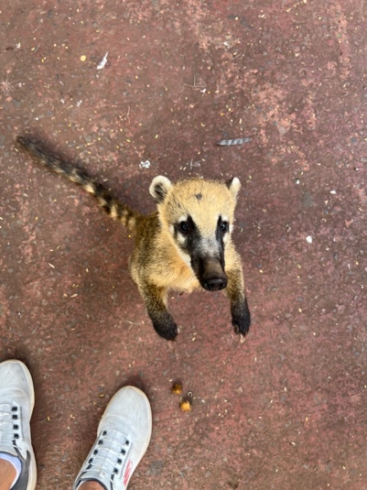
Today we'll enjoy the Brazil's Iguaçu National Park, for a different view of the falls and a different kind of experience. Most of the falls are on the Argentinian side of the river, but Brazil provides the best panoramic view. We'll return to the hotel in the early afternoon and spend some time exploring the city of Foz do Iguaçu. We'll enjoy a farewell dinner this evening in a local Brazilian steakhouse and buffet.

Hotel: Foz do Iguaçu, Brazil
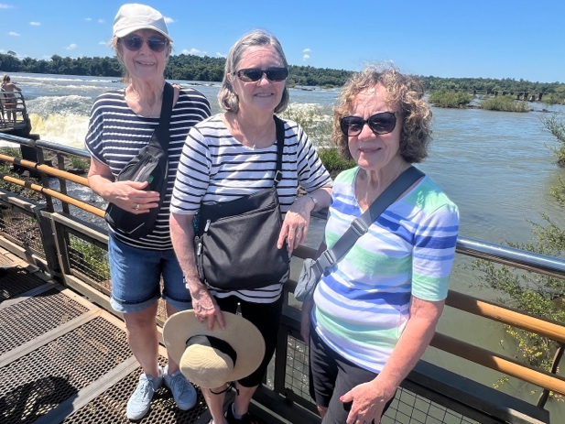

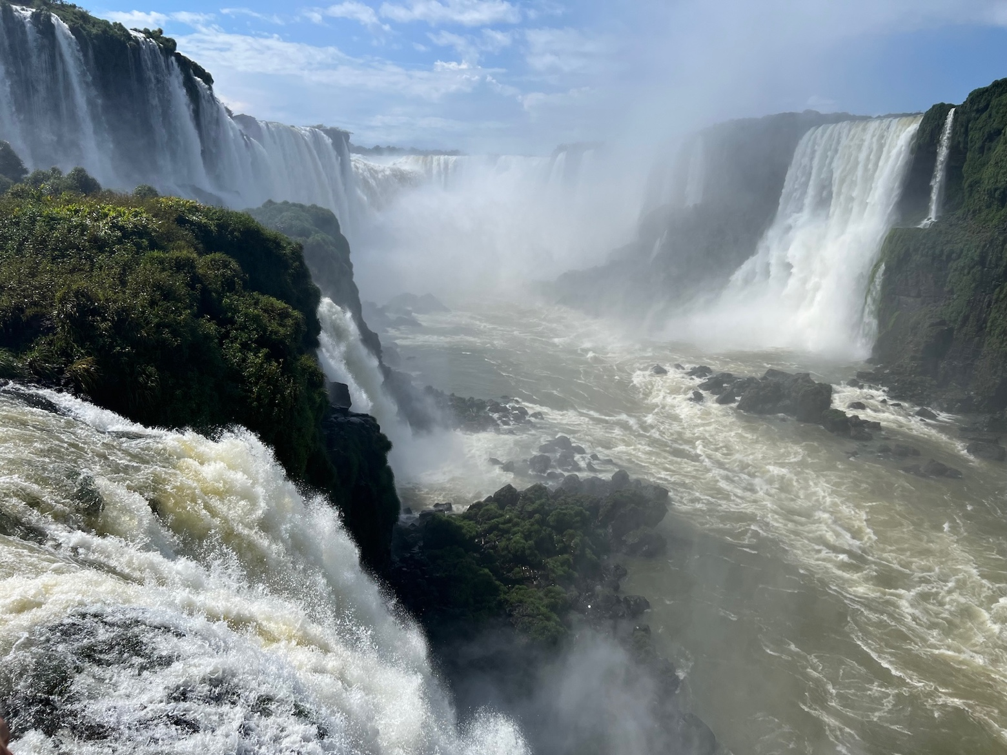

Sunday, February 14

We'll pack our bags and head back to the Foz do Iguaçu airport for the return to Rio de Janeiro or, for those continuing to Argentina, for the flight to Buenos Aires. Your flight (either to Rio or to Buenos Aires) is included in the program cost. For those returning this evening to the United States, the flight will take you back to Rio's Galeão Airport (GIG) in time for the evening departures for Miami, Atlanta, Houston, Dallas or New York. Overnight flights will arrive at the U.S. destinations the next morning. The hotel in Buenos Aires (for those continuing) is included.

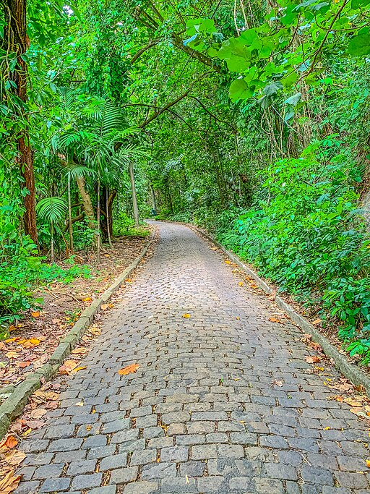
Fees and payments

Fee for the eight-night Carnaval in Brazil program is $3950.00 per person, in a double-occupancy room. The fee includes:

--Five nights tourist-class, double-occupancy lodging in central Rio de Janeiro and three nights lodging in tourist-class, double-occupancy lodging in Foz do Iguaçu, Brazil, with buffet-style breakfast each morning.

--All local land transportation, including incoming and outgoing transportation between Rio's Galeão (GIG) and Santos Dumont (SDU) airports and Foz do Iguaçu airport and the hotels, plus local metro, public transportation and private minivans, except where specified as not included.

--Entrances for the guided walking tour of Rio de Janeiro, aerial tram to the top of Sugarloaf Mountain, narrow-gauge rail to the top of the Corcovado Mountain, entrances and reserved seating in the Sambadrome for the samba parade, entrances to the Botanical Garden, and Tijuca, Iguaçu and Iguazú national parks, and the Macuco River Safari (powerboat ride).

--Roundtrip airfare between Rio de Janeiro and Foz do Iguaçu airports. For those continuing on the Buenos Aires and Patagonia program, the return trip to Rio will be switched to the flight to Buenos Aires. For this same group continuing to Argentina, the first night of lodging in Buenos Aires will be covered by this program.

--Gratuities to drivers and hotel staff.

Fee does not include international airfare from the United States, lunches or dinners, entrances not specified in the program, travel insurance or visa (as of January 2026, only required for Brazil and obtainable on the internet).

Supplement for a single room is $950.00.

This fee is based on a minimum of six paying passengers.

Payments are due on the following schedule:

July 31, 2026: $ 500.00 deposit due
September 1, 2026: $ 3450.00 due (plus $950 single-room supplement if applicable)

Payments should be made to River Plate Seminars by check at this address: Mark McMeley, 1001 Brynlor Lane, Orlando, Florida 32818, or though Venmo at Mark-McMeley-1, or through Zelle at phone number 321-977-1389, or by wire transfer to the following account:

Chase Bank
7674 Dr. Phillips Blvd., Orlando, Florida 32819
account: 105 987 770
routing number: 021000021
attn: Mark McMeley

