
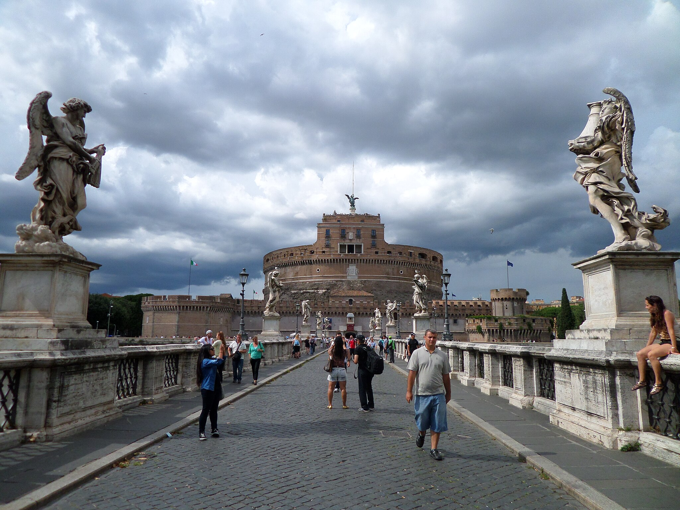

November 2025

Dear Travel Friends,

We're thrilled to share details of our Travel Friends trip to Italy in October 2026! Italy has been our top destination for decades--full of great sights, wonderful food, beautiful countryside and some of the world's great seaside destinations. We hope you'll join us next fall.

Our small group will meet in Rome on Saturday, October 17. We'll spend four nights in Rome, the "Eternal City," seeing the Colosseum, the Forum, St. Peter's Basilica and the Vatican Museums, plus a day for the Castel Sant'Angelo and some out-of-the-way gems in the Trastevere neighborhood. We'll take the train to Siena, a lovely, small Tuscan city and our base to see Florence, the medieval town of San Gimignano and nearby Pisa. Then we're on the high-speed train to the south, to Salerno, where we'll have two days to see the Amalfi Coast and the fabled island of Capri, plus a day in the shadow of Mount Vesuvius to explore the famous ruins of Pompeii. We'll return to Rome with one night near the airport for easy departure for home the next day.

Cost of the thirteen-night program is $3700 per person in a double occupancy room. The price includes thirteen nights of tourist or superior-tourist class lodging in Rome, Siena and Salerno, all ground transportation, including in and out transfers from and to the airport at the start and end of the program, public transportation passes in Rome, intercity train tickets, museum and site entrances, guided visits as indicated in the program, boat trips on the Amalfi Coast and continental breakfasts each morning in the hotels. International airfare, meals and travel insurance are not included. Each of the three parts of the program--Rome, Tuscany and the Amalfi Coast--start and end in Rome. It is possible to join us for just one or two of these segments, but we hope you'll join us for the full itinerary. Even if you've visited before, Italy is just as wonderful the second time around!

Rome, Tuscany and the Amalfi Coast offer you the best of Italy. Our small-group format helps you see great destinations up close and the time to wander and enjoy. We hope you'll join us next fall!

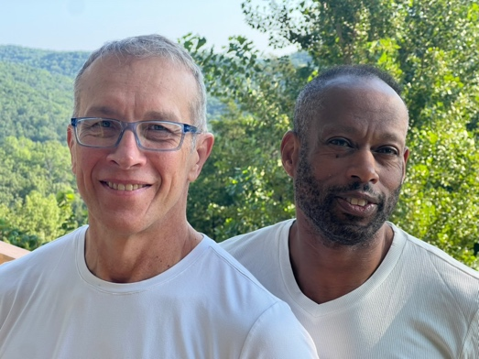

Mark McMeley
Karl Atkinson
e-mail: travelfriends@icloud.com
web: https://travelfriends.info/

Rome, Tuscany and the Amalfi Coast, Fall 2026
October 17-30, 2026

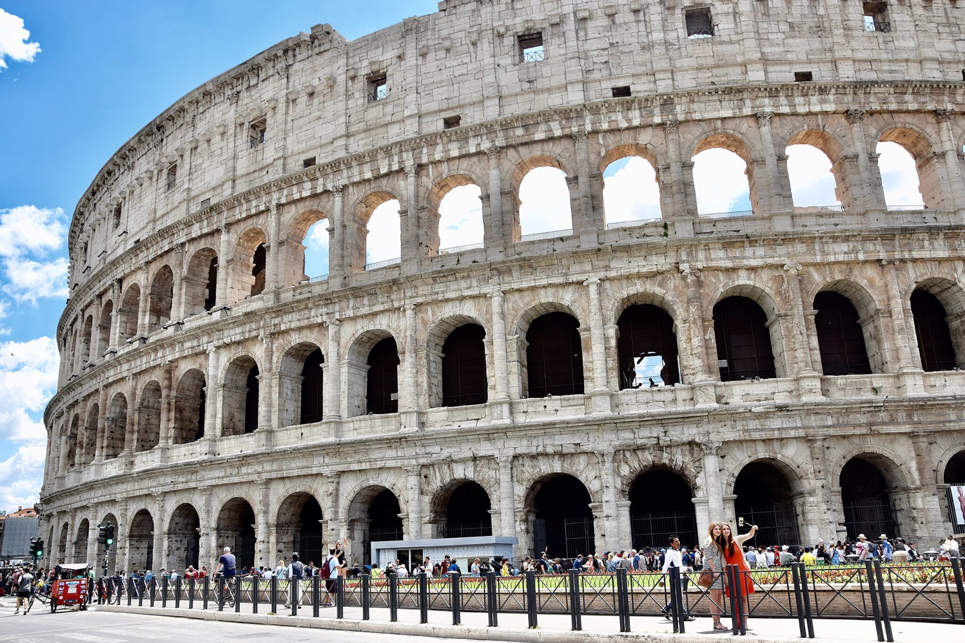

Friday, October 16

Program participants depart the U.S. for Rome. There is no group flight, but we can put you in contact with other group members if you'd rather not fly alone.

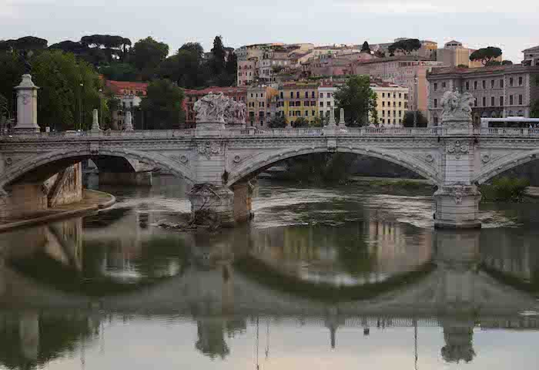
Saturday, October 17

Participants will arrive at Rome's Fiumicino Airport. The program conductor will meet everyone outside Customs and take everyone to the hotel. Transportation to the hotel is included in the program price. Italy is six hours ahead of U.S. Eastern Time. We'll have time this afternoon for some easy walks around the hotel to become familiar with our neighborhood. This evening we'll walk over to see St. Peter's Square as the Square and the Basilica are lit up.

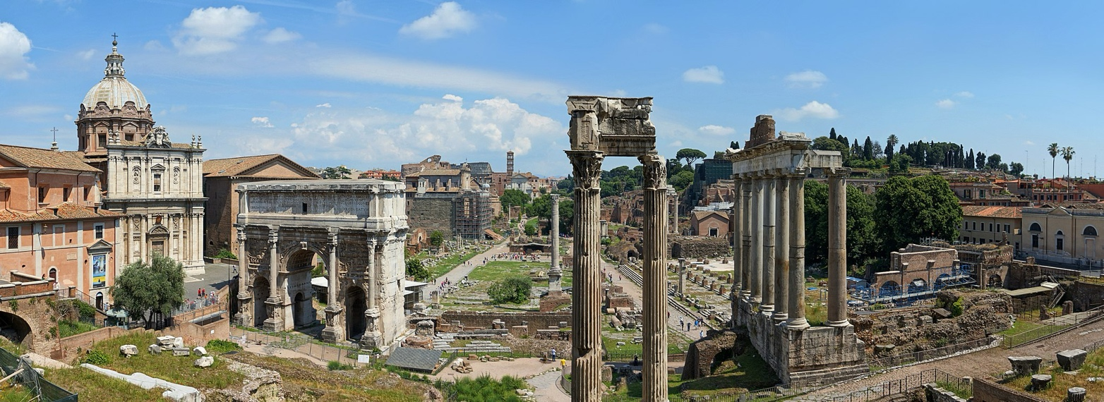

Sunday, October 18

After breakfast at the hotel (included with each night of our stay), we'll see some of the greatest monuments from the city's ancient past, the Colosseum and the nearby Forum. We'll take a guided visit in English of both sites. We'll find a spot in the beautiful Trastevere neighborhood for a leisurely lunch, then make our way back to the hotel. We'll make use of our transit passes on the Metro and city buses to wander as we wish this afternoon.

Monday, October 19

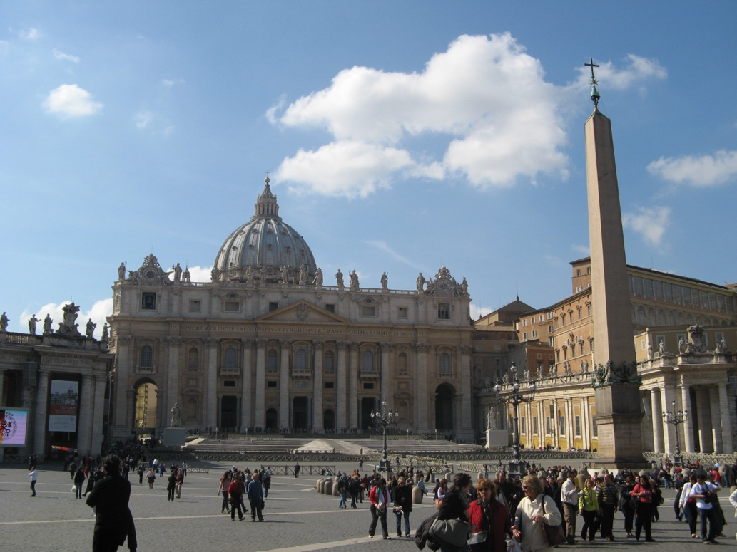
After breakfast, we'll head to the Vatican Museums to see one of the world's greatest collections of art. The Museums preserve Rome's ties to ancient Greece, its centuries as the head of a great empire and its rise as the center of Western Christianity. We'll enter the Sistine Chapel and have time to take in the great frescoes painted by Michelangelo, then visit St. Peter's Basilica, with its monumental sculptures and the great baldacchino over the main altar, placed above the tomb of Peter. Those who wish may choose to climb the stairs to the top of the dome, for a panoramic view of the square, the city of Rome and the Tiber River below. (Dome tickets are not included.) Dinner near the hotel.

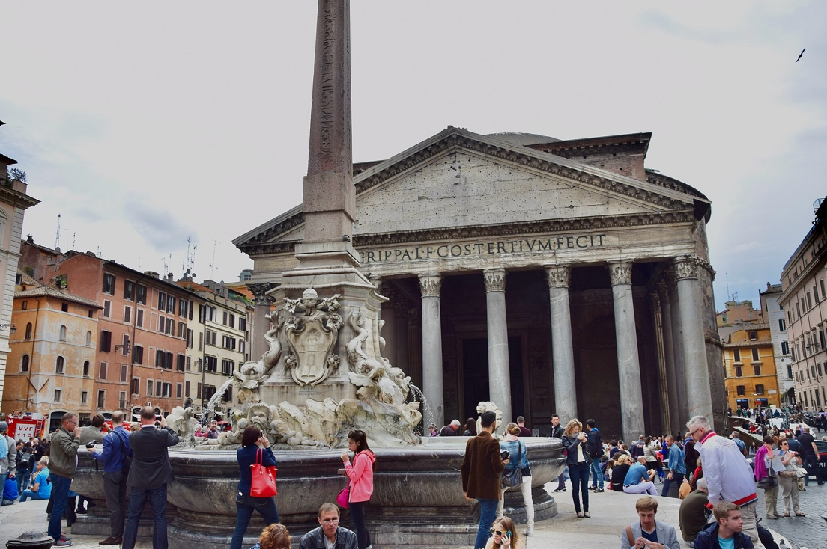
Tuesday, October 20

Today we'll visit the Pantheon, the great temple erected in the reign of the Emperor Hadrian and converted into a church in AD 609. The coffered, unreinforced dome, at 121 feet in width, is still the world's largest such structure. We'll have time today, too, to visit the imposing Castel Sant'Angelo, constructed on the banks of the Tiber River by Hadrian as a mausoleum for himself and later converted into a fortress and residence by the Christian popes. We'll walk along the defensive walls built by the Emperor Aurelian in AD 270, that later served as an elevated passageway for popes taking refuge in the converted mausoleum. This evening we'll celebrate our discoveries in Rome over dinner, near the hotel.

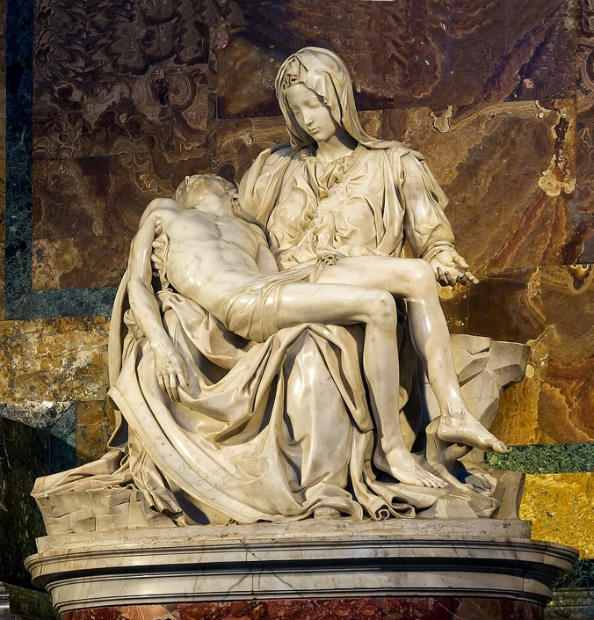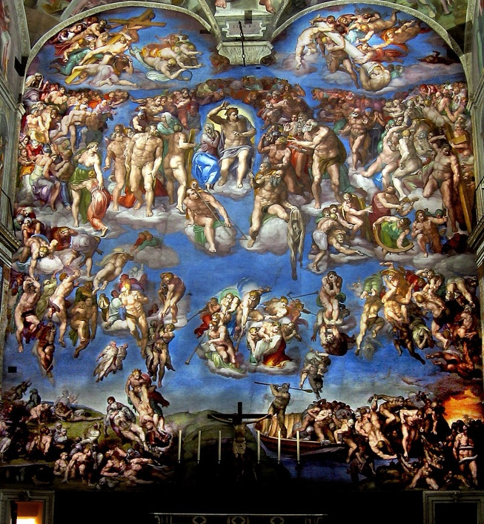

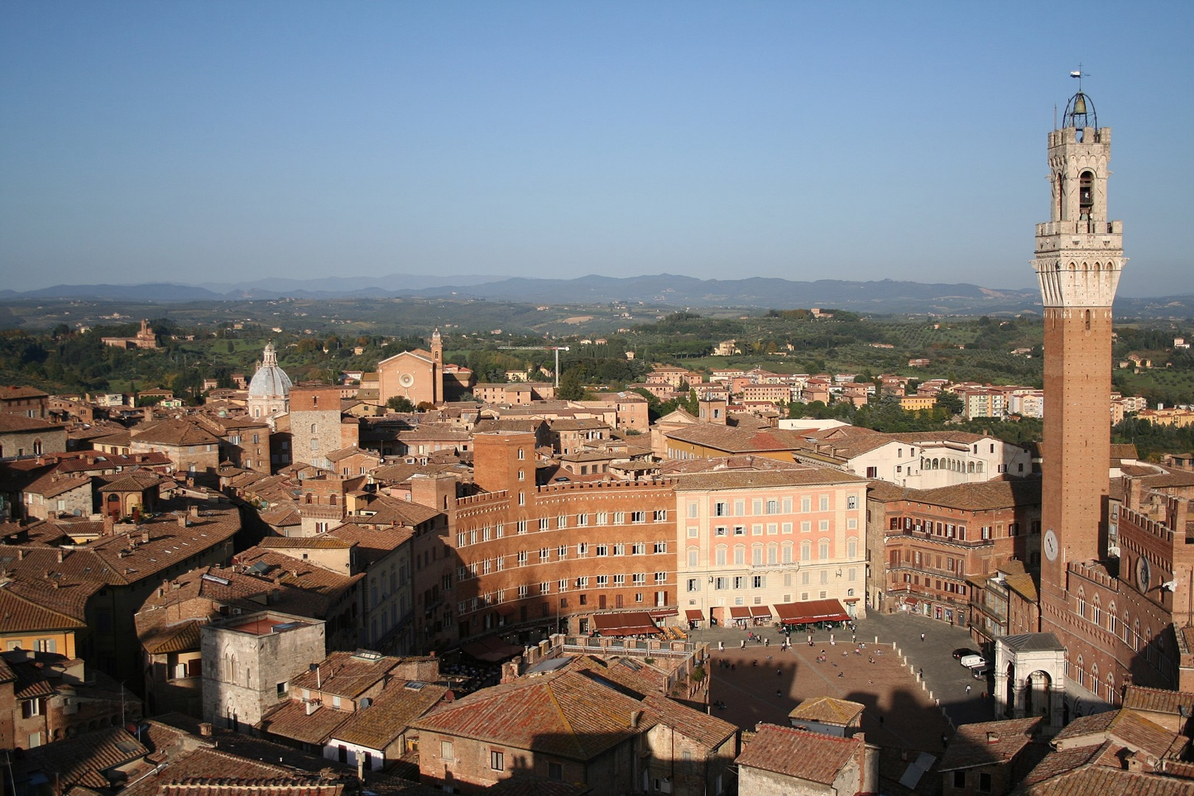

Wednesday, October 21

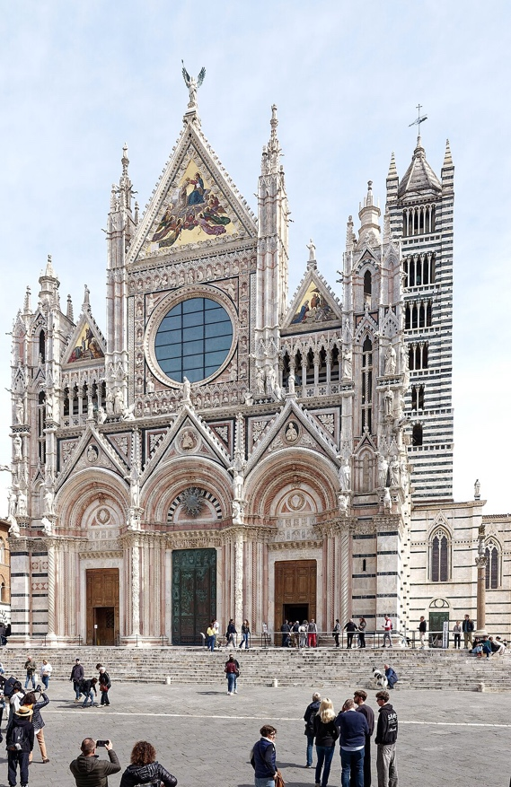
After breakfast, we'll have time to pack our bags, check out of the hotel and head to Termini, Rome's main train station, for the train trip to Siena. Siena, in the heart of Tuscany, was an independent city state and an important center of trade and banking going back to the Middle Ages. We'll settle into our rooms this afternoon and take some short walks to enjoy one of the most picturesque small cities in Italy. Dinner near the hotel.

Thursday, October 22

After a leisurely breakfast we'll walk over to the cathedral, one of the city's architectural gems and a monument to Siena's growing wealth in medieval times. We'll stroll over to the Piazza del Campo, the town square, a popular place for townspeople to gather and relax and the site of the famous Palio horse races which take place twice each year. We'll also see the Basilica of San Domenico and the relics of Saint Catherine, one of the patron saints of Europe. Siena is hilly, but the historic center is compact and we can take our time to sit and enjoy whenever we wish. While we're out, look for the plaques and flags featuring real or mythological animals that mark the boundaries of the contrade, the wards or neighborhoods that have been at the center of Sienese life since the Middle Ages. Dinner near the hotel this evening.

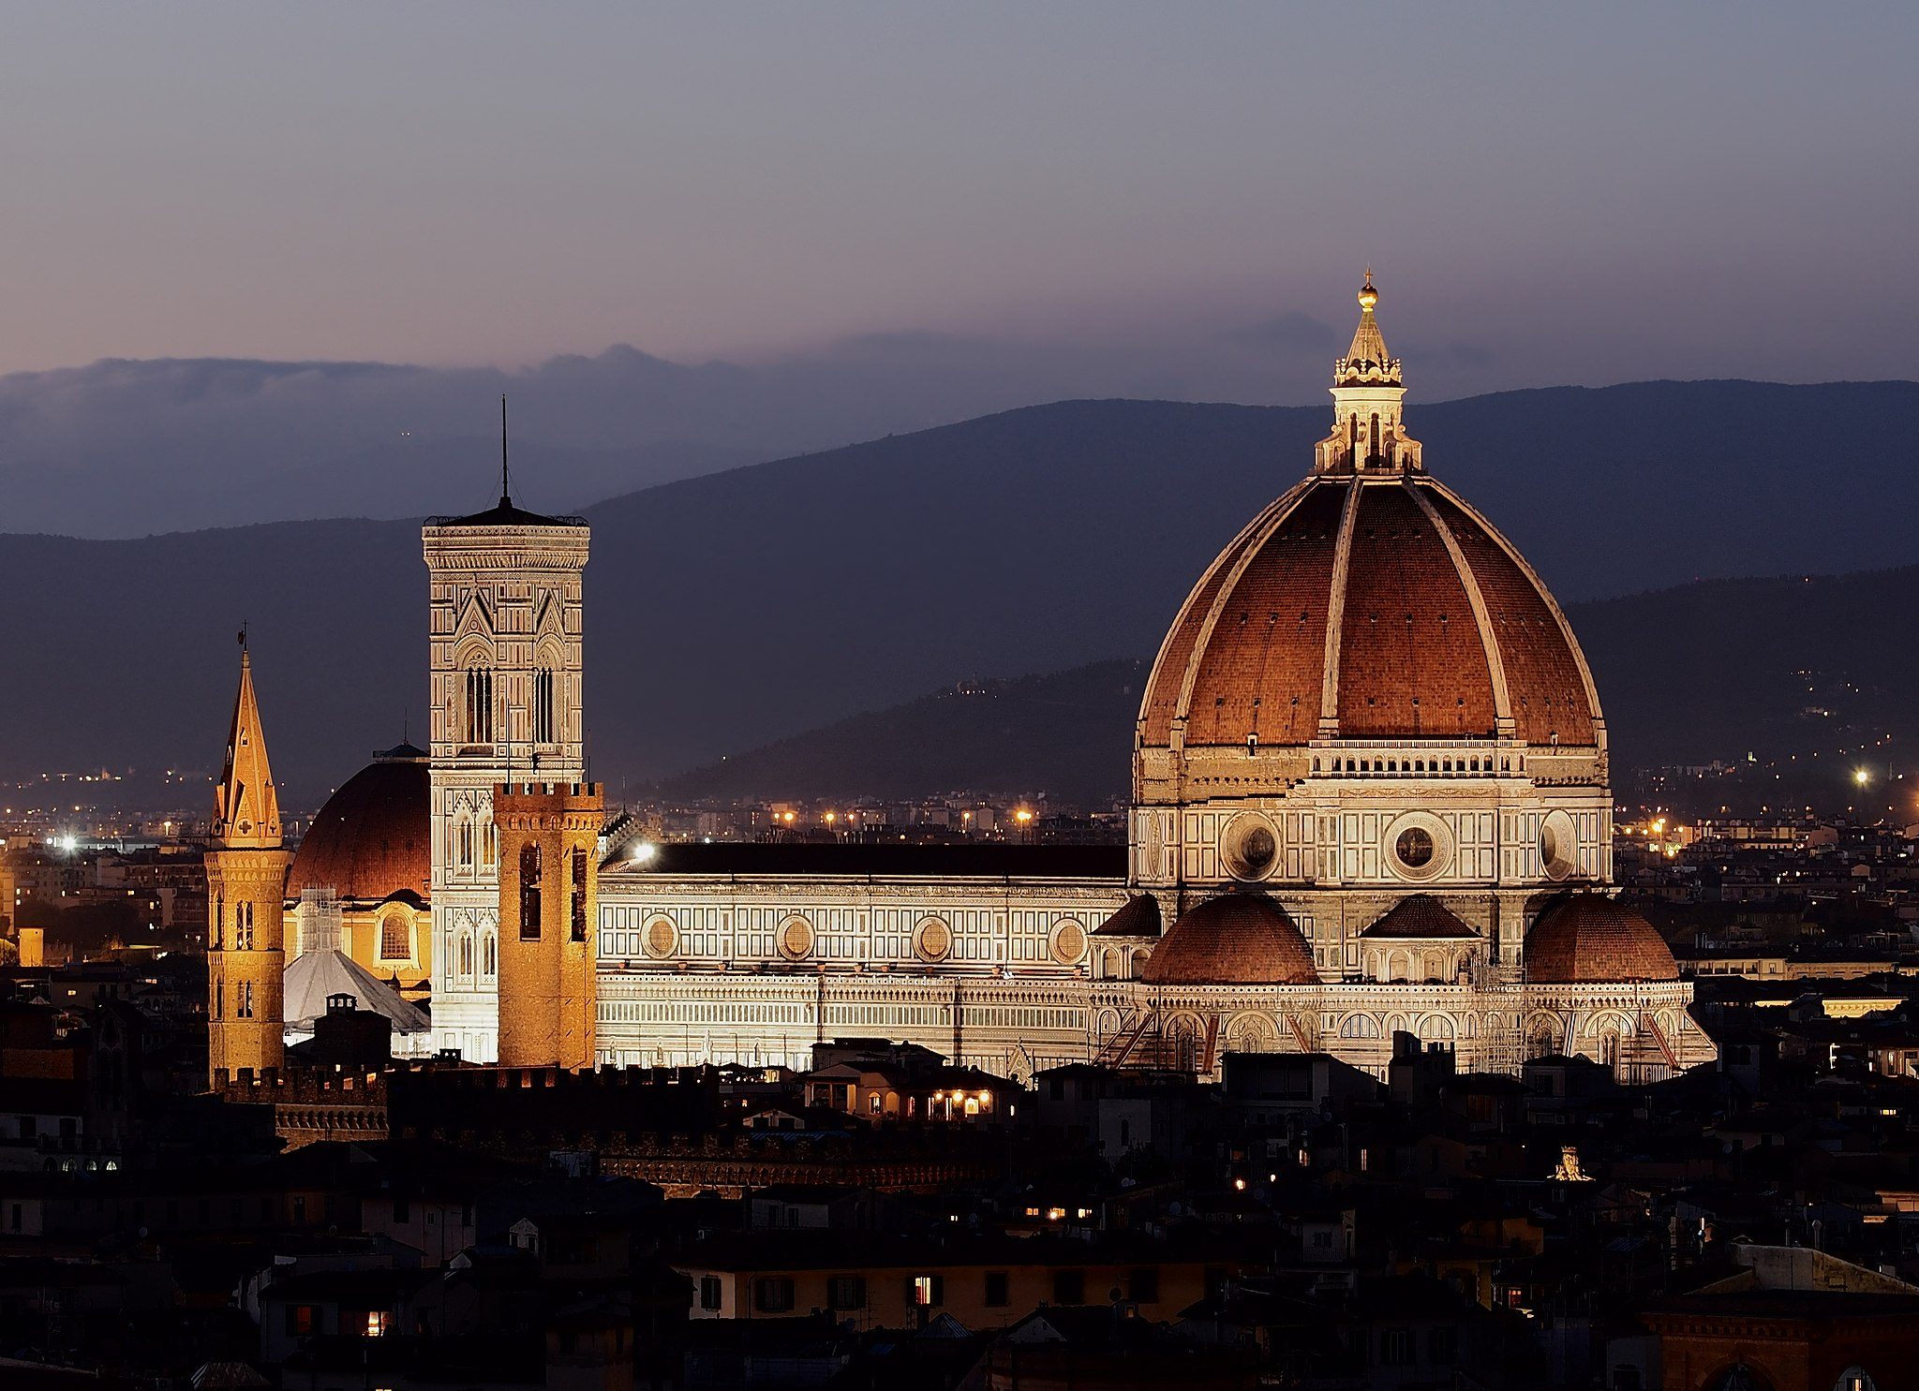
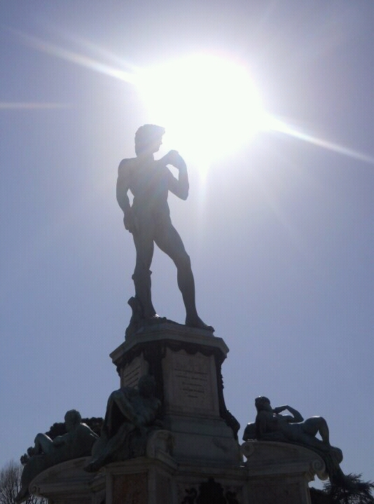

Friday, October 23

We'll take a train this morning for the one-hour ride to Florence, the once-powerful and fabulously wealthy city-state of the Medici Dynasty that gave us new ways of thinking about human nature, the period we call the Renaissance. Florence is a popular destination for international tourism, and we'll see these highlights--the beautiful baptistery, bell tower and cathedral, the Piazza della Signoria and Michelangelo's David (the original is inside the museum), and the Ponte Vecchio, the medieval bridge crossing the Arno River. We'll return by train to Siena in the late afternoon.

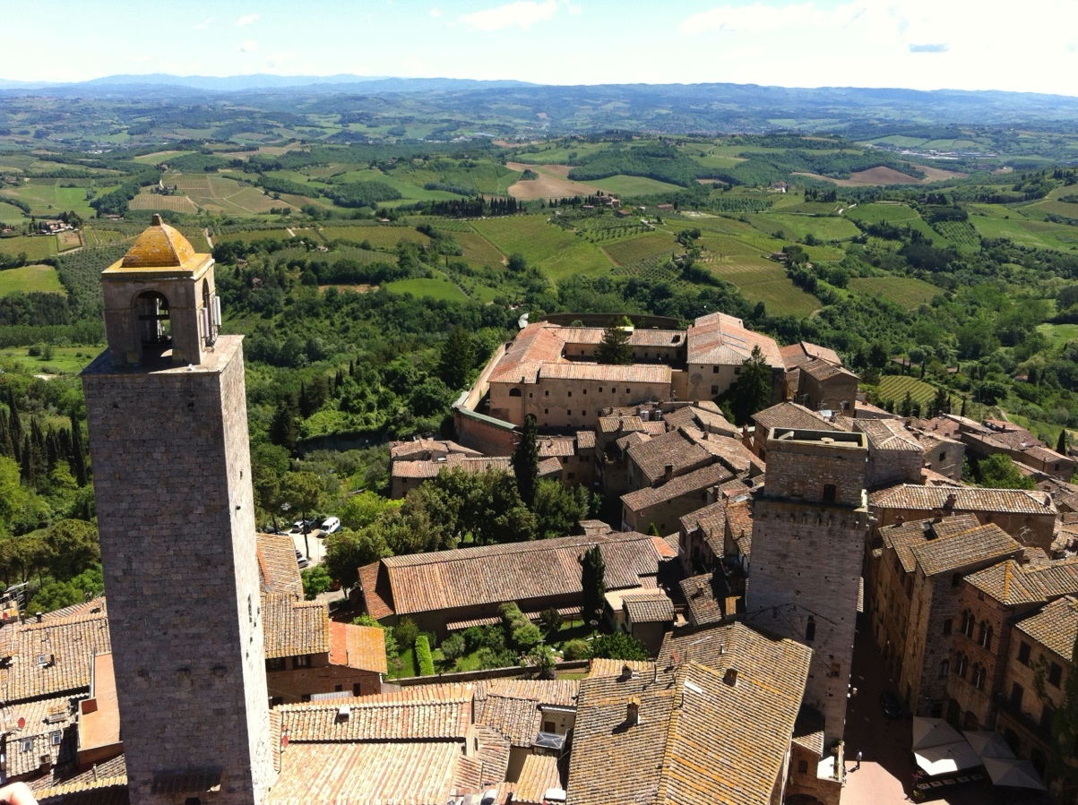

Saturday, October 24

After breakfast, we'll take a bus tour to explore San Gimignano, one of the gems among the Tuscan hill towns, and Pisa to see the famous Tower. We'll have time to sightsee, enjoy lunch or a drink and watch the passersby as they go about their day. We'll return to Siena in the late afternoon. Dinner this evening near the hotel.

Sunday, October 25

This morning we'll check out of our Siena hotel and will take one of the new high-speed trains that will bring us down the Italian peninsula, through Rome, and continue to Salerno, on the Amalfi Coast. Salerno has been a crossroads of civilizations since antiquity and will be our base for the next four nights. We'll settle into our lodgings this afternoon and have time to stroll the pedestrian streets and have dinner nearby.

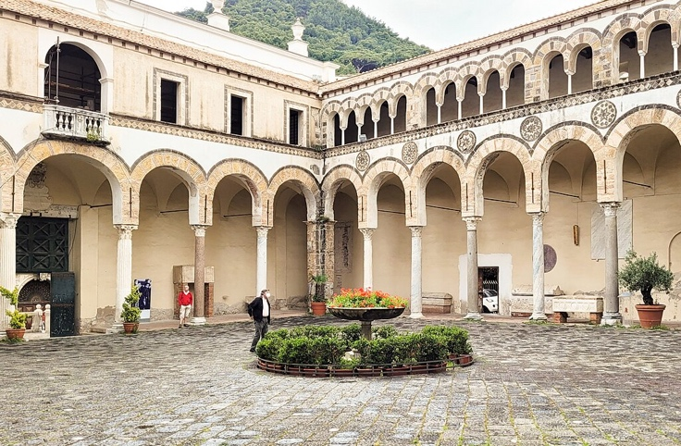
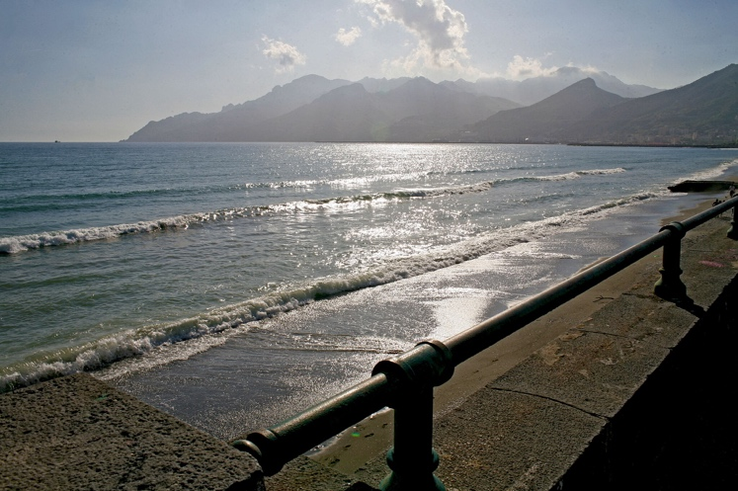

Monday, October 26

After breakfast, we'll board a passenger ship for the beautiful seaside towns of Positano and Amalfi, each clinging to the rugged hillside and offering some of the most picturesque locations on the Mediterranean. We'll have time to sit and relax in the cafés and restaurants, watch the fishermen bring in their morning catch and enjoy a leisurely day by the sea. We'll return by ship to Salerno in the late afternoon.

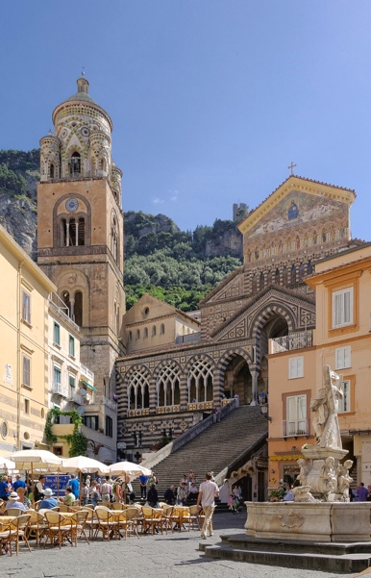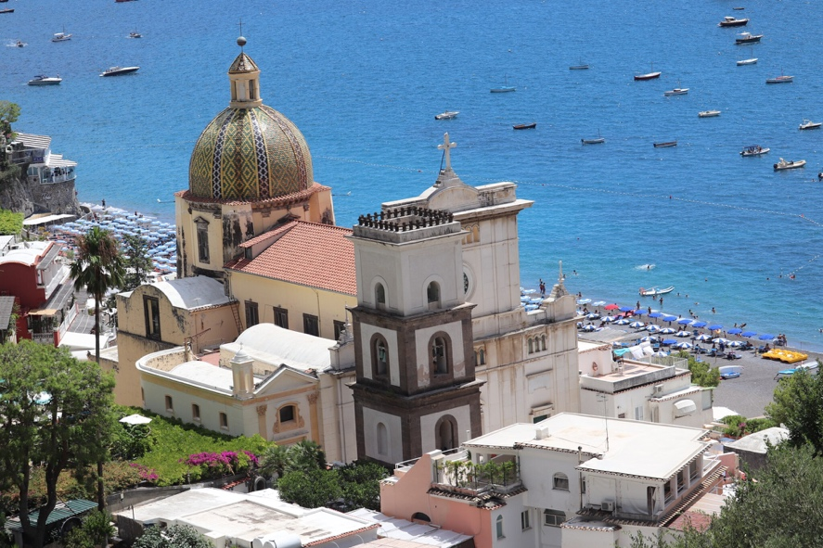

Tuesday, October 27

We'll take a 30-minute ride on the train this morning to nearby Pompeii, the vast archeological site that preserves the remains of this once-thriving town destroyed by Mount Vesuvius in 79 AD. We'll take a guided visit of the ruins to get a deeper understanding of life in the Roman Empire. We'll have time to stroll through Pompeii's many streets that have been excavated before heading back by train to Salerno in mid-afternoon. Dinner near the hotel in Salerno.
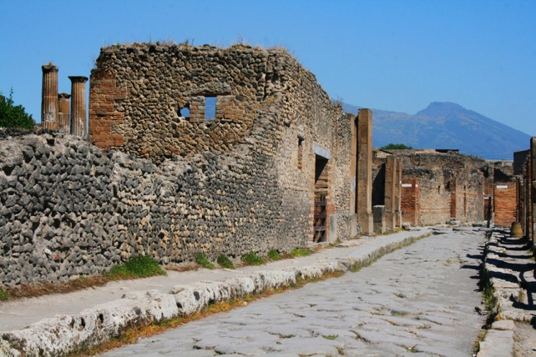
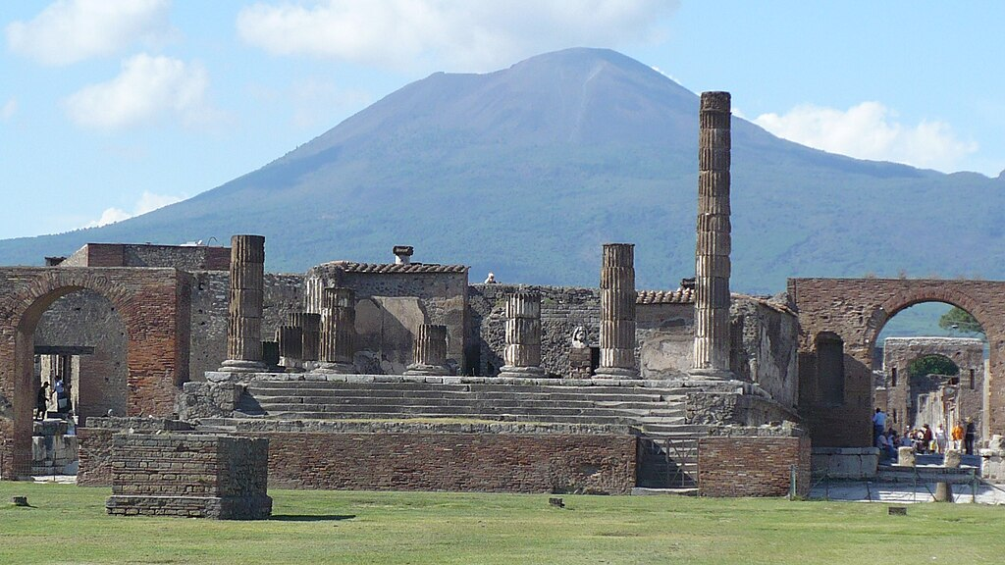

Wednesday, October 28

Today we'll enjoy a boat trip to the Isle of Capri, the fabled offshore residence of Emperor Tiberius, known for its rugged landscape and stunning cliffside views of the sea. We'll have the day to walk through the two small towns, Capri and Anacapri, enjoy a leisurely lunch and window-shop the upscale stores. Those who wish may walk the trail to Villa Jovis, completed by Tiberius in 27 AD, and enjoy the breathtaking views of the sea toward Naples and Vesuvius. We'll board the boat for the return to Salerno in the late afternoon. Dinner near the hotel this evening.

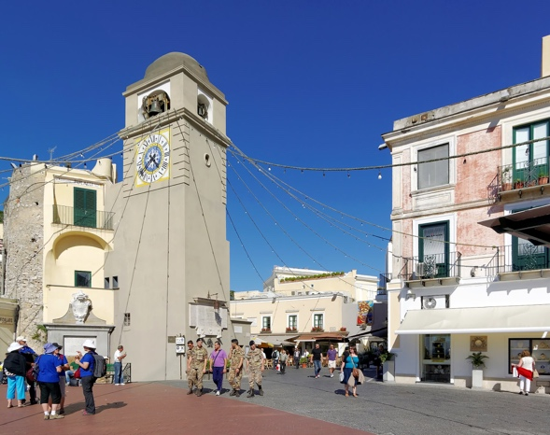
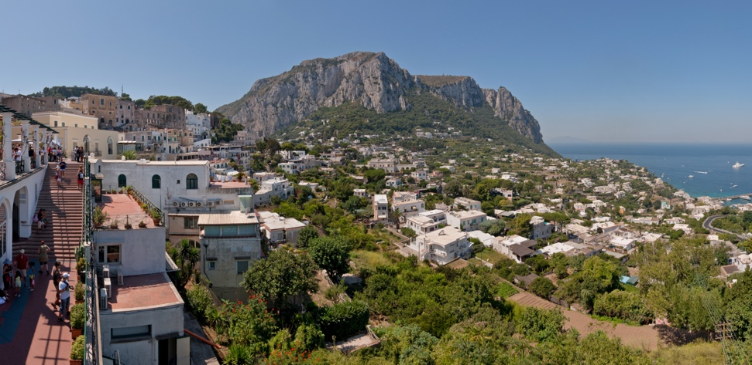

Thursday, October 29

We'll pack our bags this morning and board a train for the return trip to Rome. We'll connect at the Termini station for Fiumicino, where we'll check into a hotel close to the airport. We'll enjoy our last evening together over dinner, and recount stories of our many Italian adventures.

Friday, October 30

The tour conductor will be available to accompany you to the airport terminal and check in for your return trip home. He'll also be available to take anyone staying in Europe back into the city to connect by train to other destinations.

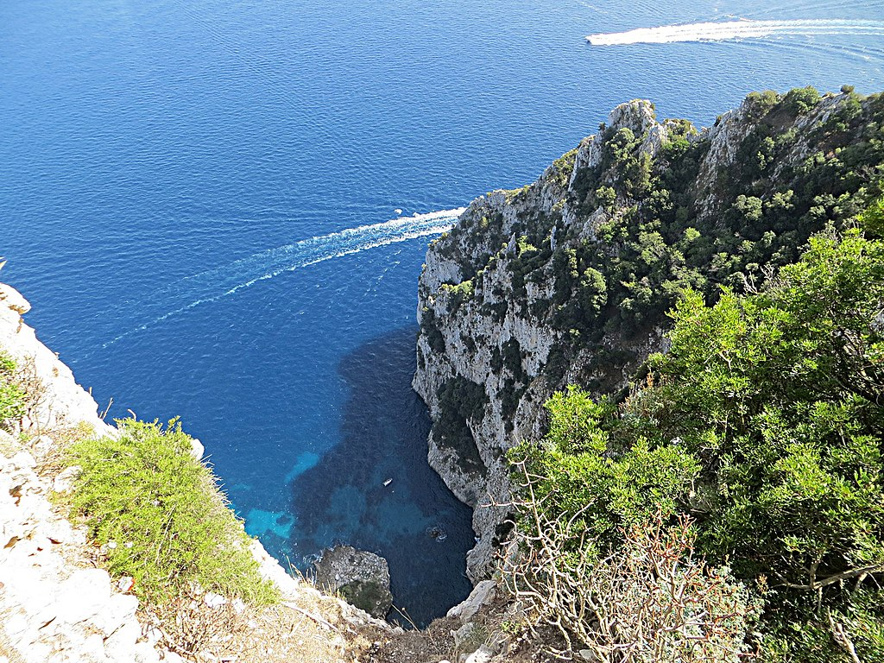

Fees and payments

Fee for the thirteen-night Rome, Tuscany and the Amalfi Coast program is $3700.00 per person, in a double-occupancy room. The fee includes:

--Thirteen nights tourist-class, double-occupancy lodging in Rome, Siena and Salerno, Italy, with buffet-style continental breakfast each morning.

--All local land transportation, including incoming and outgoing transportation from and to Rome's Fiumicino Airport (FCO), two-day Rome public transportation passes, intercity train tickets, day tour to San Gimignano and Pisa and boat passes from Salerno to Amalfi, Positano and Capri.

--Entrances and guided visits to the Colosseum, Forum, Vatican Museums and the Pompeii Archeological Site, entrances to the Baptistery and Museum dell'Opera del Duomo in Florence and the Duomo (cathedral) of Siena.

--Gratuities to drivers and hotel staff.

Fee does not include international airfare from the United States, lunches or dinners, entrances not specified in the program, travel insurance or visa.

Supplement for a single room is $1200.00.

This fee is based on a minimum of six paying passengers.

Payments are due on the following schedule:

March 31, 2026: $ 500.00 due
May 31, 2026: $3200.00 due (plus $1200 single-room supplement if applicable)

Payments should be made to River Plate Seminars by check at this address: Mark McMeley, 1001 Brynlor Lane, Orlando, Florida 32818, or though Venmo at Mark-McMeley-1, or through Zelle at phone number 321-977-1389, or by wire transfer to the following account:

Chase Bank
7674 Dr. Phillips Blvd., Orlando, Florida 32819
account: 105 987 770
routing number: 021000021
attn: Mark McMeley




