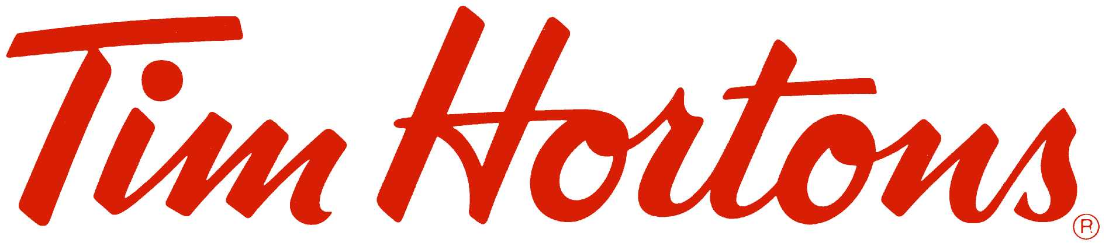
HEALTH & SAFETY
ORIENTATION
Handbook

___________________________________________________________________________________

___________________________________________________________________________________

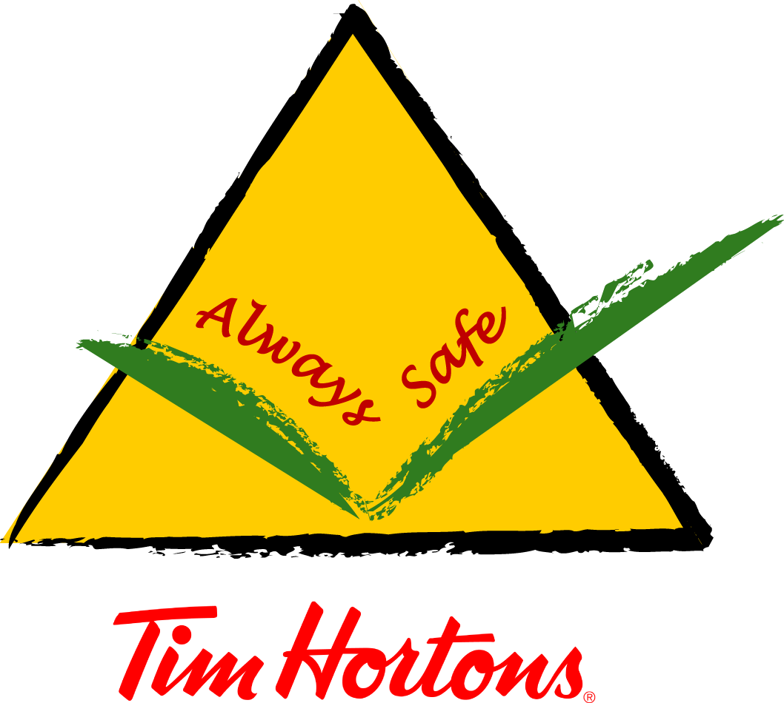

Table of Contents

 |  | SECTION | PAGE
 |  | Introduction | 1
 |  | Rights & Responsibilities | 2
 |  | Health & Safety Policy and Program | 3
 |  | Restaurant Health and Safety Policy  Joint Health & Safety Committee  Health & Safety Representative | 4  5
 |  | Reporting Hazards  Reporting Injuries/Illness and First Aid | 6  7
 |  | Early & Safe Return to Work | 8
 |  | Emergency Plan  Lifting Basics  Ladder Safety | 9  13  14
 |  | WHMIS | 16
 |  | Conclusion | 20

___________________________________________________________________________________
Introduction

Did You Know?  New workers are 5 times as likely to have a serious injury during the first few weeks on the job. |  | The Internal Responsibility System (IRS)  The Internal Responsibility System (IRS) is a health and safety philosophy based on the principle that every individual in the workplace is responsible for health and safety. That includes employers, management and Team Members.  Health and safety legislation is based on the concept of IRS. It outlines the rights, duties, roles and responsibilities for all workplace parties (i.e. Team Members, Supervisors and the Restaurant Owner). With IRS, workplace parties share responsibility for health and safety, and their roles and responsibilities are complementary.
Why do I Need Health and Safety Training Before I Start My Job?
Starting any new job puts you at risk for illness and/or injuries, which are more likely to happen in the early days and weeks of a new job. To keep yourself safe while you’re learning the job, there are some things that you need to know:

- What are your rights and duties under the law?
- What are the duties of your Manager and employer?
- Where can you find information about health and safety in your workplace?
- What are the real and potential hazards in your workplace?
- What should you do in an emergency?
- Who do you report health and safety concerns to?

Why is it Important to Have a Safe and Healthy Workplace?
- To prevent injury and illness.
- Control the costs of doing business.
- It sends a message that people care about one another.
- It’s the law!

What Gets “In the Way” of Working in a Safe and Healthy Way?
- Doing a job that you are not used to doing.
- Working too fast.
- Not being sure how to use equipment.
- Not wanting to report another Team Member.

__________________________________________________________________________
Rights and Responsibilities

Team Members  You have three basic rights under the Act:  - The Right to Participate  You can identify or make suggestions about health and safety concerns. Discuss these with your Manager or health and safety representative.  - The Right to Know  It is your right to know how to do your job in a safe and healthy way. You also have the right to know what real or potential hazards are in your workplace. For both of these, you need training. Participate in all the training that is provided for you.  - The Right to Refuse  If you have reason to believe that a task is unsafe for you or a co-worker, you have the right to refuse to do that task. There are several steps that must be followed.  What are My Duties as a Team Member?  Every Team Member must:  - Do the job in a safe and healthy way.  - Use or wear personal protective equipment or clothing the right way.  - Inform your Manager if equipment is missing or not working properly.  - Tell your Manager about any hazards in your workplace.  - Report any known violation of health and safety legislation to your Manager.  - Follow instructions for using equipment safely, and follow safe work practices.  - Not remove or change any device that is in place to keep Team Members safe.  - Not push, shove, be part of any prank, run or act in a rough way in the workplace. |  | What Duties Does My Employer Have?  The employer has an important role in making sure that the workplace is safe and healthy. An employer must:  - Take every precaution reasonable to ensure health and safety.  - Make sure that everyone follows the health and safety legislation.  - Have a written health and safety policy and program that is reviewed every year.  - Make sure that Team Members have competent supervision.  - Help the Joint Health and Safety Committee or Health and Safety Representative, if any, carry out duties.  - Inform Team Members and Managers about workplace hazards or potential hazards.  - Provide training in workplace health and safety.  - Provide and maintain in good condition personal protective equipment.  What Are My Manager’s Duties?  Your Manager must:  - Ensure that everyone works in a safe and healthy way.  - Take every precaution reasonable to protect Team Members.  - Inform Team Members about any real or potential hazards in the workplace.  - Be sure that Team Members use personal protective equipment correctly.  - Provide instruction for safe work practices for all job tasks.
__________________________________________________________________________
Health & Safety Policy and Program

Policy
A written Health & Safety Policy is the basis of a workplace health and safety program. It is:
- A statement of the company’s commitment to health and safety.
- It indicates that safety is a shared responsibility of everyone.
- Is reviewed annually and posted so that everyone can read it.

A copy of your Restaurant’s policy is shown on the next page.

Program
A health and safety program is a plan of action designed to prevent accidents and injuries. It is comprised of many elements as illustrated below.

[insert your Health and Safety Policy]
__________________________________________________________________________
Joint Health & Safety Committee
Health & Safety Representative

Joint Health and Safety Committee (JHSC)  What is a JHSC?  A Joint Health and Safety Committee (JHSC) is one way in which Team Members can participate in workplace health and safety decision making. The committee consists of a group of Team Members and Managers who meet on a regular basis, and who make sure that health and safety concerns are identified and action taken.  At least half of the committee must represent Team Members. Team Members must select their representative(s), and the management member(s) are appointed by the employer.  What Does a JHSC Do?  Activities include:  - Suggesting ways to improve workplace health and safety.  - Conducting inspections of the workplace.  - Identifying hazards and obtaining information.  - Recommending corrective action.  - Participating in accident investigations.  - Participating in resolving work refusals. |  | Health and Safety Representative (H&S Rep)  How Does a H&S Rep Differ From the JHSC?  Smaller workplaces, depending on the number of Team Members, might be required to have one person serve as a health and safety representative rather than a committee.  The representative must not have a managerial function, and is selected by the (non-management) Team Members.  H&S Reps essentially have the same duties as JHSC members.  _______________________________________  How Do I Know Who My JHSC Members/H&S Rep(s) Are?  Your Manager should inform you who your JHSC members or health and safety representative is during your orientation, and their names should be posted in the Restaurant.

___________________________________________________________________________________Reporting Hazards

Reporting Hazards  What Hazards Might Be In My Workplace?  Simply stated, a hazard is anything that may harm you or anyone else in your workplace. There are safety and health hazards in every workplace. During your in-Restaurant training, you will receive instructions on work practices and procedures. Know and follow these, and ask questions if you are not sure about any task.  Examples of Common Hazards at Tim Hortons:  Slips, Trips and Falls, resulting from things like wet floors, objects blocking a path, or not using a ladder correctly.  Sharp Objects, which can result in cuts and lacerations from things like broken glass or china, or not using a knife correctly.  Hot Materials, which can cause burns and scalds from things like not following proper procedures when preparing hot drinks, handling hot product from the ovens, or using the dishwasher.  Chemicals, which can result in injuries or illness from things like not using a cleaning chemical safely, not using or wearing the required personal protective equipment.  Ergonomics, which could result in sprains and strains from things like not lifting properly, repeated motions, or not using the correct tools.  Violence associated with factors such as working with the public, cash handling, operating during early mornings and late at night. |  | Reporting Hazards  It is important to immediately report a hazard or other health and safety concern to your Manager or Supervisor.  Personal Protective Equipment (PPE)  What is Personal Protective Equipment (PPE)?  PPE is worn by a Team Member to minimize exposure to specific occupational hazards. Examples are:  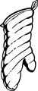  - Goggles  - Gloves  - Respirator  - Apron  - Oven Mitts  - Jackets for work in a freezer  The PPE you require depends on what job you are doing. The three things that you will need to know are:  - What type of PPE you will need.  - When you need to use or wear the PPE.  - The right way to use or wear this equipment.

__________________________________________________________________________
Reporting Injuries/Illness and First Aid

Reporting Injuries  Accident/Incident Investigations are conducted in order to determine what caused an injury and to prevent the same or similar accident from happening again. Your cooperation is very important as you can provide valuable information.  What Should I Do If I am Injured at Work?  In case of injury or illness you should:  1. Get proper medical treatment  Go to the nearest first aid station immediately and notify a staff member trained in first aid. An accurate record should be kept of the treatment you receive.  If your injury or illness is serious (or you are not sure how serious it is) go to a doctor or hospital. Your employer is responsible for providing transport to medical treatment and may have to call an ambulance or assign someone to accompany you.  2. Report the incident to your employer  Your Restaurant Owner or Manager needs to know about your injury or illness to provide help, fulfill their employer responsibilities for reporting, and take measures to prevent further incidents. Report the incident to your Manager immediately. |  | First Aid Kits  First aid requirements are regulated by the provincial workers’ compensation or occupational health and safety division. Employers are required to have first aid equipment (ie. kits), facilities and first aid trained personnel in all workplaces.  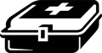  When an item from the first aid kit is used, it must be documented on the First Aid Log found in or near the kit. This report provides valuable information to the employer for tracking and analyzing workplace injuries. For example it can be determined whether additional training or reviewing work practices is needed.  Remember to report all injuries to your Manager, regardless of how minor.
__________________________________________________________________________
Early & Safe Return to Work

Preventing workplace injuries and illnesses is the responsibility of everyone in the workplace. However, if an injury or illnesses does occur, it is important for you and your employer to try to minimize the impact by focusing on returning you to safe and productive work as soon as it is medically possible and safe for you to do so.  Why Early and Safe Return to Work?  Most people who have a workplace injury or illness are able to return to some type of work even while they are still recovering, provided the work is medically suited to the injury or illness.  Returning to daily work and life activities can actually help an injured worker's recovery and reduce the chance of long- term disability. In fact, worldwide research shows that the longer you are off work due to injury or illness, the less likely it is that you will return to work.  It is to your benefit to cooperate in with your early and safe return to work plan. You benefit by restoring your source of income and staying active and productive, which are important to the healing/recovery process.  What are My Responsibilities?  Your responsibilities are:  - Get proper medical treatment immediately following a work-related injury or illness and follow the recommendations of your health care providers.  - Report your injury to your employer as soon as possible.  - Contact your Manager as soon as possible after the injury or illness occurs. Stay in contact with your Manager throughout your recovery, to keep the company informed about your progress and status. |  | - Help your Manager identify suitable work that is available, that is consistent with your functional abilities, and that restores pre-injury earnings when possible.  - Cooperate with your Manager and your case manager at the Compensation Board (Commission) in your early and safe return to work.  What are my Employer's Responsibilities?  Your Restaurant Owner is required to:  - Report your injury to the Compensation Board (Commission).  - Contact you as soon as possible after your injury and stay in contact throughout your recovery.  - Attempt to provide you with suitable work. This is work that:  - is safe and within your physical capabilities  - you have the skills to do or that you can learn the skills to do  - restores your pre-injury earnings as much as possible  - Give the Compensation Board (Commission) any information requested about your return to work.

__________________________________________________________________________
Emergency Plan

The best approach to any emergency is to prevent it. The next best is to be ready for it.  What Kind of Emergencies Can Occur?  Emergencies can be serious and urgent. Here are some examples:  - Fire  - Threats of Violence  - Robbery  What Should I Do In an Emergency?  This depends of the type of emergency and your workplace. It also depends on whether or not you are trained to respond.  Each Restaurant has an EMERGENCY PROCEDURES flipchart posted. These procedures will be reviewed with you by an in-Restaurant Trainer or Manager.  Some general guidelines for emergency situations are:  - Get first aid right away for anyone who is injured. If you are hurt on the job, be sure to get first aid right away. Contact the certified first aid person.  - Contact your Manager right away. Do not try to respond to an emergency on your own unless you have been trained to do so.  - Correctly use any required PPE.  - Identify the emergency area and warn others in your area about it. Stay clear of the area if you are not involved. |  | What Emergency Equipment Should I Be Able to Find?  - First aid equipment  - Eye wash station  - Fire equipment  FIRST AID STATION  Contains first aid supplies.  Is under the control of a certified first aid worker.  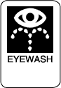  EYE WASH STATION  Located where Team Members may splash hazardous chemicals in their eyes. The station contains clean water, which is used to gently flush the affected eye.  FIRE EQUIPMENT  Includes extinguishers, sprinklers and alarms. It is also important to know where the exits are located.  If There is a Medical Emergency…  - Contact emergency services if needed (dial 9-1-1).  - Contact shift first aid attendant immediately and report exact location of patient and nature of injuries.  - Ensure the accident scene is safe – no further danger to self or injured Team Member.  - Do not move the injured person unless there is a high risk of further injury or death. Keep calm and do not leave the Team Member unattended.

If There is a Fire…  IMPORTANT: Please refer to the in-Restaurant Emergency Procedures flipchart for specific procedures.  These are general guidelines for responding to a fire:  - Call the Fire Department.  - Evacuate all Team Members and customers away from the restaurant.  - If you can do without endangering yourself, turn off power for the equipment on fire at the circuit breaker.  - Extinguish the fire with the extinguisher if you have had training and can do so safely.  For Violence in the Workplace…  IMPORTANT: Please be sure to read and follow the guidelines in your Restaurant’s Emergency Procedures flipchart for threats of violence.  - Inform Manager on duty.  - If threat of immediate danger to life or bodily harm exists, keep distance from threat and call 9-1-1 or local police.  Being Aware of Potentially Violent People  People who become violent might show it:  - In the face (going red or white, scowling, sneering, grimacing, glaring or avoiding eye contact)  - In the body (sweating, pacing, being restless or repeating certain movements, trembling, shaking, clenching jaws or fists, making exaggerated or violent gestures, or by moving too close)  - In the voice (loud talking, chanting or using abusive language)  - In the breath (shallow or rapid)  Dealing with a Potentially Violent Person  Tips for verbal communication:  DO:  - Focus on the person to show your interest.  - Stay calm |  | - Speak simply, slowly, quietly and confidently.  - Listen carefully. Do not interrupt or offer unsolicited advice or criticism.  - Encourage the person to talk. Do not tell the person to relax or calm down.  - Remain open-minded and objective.  - Use silence as a calming tool.  - Acknowledge the person’s feelings. Say that you can see he or she is upset.  DO NOT:  - DO NOT glare or stare, it may appear challenging.  - DO NOT convey complex information when emotions are high.  - DO NOT:  - Confront  - Challenge  - Criticize  - Antagonize  - Belittle  - Threaten  - “Talk down” or use jargon  Tips for non-verbal communication:  DO:  - Use calm body language. Stay relaxed. Keep your hands unclenched.  - Stay at a right angle rather than in front of the other person.  - Give the person enough space, usually about 2 to 4 feet.  - Get on the other person’s physical level. If they are seated, try kneeling or bending over, rather than standing over them.  DO NOT:  - DO NOT stand directly opposite someone, put your hands on your hips, point your finger, or wave or cross your arms.  - DO NOT make sudden movements which can be seen as threatening.  - DO NOT fight. Walk or run away. Get help from security or police.
Robbery Prevention  - Best deterrent is by staff showing that they are alert, active, prepared and visible.  - Maintain a neat and organized business.  - Make sure P.O.P. Displays are not blocking the clear view of the Restaurant’s interior or blocking cameras.  - Be friendly and greet all customers – robbers do not want attention directed towards them.  - Suspicious people should be approached carefully to see if there is anything you can do for them.  - Avoid established routines that would allow a robber to catch you off guard (bank deposit drops, coin orders, taking out garbage).  - Keep cash floats low and make regular skims throughout the day.  - Keep the Back Door locked at all times, and enforce the Back Door Policy.  - Install Robbery Prevention stickers to show your involvement in a crime proofing program.  - Only allow on-duty staff to be in the Restaurant.  - Have the Emergency Procedures Chart posted by the telephone for all staff to use.  - Take note of suspicious people loitering in and around the Restaurant and contact the police if you feel it is necessary.  - Ensure lighting in the parking lot is bright and that there is no area for would be robbers to hide (overgrown shrubs, garbage, etc.).  - Do Not count cash in plain view of customers or staff.  - Video cameras should be installed and set up in clear view to all customers as they enter or exit the Restaurant.  - Check references for all potential staff so that you are not hiring anyone of questionable background.  - Encourage police to frequent your Restaurant during the non-peak times and during the night shift.  - Always have a Robbery Description Form under each register to be filled out in the event of a robbery. |  | During a Robbery  - Do Not Panic, Stay Calm and Co-operate Fully  - Follow the directions the robbers gives you and Do Not Resist as this could endanger your life and the lives of others.  - Do Not argue or withhold any money.  - Do Not make any quick movements that might scare the robber – this could only provoke them to violence.  - Staff should try to make a mental note of the robber only if it does not endanger themselves.  - Do Not volunteer any information.  - If a member of the staff or a customer is out of sight, tell the robber.  - Do Not attempt to overpower the robber.  - Do Not follow the robber out of the Restaurant, but make a mental note of which direction they fled.  - If at all possible, Do Not leave with the robber.  - Most importantly, remember that your safety and that of your customers is always the first priority.  After a Robbery (When it is Safe)  - As soon as the robber has left the Restaurant, Call the Police, lock the door and see that all the customers are alright, calling an ambulance if necessary.  - Inform the Manager about the incident, if they are not present.  - Go to your register and fill out the Robbery Description Form found there.  - Do Not discuss the details of the robbery with your fellow staff members as this may distort your memory; wait for the police to arrive.  - Do Not reveal how much money was stolen with fellow staff members or customers.  - Try to see which direction the robber fled and let the police know when they arrive.  - If the robber has touched anything (counter, register, door handle), try not to disturb the area as police will want to fingerprint it.  - If customers want to leave, advise them to stay until the police arrive to answer any questions. Remember, you cannot force a customer to stay – you must allow them to leave if they want to.
If There is a Power Failure…
IMPORTANT: Please refer to the in-Restaurant Emergency Procedures flipchart for specific procedures.
Your Manager will coordinate:
- Calming customers and Team Members.
- Evacuating customers and Team Members if necessary.
- Clearing emergency exits.
- Locking and securing cash drawers and customer entrances.
- Turning off cooking equipment, monitoring food temperatures and discarding food and beverages as required.

If There is a Bomb Threat…
IMPORTANT: Please refer to the in-Restaurant Emergency Procedures flipchart for specific procedures.
- If possible, pass the phone call to your Manager.
- The person speaking with the caller should:
- Stay calm.
- Ask the caller to repeat the message, listen carefully and note things like if caller is male or female, if caller is excited or calm, if caller has an accent, any background noises.
- Get as much information as possible, such as where the bomb is, when it will go off, why has bomb been placed there.
- Tell the caller that there are people in the building who may be harmed.
- After the call, write down everything you can remember.
- Call the police.

If There is an Earthquake…
IMPORTANT: Please refer to the in-Restaurant Emergency Procedures flipchart for specific procedures.
- Get under sturdy furniture or stand against an outside wall.
- Move away from windows and doors, hanging objects, or unsecured furniture, and shelves.
- Don’t panic – Stay calm.

Lifting Basics

Techniques for Safe Lifting
Safe lifting means keeping your back aligned while you lift, maintaining your centre of balance and letting the strong muscles in your legs do the actual lifting. By using the following techniques, you can learn how to lift safely and save your back from accidental strain and injury.

√ The RIGHT Way to Lift

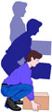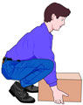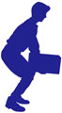

Bend Your Knees  Bend your knees, not your waist. | “Hug” the Load  Try to hold the object as close to your body as possible, as you gradually straighten your legs to a standing position. | Avoid Twisting  Twisting can overload your spine and lead to serious injury. Make sure your feet, knees and torso are pointed in the same direction when you are lifting.

The WRONG Way to Lift

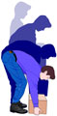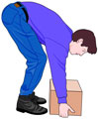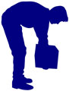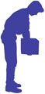

REMEMBER! Get help with heavy or awkward loads. It's important to recognize your own physical limitations and abilities. Many people have injured their backs because they were afraid to ask for help.
__________________________________________________________________________
Ladder Safety

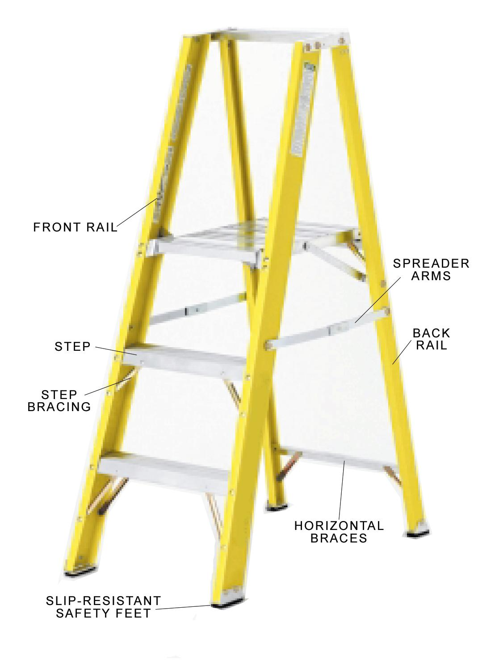  What Are the Hazards?  Ladders are a simple and common tool in most workplaces; however, they do pose a hazard if used incorrectly.  Common types of minor injuries from falls from ladders include:  - fractures  - sprains and strains  - cuts and punctures  What Are the Requirements for Safe Ladder Use?  General Practices:  - Use the right ladder for the job.  - Do not use a counter top, chair, milk crate, barrel or box instead of, or in combination with a ladder.  - Make sure that only one person at a time is on the ladder. |  | - Never store a ladder in a freezer, or where they are exposed to weather.  - Do not use a ladder with loose, broken or missing rungs, screws or bolts.  - Do not use a ladder in a horizontal position as a scaffold, plank or runway.  - Never leave a ladder set up and unattended.  - Never use a step or platform ladder as a straight ladder by leaning it against a wall.  - Avoid pushing or pulling off to the side of the ladder. Do not “walk” or “shift” the ladder while on it.  Preparation  - Inspect the ladder before each use for loose or damaged rungs, steps, rails or braces, damaged or missing slip-resistant feet.  - Tag a defective ladder for repair or replacement.  - Place the ladder on a stable and level surface.  - Ensure the floor in the area the ladder will be set up is free from debris, spills and ice.  - Set up a barricade and warning signs when using a ladder in a doorway or aisle.  - Keep the ladder away from electrical circuits and power lines.  - When carrying a ladder, hold it near the center and keep it close to your body.  - When using a ladder, make sure that it’s fully open and that its spreader arms are locked securely.  - Place the stepladder at right angles to the work.  - Wear warm clothing when working in the freezer.

Climbing and Dismounting  - Clean footwear thoroughly before climbing the ladder. Ensure the soles of footwear are not muddy or slippery.  - When climbing up or down, always face the ladder and maintain at least 3 points of contact (2 hands/1 foot or 2 feet/1 hand).  - Keep the center of your body between the side rails of the ladder.  - Maintain a firm grip.  - When reaching for a product, ensure you reach directly in front of you, not to the sides.  - Don’t overreach. Move the ladder closer to the product to ensure you are always reaching for products properly.  - When using a ladder to remove product from a shelf ensure someone is available to pass the product to.  - Limit twisting and bending and ensure both feet maintain contact with the ladder while passing product to a second person.  How Do I Perform a Ladder Inspection?  It is important that the individual responsible for conducting ladder inspections knows what to look for. For example:  - Ladders should always have all non-slip grips on the feet, and feet should be in good condition.  - Inspect for cracks and dents and ensure bolts, nuts and rivets are tight.  - Ensure spreader arms are tight and move freely.  - Inspect all steps and step braces, making sure they are tight.  - Inspect the front and back side rails for cracks, dents and bends.  - Side rails that have been damaged or bent should not be straightened. Once material has been bent the strength characteristics of the profile have been compromised.  - Loose rungs are normally caused from the severe over-stressing of the ladder. Simply tightening the rungs will not make the ladder structurally sound. |  | If a ladder is found defective, it must be tagged as “Do Not Use”, and must be taken out of service until properly repaired or replaced.  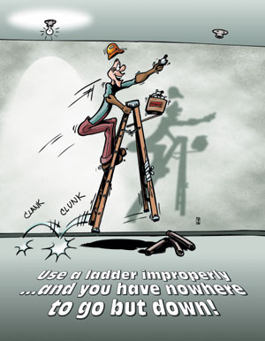  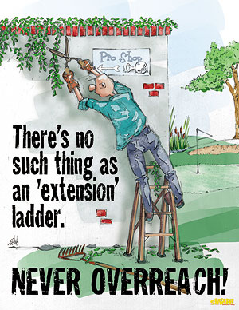

__________________________________________________________________________
Workplace Hazardous Materials Information System

What is WHMIS?  WHMIS is a short form for Workplace Hazardous Materials Information System, and is a Canada-wide program that regulates information about potentially harmful industrial chemicals, known as “controlled products”. It was created in response to the Canadian workers' right to know about the safety and health hazards that may be associated with the materials or chemicals they use at work. WHMIS became law October 31, 1988.  There are three key components:  - Team Member Training – Under your Right to Know, your employer must provide training, instruction and information about any potentially harmful material you may contact at work. Do not use any chemical unless you have received specific training on how to do so safely.  - Product Warning Labels – Team Members must be able to immediately see that a hazard is present. Therefore, all chemicals that are controlled under WHMIS and in their original containers must carry a WHMIS warning label that includes WHMIS warning symbols.  - Material Safety Data Sheets (MSDS) – Suppliers must provide detailed information to employers and Team Members about hazardous WHMIS products used in Canadian workplaces.  WHMIS Warning Symbols  There are 8 distinctive warning symbols:  Compressed Gas  Can explode and take off like a rocket. |  | 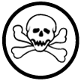      Oxidizing Material  Will feed oxygen into any fire, making it larger and hotter.  Flammable and Combustible Material  Can burst into flames very suddenly if container is damaged or misused.  Materials Causing Immediate and Serious Toxic Effects  Will cause immediate and serious poisoning.  Materials Causing Other Toxic Effects  Can cause slow poisoning and long-term illness.  Biohazardous Infectious Material  Can give you a serious infectious disease.  Corrosive Material  Can seriously harm your eyes and burn your skin.  Dangerously Reactive Material  Can explode from vibration, shock or sudden temperature change.

WHMIS Labels  There are two kinds of WHMIS labels – supplier labels and workplace labels.  Supplier Labels  The suppliers of industrial chemicals controlled under WHMIS must attach a supplier label on the container before the material is shipped to the workplace.  This label must have a distinctive border, be written in English and French, and show:  Product Identifier: By chemical, generic, trade, brand or code name.  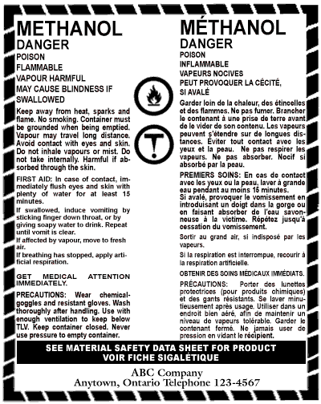  Hazard Symbol(s)  First Aid Measures: To be taken incase of acute exposure.  Precautionary Measures: The essential measures to be taken when using or handling the product.  Risk Phrases: Explains nature and risk of hazard.  Supplier Identifier: Name of supplier of the controlled product.  Reference to an MSDS: A statement to indicate that an MSDS is available. |  | Workplace Labels  Workplace labels must be put on any hazardous chemical transferred from its original container into a new one.  A workplace label must include:  - The name of the material.  - Safe handling instructions.  - The availability of an MSDS.  Material Safety Data Sheets  A Material Safety Data Sheet (MSDS) is a document that contains information about the potential health effects of exposure to the chemical and how to work safely with it. It contains hazard evaluations on the use, storage, handling and emergency procedures all related to that material. The MSDS contains much more information about the material than the label and it is prepared by the supplier. It is intended to tell what the hazards of the product are, how to use the product safely, what to expect if the recommendations are not followed, what to do if accidents occur, how to recognize symptoms of overexposure, and what to do if such incidents occur.  Your employer is required to ensure that all MSDSs are readily available in your workplace. They should be stored near where hazardous materials are used or kept. MSDSs must be updated every 3 years and whenever new information becomes available.

The information provided below explains each of the headings on a material safety data sheet.  PRODUCT INFORMATION  - The name, address and emergency telephone number of the manufacturer and supplier.  - Product identifier (name).  - What the product is used for.  HAZARDOUS INGREDIENTS  - Identity and concentration of hazardous ingredients.  PREVENTATIVE MEASURES  - Personal protective equipment to be used.  - Specific engineering controls required.  - Procedures in case of a leak or spill.  - Waste disposal methods.  - Handling and storage procedures.  PHYSICAL PROPERTIES  - The physical state - gas, liquid or solid.  - Odour and appearance.  TOXICOLOGICAL PROPERTIES  - Route of entry into the body, including skin contact or absorption, eye contact, inhalation or ingestion.  - Effects of acute and chronic exposure.  - Exposure limits.  FIRST AID MEASURES  - Specific first aid measures in the event of contact, inhalation or ingestion.  FIRE AND EXPLOSION DATA  - Description of fire hazards.  - Means of putting out fire.  - Other information such as flashpoint and explosion data.  REACTIVITY DATA  - Stability of product.  - Conditions under which a product is chemically unstable.  - Conditions of reactivity. |  |  | PREPARATION INFORMATION  - Name and phone number of the group, department or person responsible for preparing the MSDS.  - The date the MSDS was prepared.  Instead of these nine headings, your MSDSs may have the 16-item international format. Although MSDSs must contain this information, they do not all look the same – each supplier designs its own documents.  You should always:  - Check the MSDS when handling, mixing, using or storing hazardous materials, or when cleaning up spills or disposing of hazardous materials.  - Use all controls and procedures mentioned in the MSDS.  - Provide MSDSs to firefighters, paramedics and other personnel who respond to an emergency at your workplace.  You can protect yourself from these substances by:  - Recognizing the Hazard – recognizing the WHMIS symbols that identify hazardous substances.  - Assessing the Hazard – reading the MSDS.  - Controlling the Hazard – at the source, along the pathway and at the worker.  - Controls at the Source: This is the best place to control hazards, and should always be considered as the first option. It completely removes the hazard. Eg. Substitute one chemical for a less hazardous one.  - Along the Path: Change the work practice or equipment to make the job safe. Eg. Safe work procedures and training.  - At the Worker: Providing workers with Personal Protective Equipment (PPE).  - Knowing what to do if you or a co-worker is overexposed to toxic fumes or hazardous substances.
The Air We Breathe  If you breathe in contaminated air, you run the risk of serious illness or injury, or even death. Three symbols in particular help you identify materials that can affect the air you breathe.  Materials Causing Immediate &  Serious Toxic Effects  Materials Causing Other Toxic Effects  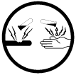Corrosive Material  Fire and Explosion  Four of the WHMIS symbols in particular help you identify chemicals and materials that can explode or cause serious fire.  Compressed Gas  Flammable and Combustible Material  Oxidizing Material  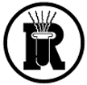Dangerously Reactive Material  Eyes and Skin  There may be substances that you use on the job that have the potential to poison you, burn your skin or eyes on contact, make you sick if swallowed or transferred from your hands to food, drink or cigarettes or give you a serious infectious disease or illness. |  | Four WHMIS symbols in particular help you identify materials that can injure you or cause sickness and disease if they come into contact with your skin, eyes, or are accidentally swallowed.  Materials Causing Immediate &  Serious Toxic Effects  Materials Causing Other Toxic Effects  Corrosive Material  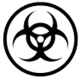 Biohazardous Infectious Material  If something goes wrong, immediate response to exposure to a poisonous, corrosive, or infectious substance is essential. Have the MSDS on hand for emergency personnel.  A True Story  “The Toronto District School Board was convicted of contravening the training provisions of the Ontario WHMIS Regulations, section 7(1), following the death of a school janitor who had mixed a toilet bowl cleaner and a sanitizer. The part-time janitor, who had worked for the board for more than 20 years, died from exposure to chlorine gas created by the mixing of the two products. The worker had received WHMIS training 13 years earlier. However, the worker had not been specifically instructed as to the contents of the MSDSs for the products, not on the procedures for their safe use and handling or procedures in case of emergency.” The school board was fined $150,000.  -ACCIDENT PREVENTION September 2005
__________________________________________________________________________
Conclusion

You have a very important part in health and safety on the job.

On the job, remember to:

- Work in a safe and healthy way.
- Follow procedures and instructions intended to keep you and your workplace safe and healthy.
- Be on the lookout for hazards.
- Correctly report any hazards or health and safety concerns to your Manager right away.
- Know what action to take when you see unsafe work practices or hazards.
- Know what to do in an emergency.
- Use the right PPE and use it in the right way.
- Don’t be afraid to talk to your Manager.
- Work as a team to Recognize, Assess and Control (RAC) hazards.
- Keep on learning about health and safety on the job.
- Get involved in health and safety. Protect yourself and your friends.

