**PRODUCT**



**TECHNICAL FILE**

Laboratori Collagenil is the synthesis of our dermatological and pharmaceutical experience for the benefit of aesthetic medicine.



We use the most modern technologies, without forgetting the continuity and values of the history and roots of our company.

THE PRIVILEGE OF TELLING

AN IMPORTANT STORY

Laboratori Collagenil is defined by its dedication to our clients’ continuous and evolving needs and providing exceptional value. Over time, we have consolidated our expertise with ongoing R&D in close collaboration with doctors and researchers.

**ALL LABORATORI COLLAGENIL PRODUCTS ARE ENTIRELY FORMULATED AND MADE IN ITALY**



INNOVATIONS THAT CREATE SHARED VALUE

We have always felt the obligation and responsibility to research cutting-edge formulations that make the best results more accessible; aiming to improve and harmonize your appearance while maintaining the utmost safety.

NO COMPRIMISE ON EXCELLENCE

Our formulation and production processes follow a very scrupulous approval system, during which we validate the quality, safety, and effectiveness guaranteed on all our products.

Safety and effectiveness guide our choices, from scouting raw materials to packaging. We carefully select our active ingredients after thorough research and rigorous analysis. All our research is developed to obtain the best, without compromise, in a perfect balance between science and wellness.

OUR PHILOSOPHY

### At Collagenil, we believe that beauty is balance and harmony.

We created a collection of cosmeceuticals, selected after careful research, inspired by our commitment to wellness, and supported by science.

We offer the best cosmetic and medical knowledge combined with highly active products.

### A perfect encounter between aesthetic medicine and cosmetics for your beauty needs.

Laboratori Collagenil collections are ideal when combined with aesthetic medicine treatments, since they contribute to maintaining a timeless and harmonious beauty.

Our products integrate, complement, and support even the most advanced treatments in aesthetic medicine.

In close collaboration with doctors and researchers,

we thrive on finding the ideal combination of medical treatments and at-home skincare formulations.

Laboratori Collagenil collections help preserve the results of aesthetic medicine treatments longer and contribute to maintain a timeless and harmonious beauty.

### Taking care of your skin in one single gesture.

Collagenil formulations are created and designed to be specific and targeted solutions that differ according to skin type and needs.

Collagenil collections are formulated for easy use and developed from sophisticated ingredients that undergo thorough clinical analysis and studies, offering visible results in a short time.

Laboratori Collagenil cosmeceuticals are committed to offering combinations of highly-concentrated active ingredients, which rapidly and visibly help improve the most common imperfections.

### Effective and synergistic formulations for wellness and skincare.

We study every possible combination of active ingredients to create perfect formulas that make the synergy between the ingredients even more effective.

When ingredients are combined, their actions work together, so one improves the performance of the other, creating effective, complete, and safe cosmeceuticals.

Complicated beauty routines are no longer a problem.

All it takes is a single gesture to improve your skin imperfections.

The effectiveness of Laboratori Collagenil products is certified by the SIME, Italian Society of Aesthetic Medicine.

All Laboratori Collagenil products are formulated and made in Italy.

# CLEANSING

Extra Gentle Cleanse.

The products in our Laboratori Collagenil Cleansing line are formulated to ensure a comprehensive and gentle cleansing action while respecting and preserving your skin’s hydrolipidic film, which is the first natural protection from external agents.

Our cleansing line is developed to adapt to all skin types and is available in different formulations. These formulations delicately cleanse, hydrate, or exfoliate as needed to help your skin regain and maintain its natural balance while preventing dryness that can occur with other harsh cleansing agents.

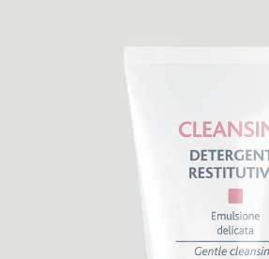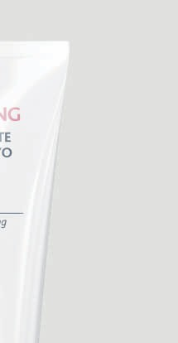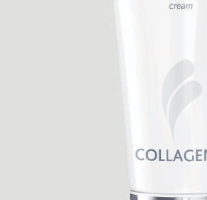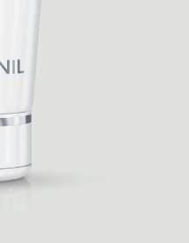

## Detergente Restitutivo

LIPID HYGIENE TREATMENT

Collagenil Detergente Restitutivo is a **cream cleanser** specifically aimed for dry, sensitive, delicate, or reddened skin.

**Size: 6.76 fl oz / 200 mL Sensoriality**

DENSITY PERMANENCE FRAGRANCE

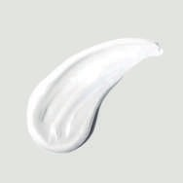

**Product texture**

#### WHY CHOOSE IT

* Gently cleanses
* Performs a soothing and softening action
* Removes impurities
* Does not alter the hydrolipidic membrane

#### HOW TO USE

Apply to dry skin all over the face with gentle circular motions, from the center moving outward. To remove make-up, place the product on a cotton pad and rub over areas with make-up. Rinse with abundant lukewarm water.

* **Ingredients**

**Fluid Triglycerides**- Coconut oil – Excellent emollient and skin replenishing on the surface, stops moisture loss.

**Phyto Extract Complex** – Anti-oxidant, removes excess oil, dead skin cells and gives a brighter complexion.

**Sweet Almond** – Moisturising, nourishing and soothing. Enhances the skin’s elasticity.

**Jojoba Seed Oil** – Excellent for sensitive skin or skin prone to breakouts.

**Dimethicone** – Helps moisturize the skin. Helps skin conditions like Eczema.

**Olive Fruit Oil** – Cleans the skin.

**Mallow** – Deeply Cleanses, plumps and repairs, strengthens the skin.

**Aloe Vera** – Anti-inflammatory, anti-bacterial and antiseptic.

**Citric Acid** – Exfoliating adjusts the skin’s Ph.

**Soluble Collagen** – Reduces irritation.

**Vitamin E** – Anti-oxidant

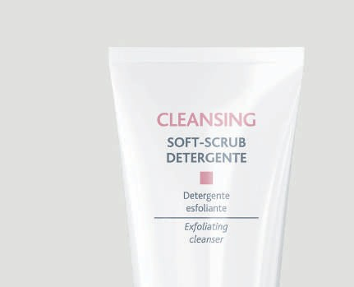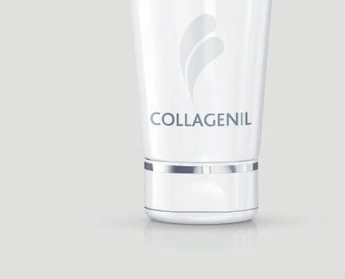

## Soft-Scrub Detergente

EXFOLIATING CLEANSER WITH SCRUBBING EFFECT

Soft-Scrub Detergente is a **cleansing cream** with **scrubbing action** that gently exfoliates while complying with the

skin’s PH.

**Size: 6.76 fl oz / 200 mL Sensoriality**

DENSITY PERMANENCE FRAGRANCE

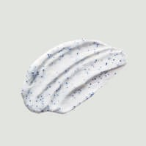

**Product texture**

#### WHY CHOOSE IT

* Gently exfoliates
* Performs a selective extra gentle cleansing action
* Frees skin of impurities and dead cells
* Acts with a soothing and refreshing activity
* Does not alter the hydrolipidic film

#### HOW TO USE

Apply a small quantity of the product on damp skin and massage with circular and gentle strokes, starting from the center and moving outwards, avoiding the eye area. Rinse with a generous amount of lukewarm water.

*  **Ingredients**

**Fluid Triglycerides**- Coconut oil – Excellent emollient and skin replenishing on the surface, stops moisture loss.

**Phyto Extract Complex** – Anti-oxidant, removes excess oil, dead skin cells and gives a brighter complexion.

**Sweet Almond** – Moisturising, nourishing and soothing. Enhances the skin’s elasticity.

**Jojoba Seed Oil** – Excellent for sensitive skin or skin prone to breakouts.

**Dimethicone** – Helps moisturize the skin. Helps skin conditions like Eczema.

**Olive Fruit Oil** – Cleans the skin.

**Mallow** – Deeply Cleanses, plumps and repairs, strengthens the skin.

**Aloe Vera** – Anti-inflammatory, anti-bacterial and antiseptic.

**Citric Acid** – Exfoliating adjusts the skin’s Ph.

**Soluble Collagen** – Reduces irritation.

**Vitamin E** – Anti-oxidant

**Micro Particles** – Gently exfoliating

# BIO LONGEVITY

Reduce.

Stimulate. Revitalize.

Bio Longevity is a comprehensive and effective revolutionary line that helps reduce the signs of aging. The products in this line rely on the synergy of next- generation active ingredients to improve wrinkles and aging processes, combining a wrinkle-reducing action with a revitalizing and stimulating effect. It is essential to take action after the age of 30, when the typical degenerative influence of chronological aging also begins altering the inner layers of your skin.

Our Bio Longevity products can help stimulate the production of hyaluronic acid and collagen through fibroblasts. When the production of these elements slows down and degenerates, fine wrinkles appear, and skin begins to sag.

**Protetivo**

**Giorno**

**Ingredients:**

**Phyto Extract Bioactive** – Anti-oxidant, improves the ATP synthesis and activates cellular metabolism.

**Squalane –** Anti-oxidant an hydrating

**Arginine –** Helps with Collagen synthesis

**Vitamin C** – Stimulates the production of collagen.

**Lupine Extract –** Swiss pear that stimulates collagen and elastin synthesis.

**Betaine –** Is a humectant that hold water in the skin.

## Serum

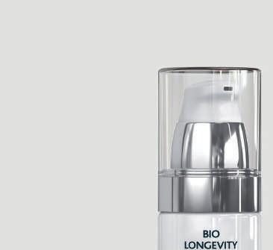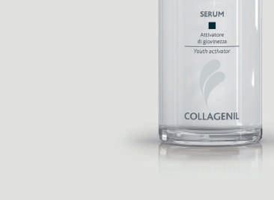

OVERALL ANTI-AGEING SERUM WITH BIOSTIMULATING ACTION

Bio Longevity Serum is a specific **intensive facial treatment** with a comprehensive **anti-aging action** designed to prevent and correct the signs of skin aging.

**Size: 1.01 fl oz / 30 mL Sensoriality**

DENSITY PERMANENCE FRAGRANCE

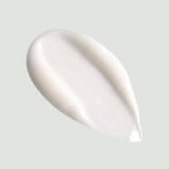

**Product texture**

#### WHY CHOOSE IT

* Fights wrinkles and loss of tone
* Protects the skin from the visible effects of free radical damage
* Provides antioxidant protection
* Counteracts cell degeneration
* Promotes new collagen and thioredoxin synthesis

#### HOW TO USE

Apply morning and evening to face, neck, and décolleté, following the opposite direction of wrinkles until completely absorbed.

* **Ingredients**

**Phyto Extract Bioactive** – Anti-oxidant, improves the ATP synthesis and activates cellular metabolism.

**Blue Algae**  – Strong brightening (Vit C) effect. Inhibits tyrosinase an enzyme responsible for the formation of melanin.

**Vitamin C** – Stimulates the production of collagen.

## Stimolante Antietà

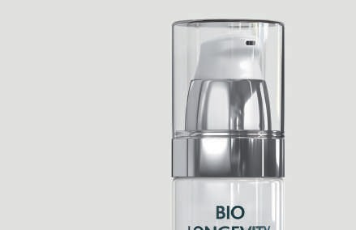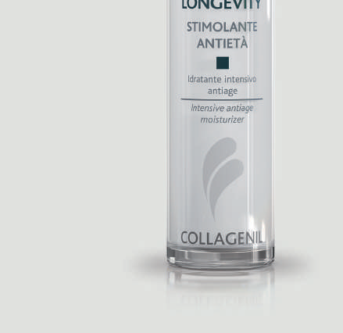

INTENSIVE ANTI AGING REVITALIZING TREATMENT

Collagenil Bio Longevity Stimolante Antietà is an **anti-aging treatment** with anti-age action, indicated to those who actively want to fight the signs of aging.

**Size: 1.69 fl oz / 50 mL Sensoriality**

DENSITY PERMANENCE FRAGRANCE

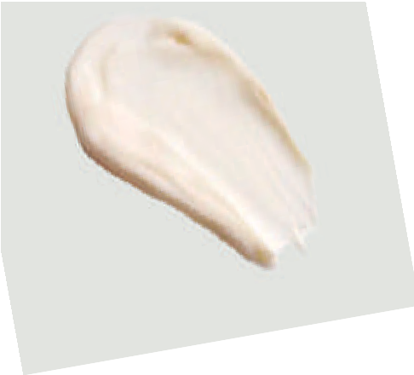**Product texture**

#### WHY CHOOSE IT

* Slows down skin aging
* Reduces wrinkles
* Fights against loss of tone and brightness
* Performs an antioxidant activity
* Gives the skin firmness and elasticity

#### HOW TO USE

Apply day and night on face, neck, décolleté and massage until completely absorbed.

* **Ingredients**

**Peptide Complex** – Tripeptide 5 made from amino acids, firms the skin, smooths wrinkles.

**Soyabean**  – Tightens the skin and reverses the effects of sun damage. Helps menopausal skin by substituting estrogen. Reduces fine lines.

**Vitamin E** – Anti-oxidant.

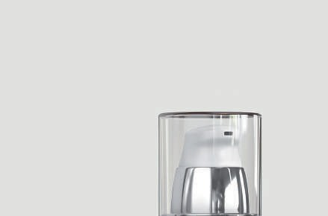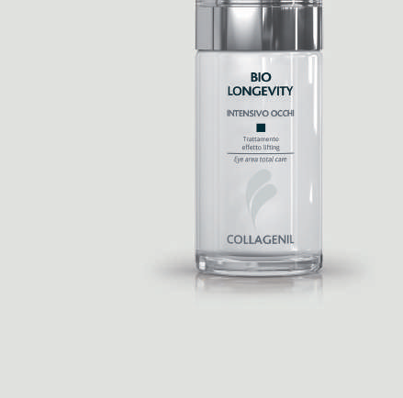

## Intensivo Occhi

EYE REGION BIOSTIMULATING AND REVITALIZING

Collagenil Intensivo Occhi is a cosmeceutical treatment for the eye contour area, indicated for skin that’s **thinned** and marked by **wrinkles,** and for those who want to restore freshness and brightness to the eyes.

**Size: 1.01 fl oz / 30 mL Sensoriality**

DENSITY PERMANENCE FRAGRANCE

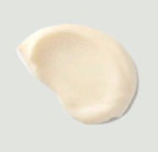

**Product texture**

**WHY CHOOSE IT**

* Reduces wrinkles
* Fights loss of elasticity
* Provides tone and firmness
* Deeply moisturizes
* Restores freshness to the eye area

#### HOW TO USE

Apply a small amount of the product morning and evening on the lower eyelid and the fixed upper eyelid (upper arch), patting from the inner corner of the eye and continuing down along the brow line.

* **Ingredients**

**Jojoba Seed Oil** – Excellent for sensitive skin or skin prone to breakouts

**Phyto Extract Complex** – Anti-oxidant, removes excess oil, dead skin cells and gives a brighter complexion.

**Avocado** – Moisturising

**Ceramides x 3** – Intercellular glue within the cells and lipid barrier

**Easyliance** – Cosmetic lifting to the skin with fast and visible results.

**Caffiene** – Reduces puffiness by speeding up lymphatic drainage.

**Allatoin** – Is a humectant takes moisture from the air and puts back into the skin.

**Aloe Vera** – Anti-inflammatory, anti-bacterial and antiseptic.

**Cholesterol** – Smoothes out wrinkles, strengthens the skin’s barrier and protects from the enviroment.

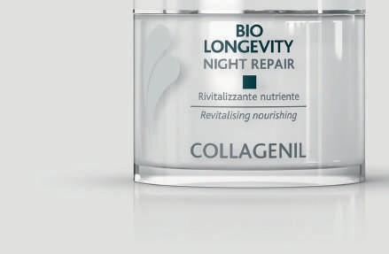

## Night Repair

GLOBAL ANTI-AGING NIGHT CREAM WITH BIOSTIMULATING AND REDENSIFYING ACTION

Collagenil Night Repair is a multifunctional **night treatment** with specific overall **anti-aging** and **firming** treatment, which helps correct skin relaxation, loss of density, and elasticity during the night when the skin is more responsive.

**Size: 1.69 fl oz / 50 mL Sensoriality**

DENSITY PERMANENCE FRAGRANCE

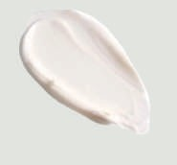**Product texture**

#### WHY CHOOSE IT

* Fights fine lines and wrinkles
* Provides a youthful, relaxed, and fresh appearance when you wake up
* Restores skin firmness
* Effective against sagging skin
* Hydrates

#### HOW TO USE

Apply daily in the evening to face, neck, and décolleté and massage until completely absorbed.

#### Ingredients:

#### Phyto Extract Bioactive – Anti-oxidant, improves the ATP synthesis and activates cellular metabolism.

**Tetrapeptide-9 –** Increases the production of collagen.

**Tetrapeptide-11 –** targets Collagen XVII in the dermal-epidermal junction, which is a major ingredient involved in the modulation of epidermal cell proliferation and adhesion and sends signals to the growth factors.

# LIFTENSIVE

Lift.

Firm. Redensify.

The products in our Laboratori Collagenil Liftensive line offer a lifting effect, combined with a long-lasting firming result, for the deeper layers of your skin to balance your facial features.

Through an innovative pool of peptides, Liftensive mimics the methods used in mini facelifts, which limit facial muscles from contracting. At the same time, synergistic active ingredients help stimulate and strengthen all the essential processes required for considerably improving the appearance of the superficial skin layer.

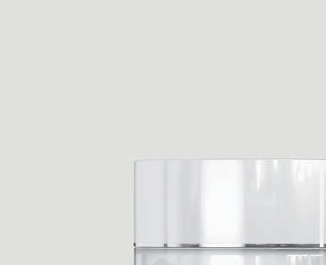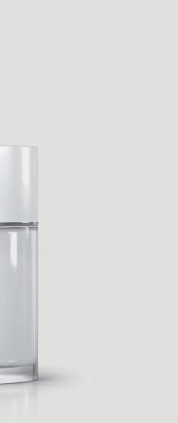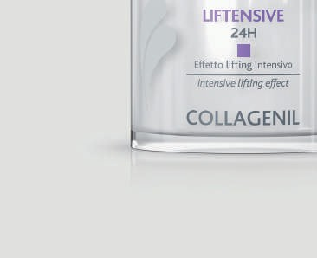

## 24H

ULTRA-LIFTING TREATMENT

Collagenil Liftensive 24H is a cosmeceutical cream treatment, particularly indicated for those who want an **ultra-lifting effect** on expression lines and **sagging skin.**

**Size: 1.69 fl oz / 50 mL Sensoriality**

DENSITY PERMANENCE FRAGRANCE

|  |  |  |  |  |
| --- | --- | --- | --- | --- |
|  |  |  |  |  |
|  |  |  |  |  |

**Product texture**

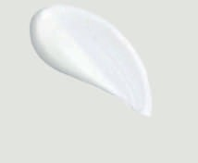

#### WHY CHOOSE IT

* It has a light and creamy texture
* Features a high concentration of peptides
* Smooths expression lines
* Provides deep hydration to the skin
* Firms and recompacts the skin tissue

#### HOW TO USE

Apply the lifting effect cream morning and evening on face, neck, and décolleté and massage until completely absorbed.

#### 

#### Ingredients:

#### Phyto Extract Bioactive – Anti-oxidant, improves the ATP synthesis and activates cellular metabolism.

**Hexapeptide-8** minics botulinum toxin, breaks down the communication to the muscle. Blocks the neurotransmitors.

**Pentapeptide-18** Blocks neuro-muscular connection, preventing neurotransmitter releasee and signal transfer from nerve to muscle.

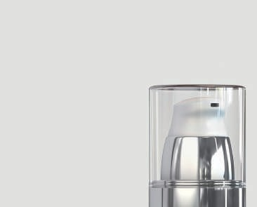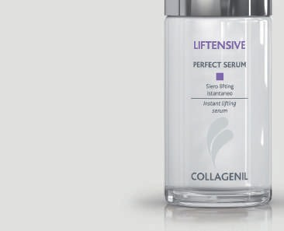

*Gatuline® Renew is a Registered Trademark of Gattefossé SAS*

## Perfect Serum

IMMEDIATE UPLIFTING & FIRMING SERUM

Collagenil Liftensive Perfect Serum is a light, highly concentrated **serum** developed to tackle the **signs of aging.**

**Size: 1.01 fl oz / 30 mL Sensoriality**

DENSITY PERMANENCE FRAGRANCE

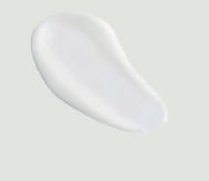**Product texture**

#### WHY CHOOSE IT

* Reduces expression lines and sagging skin
* Minimizes loss of skin elasticity and thickness
* Stimulates the cell renewal process
* Restores skin tone and firmness
* Gives the face a defined and harmonious oval shape

#### HOW TO USE

Apply morning and evening to face, neck, and décolleté, following the direction of the wrinkles until completely absorbed.

* **Ingredients:**

**Gatuline Renew** – kick starts the cellar renewal process from basal layer to stratum corneum. The epidermis is rebuilt from within.

**Neuropepetide Complex**:

* **Pentapeptide-18** Blocks neuro-muscular connection, preventing neurotransmitter releasee and signal transfer from nerve to muscle.
* **Hexapeptide-8** minics botulinum toxin, breaks down the communication to the muscle. Blocks the neurotransmitors.

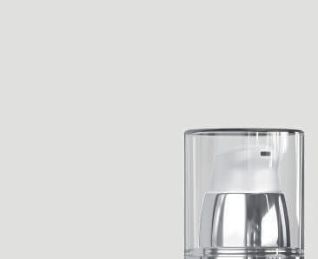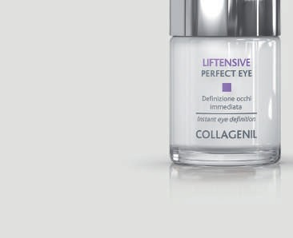

## Perfect Eye

LIFTING SERUM FOR EYELID DEFINITION

Liftensive Perfect Eye is a cosmeceutical treatment indicated to **firm** and **tone** the eye contour area.

**Size: 0.51 fl oz / 15 mL Sensoriality**

DENSITY PERMANENCE FRAGRANCE

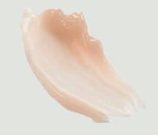**Product texture**

#### WHY CHOOSE IT

* Instantly smoothes out lines and wrinkles
* Tones and firms the peri-ocular area
* Combats droopy eyelids
* Reduces the dark coloration typical of dark circles under the eyes
* Slows down the physiological process of dermal sagging

#### HOW TO USE

Apply a small amount of product morning and evening to the lower eyelid and upper eyelid (upper arch), start pattingat the inner eye corner and continuing downward following the brow line.

* **Ingredients:**
* **Pentapeptide-18** Blocks neuro-muscular connection, preventing neurotransmitter releasee and signal transfer from nerve to muscle.

**Tetrapeptide – 5** Reduces puffiness, relieves vascular pressure by improving the vascular system.

# DRY & SENSITIVE

Moisturizing.

Protecting. Hydrating.

Dry & Sensitive is the cosmeceutical solution of Collagenil Laboratories that ensures the correct balance between moisturizing and protective properties, which is essential to improve the look of dehydrated, fragile, and damaged skin. Dry & Sensitive ensures intense hydration and protects the skin by reinforcing the skin’s natural moisture barrier. The synergy between hydrating and moisturizing ingredients makes a face look healthier, smoother, and well-nourished.

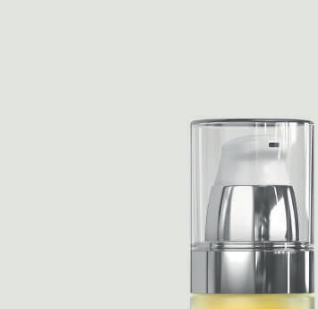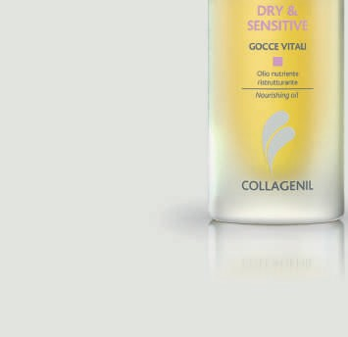

## Gocce Vitali

MULTI-RECOVERY OIL

Dry & Sensitive Gocce Vitali is a **fat-based treatment** with a light texture, specifically designed to restore, nourish and elasticize **dry and sensitive skin.**

**Size: 1.01 fl oz / 30 mL Sensoriality**

DENSITY PERMANENCE FRAGRANCE

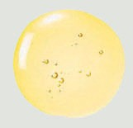**Product texture**

#### WHY CHOOSE IT

* Rebalances the natural moisture factor (NMF)
* Increases the flexibility of the skin fibers
* Boosts the action of the usual treatment if mixed with it
* Reduces wrinkles
* Refines the texture of the face

#### HOW TO USE

Apply and massage a small amount onto the face, neck, and décolleté in the evening. Or mix in the palm of your hand with your day or night cream.

 **Ingredients:**

**Filaggririn Multi Complex:** is a protein mainly in the stratum granulosum cells of the epidermis which builds the barrier function.

**Vitamin A & E –** Anti-oxidants

**Soyabean**  – Tightens the skin and reverses the effects of sun damage. Helps menopausal skin by substituting estrogen. Reduces fine lines.

**Jojoba Seed Oil** – Excellent for sensitive skin or skin prone to breakouts

# RE-PULP

Plump.

Restore.

Re-Pulp is a complete facial line with products that help improve facial feature volume in the deeper layers of your skin with immediate plumping action.

Hyaluronic acid can improve the volume and shape of essential features in its various concentrations, weights, and synergy with active ingredients, giving a more firm and youthful-looking appearance.

The primary benefit for your skin is to improve overall firmness, volume, and smoothness, all in a single gesture.

C

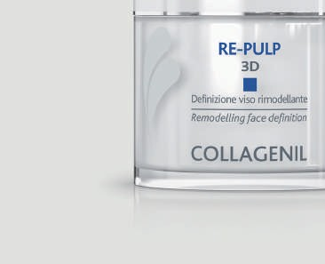

*Ultra Filling Spheres™ is a Registered Trademark of BASF Group*

## 3D

MULTI-CORRECTIVE TREATMENT WITH A PLUMPING FILLER AND REGENERATING ACTION

Collagenil Re-Pulp 3D is a cosmeceutical product ideal to improve the appearance of skin that manifests **loss of tone, volume,** and **localized skin emptying,** especially on the cheekbones, cheeks and nasogenial clefts, and those **deep wrinkles** that start from the nostrils and reach the sides of the mouth.

**Size: 1.69 fl oz / 50 mL Sensoriality**

DENSITY PERMANENCE FRAGRANCE

**Product texture**

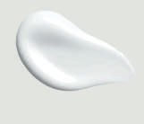

#### WHY CHOOSE IT

* Features a mix of active ingredients with plumping action
* Helps replenishing tissues
* Counteracts skin sagging
* Reduces the appearance of wrinkles
* Helps features regain their natural volumetric harmony

#### HOW TO USE

Apply cream morning and evening to face, neck, and décolleté and massage until completely absorbed.

* **Ingredients:**
* **Acmella Oleracea Extract** -Natural Botox from Lavender.
* **Jasmine and Rose wood** – Cent of the product.

**Filler Spheres:**  Cross linked Hyaluronic Acid that is dehydrated 50 times its size the n encapsulated to enter the skin , expands with water in the skin give a filling effect to wrinkles.

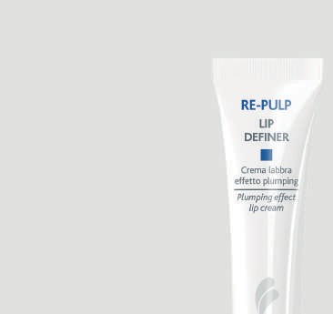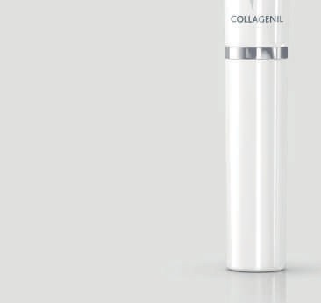

## Lip Definer

PLUMPING EFFECT LIP BALM

Collagenil Re-Pulp Lip Definer is a concentrated, soft and rich **lip balm** developed specifically to **plump** and give lips a **smooth** and **full look.**

**Size: 0.34 fl oz / 10 mL Sensoriality**

DENSITY PERMANENCE FRAGRANCE

**Product texture**

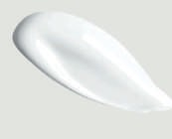

#### WHY CHOOSE IT

* Volumizes
* Redefines lip contours
* Fills in fine lines and creases
* Suitable for thin lips and those who want extra volume
* Prepares for long-lasting makeup

#### HOW TO USE

Apply to lips, allow to absorb before applying lipstick, and again apply over lipstick.

#### 

#### Ingredients:

#### Phyto Extract Bioactive – Anti-oxidant, improves the ATP synthesis and activates cellular metabolism.

**Filler Spheres:**  Cross linked Hyaluronic Acid that is dehydrated 50 times its size the n encapsulated to enter the skin , expands with water in the skin give a filling effect to wrinkles.

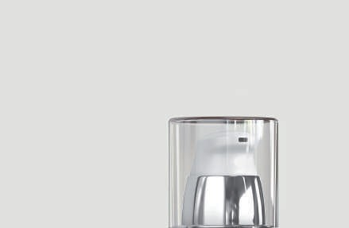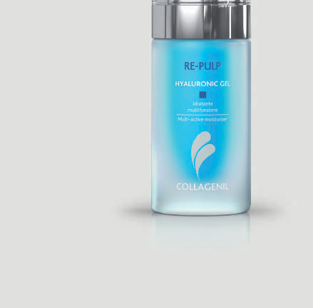

## Hyaluronic Gel

HYALURONIC ACID BOOSTER SERUM WITH PLUMPING AND ANTIOXIDANT ACTION

Collagenil Hyaluronic Gel is indicated for **all skin types,** especially in the presence of dull complexion and skin exposed daily to the damage of oxidative stress.

**Size: 1.01 fl oz / 30 mL Sensoriality**

DENSITY PERMANENCE FRAGRANCE

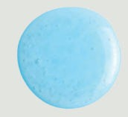**Product texture**

#### WHY CHOOSE IT

* Volumizes and moisturizes
* Provides a plumping effect
* Boosts the effectiveness of your usual moisturizers and anti-wrinkle treatments
* Tightens, relaxes, and brightens the skin
* Minimizes fine lines

#### HOW TO USE

Apply morning and evening to face until fully absorbed.

#### Ingredients:

#### Hyaluronic Acid: Three molecular weight HA, deeply hydrating all layers of the skin.

#### Panthenol: Pro Vitamin B5 improves the appearance of the skin.

#### Vitamin C -Stimulates collagen production

.

# RELUX

Brightening.

Smoothing. Lightening.

The Relux line is formulated to help reduce the appearance of dark spots and wrinkles while refining the skin’s tone and texture of the face. Its formula and advanced ingredients help enhance the skin’s brightness and create a smoother and more even-toned look.

Through the synergy of the exfoliants combined with the latest generation ingredients, the formulations of the Relux line deeply hydrate and reduce the appearance of imperfections and wrinkles. The result is a smooth and homogenous complexion for a more radiant look.

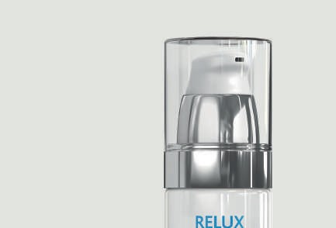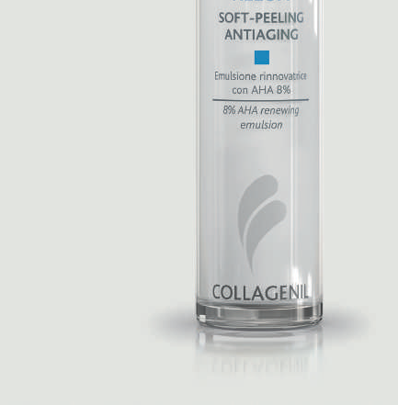

## Soft-Peeling Antiaging

8% GLYCOLIC ACID EMULSION

Relux Soft-Peeling Antiaging is a **facial exfoliating treatment** that targets the most common skin blemishes due to chrono-aging: wrinkles, dyschromia, and hyperpigmentation.

**Size: 1.69 fl oz / 50 mL Sensoriality**

DENSITY PERMANENCE FRAGRANCE

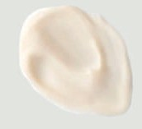**Product texture**

#### WHY CHOOSE IT

* Removes superficial cells responsible for a worn and dull appearance
* Stimulates the generation of new cells
* Reactivates the processes of collagen and elastin synthesis
* Hydrates and smoothens the epidermis
* Helps the skin regain an even complexion

#### HOW TO USE

After thoroughly cleansing and drying the skin, apply in the evening with a soft massage on the face. Carefully avoid the eye area, mucous membranes, and nasal creases. In the morning, cleanse well, and use appropriate sunscreen.

#### Ingredients:

#### 8% Glycolic Acid – Exfoliates the skin improving cellular turn over.

* **Vitamin A & E –** Anti-oxidants
* **Citric Acid** – Exfoliating adjusts the skin’s Ph.

#### Hydrolyzed Collagen: Amino Acids that help with the formation of collagen and elastin fibres.

* **Aloe Vera** – Anti-inflammatory, anti-bacterial and antiseptic.
* **Jojoba Seed Oil** – Excellent for sensitive skin or skin prone to breakouts.

#### Centella Asiatica – Penny Wart keeps the skin hydrated.

#### Mallow: Reduces redness.

#### Hydrolyzed Elastin: Is a humectant that holds moisture in the skin.

#### Vitamin C: Regulates Melanin in the skin and stimulates collagen production.

#### Horse Chesnutt:Whitens pigmentation.

.

# INTENSE

Clinical skincare.

A collection selected after careful research that’s formulated from sophisticated, active ingredients and complex molecules evaluated through in-depth clinical analyses and studies, capable of responding to the needs of the most demanding customers.

Designed to support, integrate and enhance the effects of the beauty routine or be an alternative to it.

Designed to be easy to use, these home treatments guarantee visible results in a short time.

## C-30 Complex

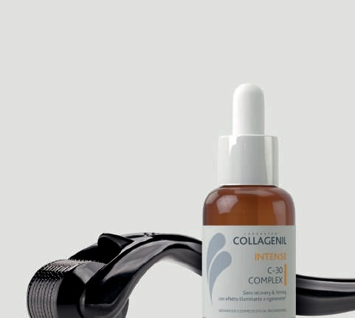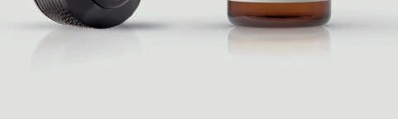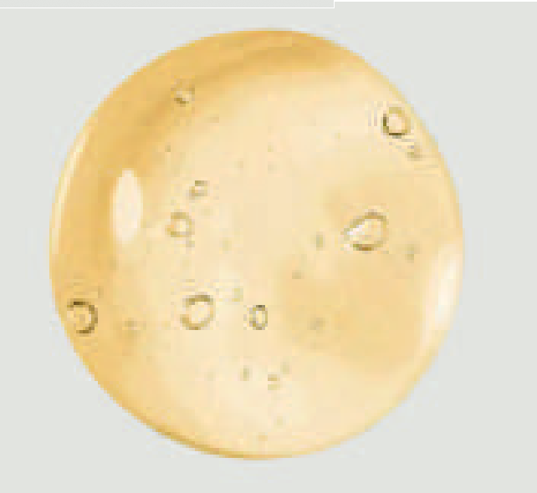

BRIGHTENING AND REGENERATING RECOVERY & FIRMING SERUM

Collagenil C-30 Complex is an ultra-concentrated 30% Vitamin C Complex recovery & firming serum designed to achieve visibly brighter, smoother, and more rested skin. Simultaneously, the high concentration of Vitamin C, low and medium molecular weight Hyaluronic Acid, and peptide complex restore the skin’s natural radiance and promote a deep moisturizing action, increasing tissue firmness and elasticity

**Size: 1.01 fl oz / 30 mL Sensoriality**

DENSITY PERMANENCE FRAGRANCE

**Product texture**

#### WHY CHOOSE IT

* Brightens the skin
* Reduces wrinkles
* Protects against oxidative stress
* Has a toning and firming effect
* Intervenes against dull complexion

#### HOW TO USE

Apply to the face, neck, and neckline. Massage from the center outward and from the bottom upward. Avoid direct contact with eyes. Keep out of reach of children.

#### WHAT IT CONTAINS

* **Vitamin C complex 30%** – brightening and antioxidant action
* **Hyaluronic acid** – moisturizing action
* **Peptides** – fight the signs of aging

#### HOW TO APPLY

C-30 Complex is designed to be used in conjunction with and in support of aesthetic medicine treatments or as a unique all-in-one pre- and post-treatment solution. Especially useful is Collagenil C-30 Complex’s support of derma-rolling, it penetrates into the deeper layers of the epidermis, and further cues collagen production and the skin’s regeneration process. The simultaneous action synergy of its actives with the cueing and conveying activity of the derma-roller make this combination the ideal ally for improving skin quality.

## Resurfacing

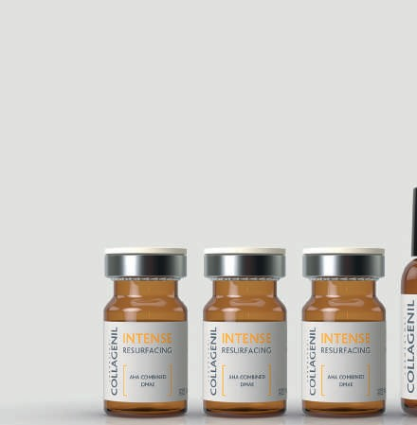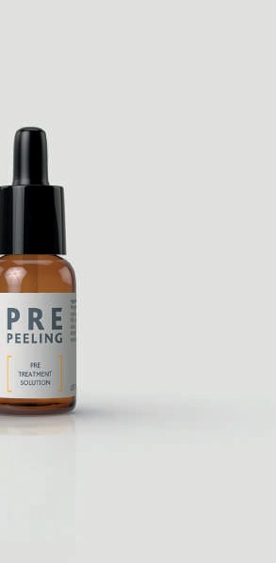

COMBINED PEELING

Collagenil Resurfacing is an advanced formulation for home use. It is designed to drastically reduce fine lines and wrinkles on the face and decollete while making the skin luminous and toned. It is made with a combined acid, and antioxidant exfoliants (Alpha Hydroxy Acid + DMAE) specifically developed to accelerate cell turnover. Specifically created to be a one-step booster to the daily beauty routine and a targeted and complete solution for skin care.

**Size: 1 bottle (Pre-Peeling, 15 mL)**

**3 bottles (Resurfacing, 5 mL)**

**Sensoriality** DENSITY PERMANENCE FRAGRANCE

**Product texture**

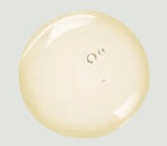

#### WHY CHOOSE IT

* Stimulates skin exfoliation
* It fights the damage of photo-aging and reduces fine wrinkles
* Acts on loss of tone, elasticity, firmness and brightness
* It gives evident and immediate results
* It is simple to apply

#### HOW TO USE

* Cleanse the area to be treated with warm water to allow the first elimination of dead cells and sebum.
* Dry the skin completely: do not apply on wet or damp skin;
* Apply the Pre-peeling solution provided in the package evenly over the entire area to be treated, using a cotton pad; wait for the solution to dry completely without rinsing. This is an essential step to ensure a homogeneous action of Collagenil Resurfacing.
* Open the vial and draw the product using the graduated pipette provided (about 2.5 mL in total).
* Apply small quantities of the product on the face, neck and décolleté; use your fingertips and make slow movements to spread the product evenly. Do not go over the part already treated.
* Avoid the eye area, the mucous membranes of the lips and nose.
* Leave on for a few minutes (5-10 minutes) depending on the sensitivity of the skin and the area of application; in case of redness, proceed immediately with rinsing with cold water.
* After a few minutes (max 10, depending on your skin type), rinse with plenty of lukewarm water.
* After the treatment, it is recommended to apply Collagenil Hyaluronic Gel to soothe the skin and hydrate it deeply.
* You can apply make-up after 24 hours from the treatment.
* It is recommended to carefully close the vial with the supplied cap after use; the remaining product will be used for the subsequent treatment and no later than 30 days after opening.
* It is advisable to apply Collagenil Resurfacing at intervals of 8/10 days until the product is used up. We suggest using it, preferably in

the months from September to May.

#### WHAT IT CONTAINS

* **AHA combined 20%**
* **DMAE**

#### HOW TO APPLY

The content of a single vial is sufficient for 2 applications; between one application and another it is recommended to wait 8/10 days. Before applying the product, it is recommended to test it on the forearm to rule out hypersensitivity reactions. Do not use in case of known incompatibility with any of the components of the preparation.

If the product gets into the eyes, wash immediately with plenty of running water, keeping the eyes wide open under the jet of water; remove any contact lenses. Do not use on skin that is not intact or in the presence of inflammation and infections in place at the application site. The treatment is also contraindicated in pregnancy and lactation.

The product contains an alpha hydroxy acid (AHA) which can increase the skin’s sensitivity to sunlight, therefore it is recommended to avoid sun exposure for up to a week after use and always use adequate sunscreen (50+ ).

Do not use the product if the container is damaged. Do not use the product after the expiration date shown on the package. Store the product in a cool place, away from sources of light and heat.

#### INGREDIENTS

**PRE PEELING:** Aqua, Glycolic acid,.

**RESURFACING:**.

* **Glycolic Acid** : Exfoliates the skin
* **Mandelic Acid** -

44875/1-USA

   

COLLAGENILUSA COLLAGENILUSA