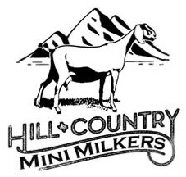
Hill Country Mini Milkers Texas Two Step
Kendall County Fairgrounds Livestock Barn – Boerne, TX
Saturday, May, 15, 2021 – Sunday, May 16, 2021
ADGA and MDGA Shows

Hill Country Mini Milkers Texas Two-Step Show
Covid Protocols

GOAL: Successfully plan and execute our show in a COVID19 positive world. This plan was developed to allow us to show while keeping our exhibitors safe. Exhibitors will adhere to all restrictions. Violators will be directed to leave the premises immediately. All restrictions apply from the time of check-in, until the time of departure as outlined herein. Each exhibitor who chooses to enter will consider the rules and agree to abide by them. While some of the COVID-19 rules may be relaxed by May 2021, we must plan for the show based on current health conditions and plan accordingly.

- Masks are highly encouraged for those exhibiting and spectators. The Livestock Barn is an open air facility but we encourage all attendees to have a mask available to wear. It will be up to each judge to determine if masks are required of exhibitors while in the ring.
- While in the ring, maintain extra spacing between exhibitors.
- Spectators are welcome. We encourage social distancing in the bleachers and entire facility.
- The goat pens are in blocks of 6 with alleys between – no minimum to purchase, but we encourage exhibitors to space out as much as they can or show out of your trailer.
- Hand sanitizer stations will be provided. Please wash your hands often, and do not touch other exhibitors animals.
- Large classes may be divided into heats if deemed necessary by the show committee.
- If you or anyone in your party is experiencing COVID symptoms, please notify the committee and do not attend the show. If you are already on the show premises, please mask up and leave immediately after notifying the committee.

