REGISTRATION FORMS
Enclosed within this pack are the registration forms required for the coming season. You will find the following forms:

Standon & Puckeridge Hares F.C. Membership and Contact Form
This form is to register the player to Standon & Puckeridge Hares Football Club and ensures that the player is then covered by the Club insurance as well as confirming the Club has all the relevant details including any medical conditions. Please ensure that all contact details are included. If details change throughout the year, please remember to notify the Club Secretary as well as the squad manager(s). Please ensure the membership form is not only completed but signed in the relevant places. It is a requirement that the details of all players and anyone who trains regularly at the Club are held on a Club register that must be made available to the F.A. if they request it. This information will NOT be available to any other individual or organisation.

Registration Fees Form

Under the payment section please add the amount of initial payment you are enclosing and how you intend to pay the remainder

League Registration

This year there are five leagues S&P Hares FC are registered to:
- Royston Crow Youth Football League (RCYFL)
- Mid Herts League (MHL)
- Cambridge & District Colts League (CDCL)
- Hertfordshire Youth League (HYL)
- Hertfordshire Girls League (HGL)

Royston Crow, Cambridge & District Colts, Hertfordshire Youth & Hertfordshire Girls Leagues

All of RCYF, CDCL, HYL & HGL use the Whole Game System (WGS) for player registration which is done electronically. All players should send a photo by email or text to the Manager or directly to the Club Secretary, new players must also include proof of identity (passport or birth certificate). WGS also requires the date of birth of the Parent/Guardian so they can verify the person associated with the young player and maintain security of the data.

Mid Herts League

MHL are now using the Whole Game System (WGS) for player registrations. See above. In addition, the MHL registration process requires independent verification of ID (passport or birth certificate). In addition to all new players & teams entering the MHL system must require this information to register regardless of whether they were registered on WGS previously.

The leagues require players to be registered by 31st July at the latest. If a team has insufficient players at this date, they may not be permitted to enter the league.

Like the Club, the leagues are staffed by volunteers and they give their time to ensure everyone is available to play by the start of the season providing the registration forms are submitted by the deadlines.

Please read through all the documents thoroughly and complete and return pages 3 and 4 plus payment to your squad manager who will check them before passing them on to the Club Secretary.

CLUB DIRECTORY
DESCRIPTION/  TOPIC | CONTACT | OFFICER | PHONE | EMAIL
Club continuity | Chris Tye | Chair | 07540 728 173 | chris.tye1810@yahoo.com
All Registration details | Andrew Price | Club Secretary | 07503 978 705 | HaresFC@outlook.com
All Club finances | Paul Greenaway | Treasurer | 07957 207 446 | greeners80@icloud.com
 | Chris Adams |  | 07753 301 299 | CJSadams@hotmail.com
Disciplinary & Grievances, Anti Bullying & Equality Policy | see web site  www.haresyouth.com
Website/Publications
Child Welfare | Laura Adams | Child Welfare Officer | 07812 669 989 | ljadams@hotmail.com
Soccer Schools | Andrew Price / Paul Greenaway |  | 07503 978 705 | HaresFC@outlook.com
TEAM CONTACTS | CONTACT | LEAGUE | PHONE | EMAIL
Academy | Phil Baines | NA |  | HaresFC@outlook.com
Under 7s | TBC | TBC
Under 8 Orange | Mick Barber | TBC | 07956 289 979 | mick.barber@fayers.co.uk
Under 9 Orange | Chris Eddy | TBC | 07538 859 586 | chriseddy047@gmail.com
Under 9 Black | Dave Beer | MHL | 07799 694 058 | dave.visibleearth@gmail.com
Under 11 Orange | Andy Blanch | RCYFL | 07961 140 598 | andyblanch78@gmail.com
Under 11 Black | Chris Adams | TBC | 07753 301 299 | CJSadams@hotmail.com
Under 11 White | Lee Cole | TBC | 07787 269 123 | lee_phoebe1@icloud.com
Under 13 Orange | Stuart Thorogood | MHL | 07469 186 092 | stuartthorogood@hotmail.com
Under 13 Black | Andrew Price | CDCL | 07503 978 705 | HaresFC@outlook.com
Under 15 Orange | Sara Sissens | MHL | 07581 231 090 | sarasissens@outlook.com
Under 15 Black | Chris Tye | CDCL | 07540 728 173 | chris.tye1810@yahoo.com

Please refer to the Club web site at www.haresyouth.com for latest amendments and additions.

REGISTRATION FEES
PLEASE NOTE THAT REGISTRATION FOR THE 2025/26 SEASON WILL NOT BE PERMITTED IF FEES REMAIN IN ARREARS TO HARES FROM THE PREVIOUS SEASON OR OTHER EVENTS

In all cases an initial payment must be made to register. The club has introduced 2 options to complete payment throughout the season:
Option 1 Subsequent payments due by 31st October and 31st January.
Option 2 Standing order from September to January for a set monthly amount.
Failure to pay the required amount on time may result in exclusion from matches and training until resolved.

Refund of fees may be available if a player leaves during the season and providing all kit is returned.
 |  |  | Subsequent Payments Option 1 |  | Option 2
 | Total Annual fees | Minimum amount payable on Registration | Instalment by  31st October | Instalment by  31st January | Monthly standing order September to January
Under 7 & 8 | £100.00 | £50.00 | £30.00 | £20.00 | £10.00
Under 9 & 10 | £125.00 | £70.00 | £30.00 | £25.00 | £11.00
Under 11 to 18 | £150.00 | £80.00 | £35.00 | £35.00 | £14.00
It is the Club’s policy that no child be excluded from playing because of financial hardship. Please contact the Club Treasurer if you find yourself in this position.

Discounts
Discount for second child: please deduct £15.00 from the total and third child deduct £20.00
Players registering for training only receive a 50% discount after all other discounts are considered

 |  |  | Initial Payment | Subsequent Payments
Players Name | 2025/26 Age group | Total Amount | (Minimum as detailed above) | Option 1 |  | Option 2
 |  |  |  | Transfer by 31st October | Transfer by 31st January | Monthly standing order
 |  | £ | £ | £ | £ | £
(-£15) |  | £ | £ | £ | £ | £
(-£20) |  | £ | £ | £ | £ | £
 | Total | £ | £ | £ | £ | £

Initial or full payment of fees can be made directly into the Club Bank account and must include player’s name and squad as a reference, e.g. H Kane U10: Please tick box if paying directly into the Bank
Account name : Standon & Puckeridge Hares FC

Sort code: 20 20 37
Account number: 90729558

Gift Aid: As long as you are a UK taxpayer, Gift Aid enables you to boost the value of your donations by currently as much as 25p for every £1 you give us. For example, if you give £10 to S&P Hares F.C., we will be able to claim an extra £2.50 from HM Revenue & Customs. If permission is granted, for each player registration, Hares will claim a £50 donation from money paid per child to qualify for Gift Aid.

Please tick box to register all future donations for Gift Aid:
Please tick box to allow club to reclaim 25p of each £1 via Gift Aid:
S&P HARES FC MEMBERSHIP & CONTACT FORM 2025-26
Player Details
Player Name:
Age as of 1st September 2025:
Date of Birth: |  |  |  |  | E-Mail if aged 16+:
Parent / Guardian Details:
 | 1st Parent/Guardian |  |  |  |  |  |  |  | 2nd Parent/Guardian
Name:
FA FAN Number (if known):
Home Address:

Parent Date of Birth required by the FA
Phone: |  |  |  |  |  |  |  | Phone:
E-Mail: |  |  |  |  | E-Mail:
Player Medical Notes:
Any known illnesses, medical conditions or allergies:
Photography
Following guidelines from the F.A. permission cannot be denied for taking photographs in public places, however if there is a legal reason why photographs should not be taken of your child you should make your team coach and the Club made aware of this.
GDPR
By becoming a member of S&P Hares FC you agree to the Club using your data for the purposes set out in the Privacy notice available on the Club web site www.haresyouth.com or from the Club Hon. Secretary.
Code of Conduct and Basic First Aid Acknowledgement Form
I have read and accept the Club rules and policies as defined in the 2025/2026 season registration pack and will ensure that anyone else attending matches and training is made aware of them and will accept them. I have read and explained them to the following players in my care. I also give permission for basic first aid to be administered on the player listed below.
Signed by Parent / Guardian |  |  |  | Date

CLUB CODES OF CONDUCT
Players | Coaches and Managers | Parents and Supports
- Respect for your coaches must be given at all times.  - There must be no bullying of any kind towards any of your club mates  - No abuse or racial remarks shall be made towards any other player, official or supporter of HYFC or any visiting club.  - You must always stay within the grounds of the training session or matches at all times whilst under the charge of the club.  - Shin-pads must be worn to both training and games.  - A non-fizzy drink should always be brought with you to training.  - Always shake your opponent’s hand after a game.  - Do not answer the referee back.  - Please adhere to the times specified for training and games.  - You must take responsibility for your own clothes at training.  - Always encourage your team and club mates. Never be negative.  - None of the official HYFC kit must be worn for training or outside use matches only please, except for Rain Jackets/Drill tops.  - All subs (where applicable) are due on the day of training.  - Your coach must be notified 48 hours in advance (where possible) if you are unable to play a pre-arranged game.  - No jewellery can be worn at training or for games  - Any kit retained by a player MUST be returned if they leave the club.  - Any player being found guilty of an unlawful act will be banned from the Club.  - A player or parent/guardian of that player MUST inform their team's manager of any injuries ASAP.  - Player’s shirts are to be tucked in whilst playing a match.  - Suitable and safe footwear must be worn for all training and matches.  - Always inform your Manager or Coach of tiredness or injury.  - Camera phones must not be used in or around the Changing rooms.  - Players are liable for any fines incurred if they are booked or sent off  - Abide to the FA Respect codes of conduct.  - No adverse comments regarding any players, Club officials or Match officials to appear on any Social Networking sites. | - Always respect your players.  - Always arrive on time.  - Always have the correct equipment available.  - A first aid kit must be made available for both games and training.  - Be available wherever possible to attend the appropriate training courses.  - Show no favouritism towards players.  - Display good sportsmanship at all times.  - No smoking or drinking alcohol whilst in charge of the players.  - Be responsible for the behaviour of players, parents and supporters during training sessions and matches.  - Ensure that suitable and safe footwear is worn by your players at all training sessions and matches.  - No swearing in and around the training area and when representing the club.  - Must be aware of any players in his/her group whose parent/guardian has not given permission for their child to be videoed or photographed.  - Must seek agreement from opposing team managers if a parent/guardian/supporter wishes to video the game.  - There must be no arguing with or abusing of any match official. Any disputes should be reported to the match delegate and if necessary, a report should be submitted to the league or governing body after the game has finished.  - Camera phones must not be used in or around the changing rooms.  - Abide to the FA Respect codes of conduct.  - No adverse comments regarding any players, Club officials or Match officials to appear on any Social Networking sites.  - The F.A. have recommended that players belonging to the Club who are under 18 should not be accepted as friends on Social networking sites unless they are family or close friends. | - There must be no negative words said to the players or coaches encouragement only please.  - If you have a problem with your child not playing or are unhappy about anything to do with the club, then this must be discussed outside of training and game times, either with the team manager or club chairman.  - There must be no arguing with or abusing of the referee.  - Any fines incurred by players during the season will be reviewed by the club committee. This review will take into account the severity of the incident in question and will decide responsibility for payment.  - Your manager or coach must be notified 48 hours in advance (where possible) if you are unable to play a pre-arranged game.  - Ensure your child arrives and is collected at the correct time.  - Inform your manager if there has been a change in your child's medical condition, or if they are carrying any injuries.  - No swearing at any player, official or other supporters.  - No abusive or racial remarks are to be made towards any player, official or supporter.  - No drinking alcohol during training sessions and matches.  - Ensure that suitable and safe footwear and clothing are worn by your child for all training and matches.  - Without approval from the team manager to do so, parents/guardians/supporters should refrain from giving children instruction on what they should be doing during matches and training as the children are trying to carry out the instructions of the manager and/or coach of the team. Additional instruction merely confuses the children.  - Any person wishing to video or photograph any match or training session must first gain the permission of the manager (the team manager will be aware of any players in his group whose parent/guardian has not given permission for such) prior to commencement of video or photography. The team manager must in turn ask the permission of the opposing team's manager if a game is being played.  - Always involve the Manager or coach by talking about arrangements and decisions relating to further football development.  - Camera phones must not be used in or around the Changing rooms.  - Abide to the FA Respect codes of conduct.  - No adverse comments regarding any players, Club officials or Match officials to appear on any Social Networking sites.  - No smoking is permitted on school grounds.
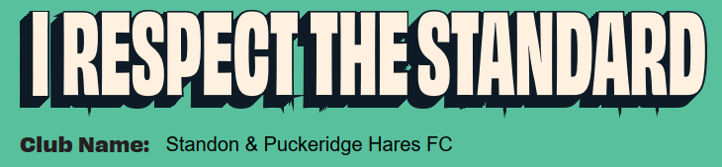
THE GRASSROOT S CODE FOR ADULTS IN YOUTH FOOTBALL

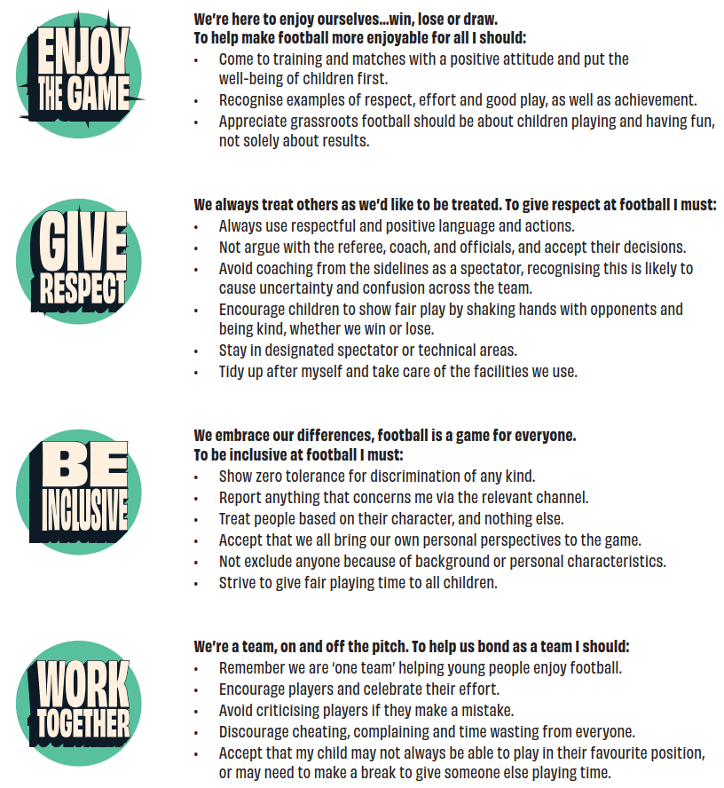

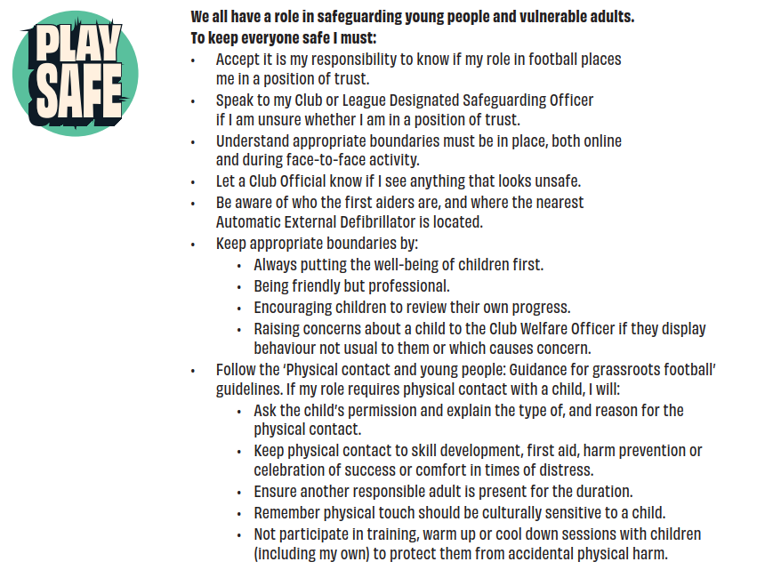
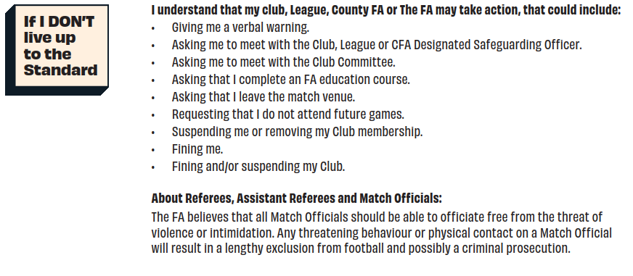
Signed: Date:

_________________________________________________________ __________________

