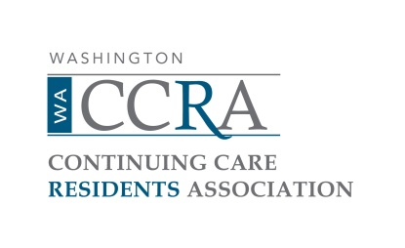

Minutes of WACCRA Board Meeting October 10, 2025

ATTENDEES:

Board: Laura Saunders, President; Kim Hickman, Vice-President; Carlos Caguiat, Barb Horrell, Mary Baroni, Steve Neville

Legislative Committee: Barb Williams (Skyline)

Guests: Keith Biever (Mirabella),

Technology Coordinator: Rick Baugh (Skyline)

MEETING (called to order at 10:05)
Welcome
Call to Order
Introduction of Attendees

Approval of the Consent Agenda

Minutes: Approved without discussion for June, July, September.

Treasurer’s Report: Approved contingent upon typos being fixed for July, August

COMMITTEE REPORTS

Membership Fee Increases: Proposed fee increases for 2026 were discussed. Consider having a periodic membership fee increases every 2-4 years.

Approved: Membership Fee increase of $5 for each of the three categories of membership, i.e. Member $35, Second Household Member $29, Family Member $10

Approved: WACCRA policy: Retain approximately one year’s expenses in a reserve account.

Approved: WACCRA reviews the reserves annually to consider increasing membership fees and other options to meet the reserve’s policy.

Annual Meeting: Mirabella Exec Dir will welcome people to Annual Meeting. Asked Liaisons to get an estimate of number of people attending and the number of cars (space for 10-15 cars). Need a list of honored guests attending. Front and aisle seats for walkers in the auditorium. Slide presentation assembled prior to the meeting and used to test the new A/V system. Name tags for all the board members, speakers and honored guests. Table for new memberships with brochures and one pager on 2025 WACCRA goals. News Mail the week before the meeting with all the detail of the meeting, including the zoom information.

Report on survey of Resident Council presidents – Steve Neville: Responses from Hearthstone and Timber Ridge provide answers to questions.

Legislative Committee: One pager describing of goals for 2026 legislature. Pushing for financial protections and aligning WA legislation with other states. Move to mandatory registration and an actuarial study for CCRCs that provide long-term care by contract.

Communications Committee: Consumer guide will likely be done by 2026. Need to have some recent residents give feedback on content.

Succession Planning: There will be a big retirement of board members in 2026.

Senior Lobby: Barb Williams attending Senior Lobby.

