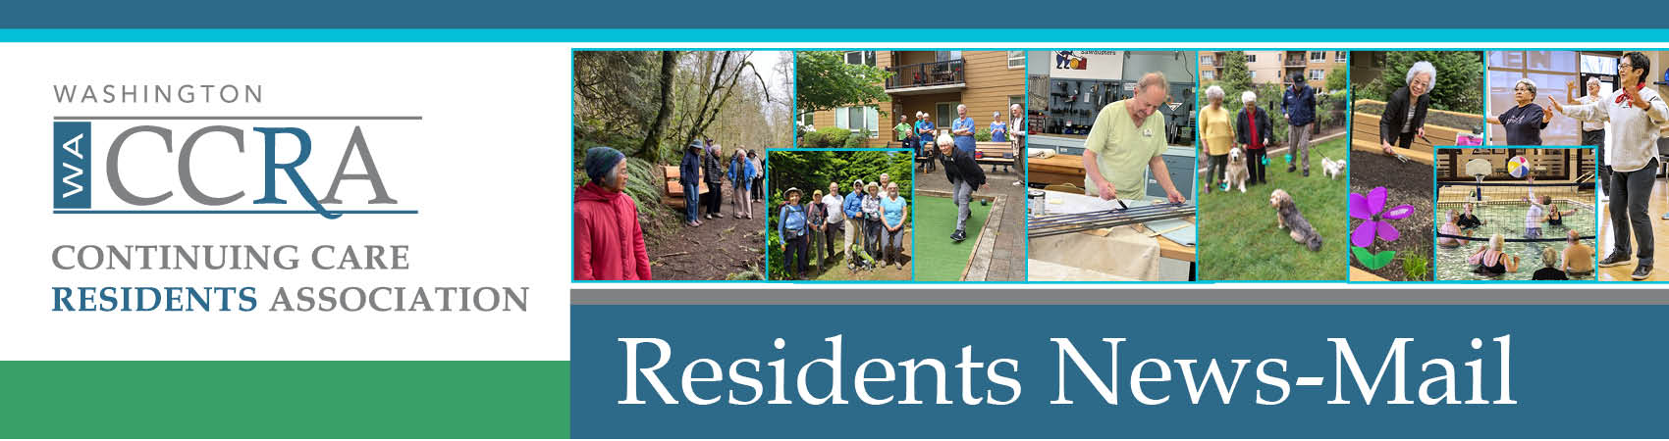

October 8, 2022

**WACCRA Ballots Arriving Soon**

The WACCRA members have the opportunity to hear about the accomplishments and priorities of WACCRA at its Annual Meeting on Saturday, October 22 at Skyline in downtown Seattle and on Zoom. Preliminary to that meeting, you have the privilege of voting on three items:

* new Board Members
* increased flexibility in WACCRA operations (Bylaw change)
* approval of the minutes of last year’s annual Meeting.

You will receive your ballots in a few days.

**PLEASE**  
When you receive your ballot, please vote and return your ballot per the instructions on the ballot. Don’t forget to vote. We need your vote in order to have a quorum for the meeting.

See you at the annual meeting. Details on how to attend in person or on Zoom will be in a subsequent News-Mail. Anyone can attend the meeting. Feel free to invite your friends to attend.

Monica Clement

WACCRA Communications Chair