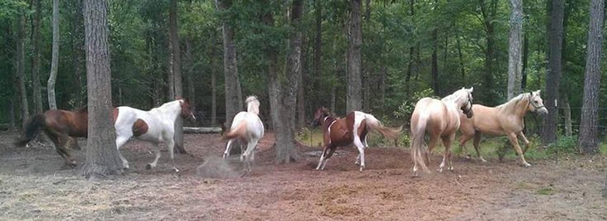

FOUR STEPS HORSE RESCUE AT CRAZY 8 RANCH

VOLUNTEER HANDBOOK

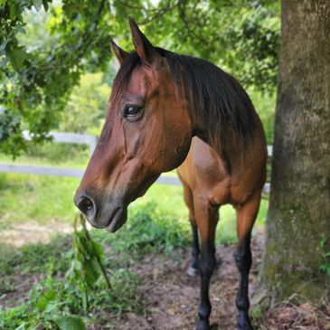

812 Sir Richard Road
Tallahassee, Florida 32310
850 524-3484
https://4stepshorserescue.com/

Welcome to 4 Steps Horse Rescue Located at Crazy 8 Ranch
About Us

4 Steps Horse Rescue is a nonprofit 501(c)(3) organization dedicated to equine rescue, rehabilitation, education, and therapy. We officially obtained our nonprofit status effective April 16, 2020, but the owner, Marcia DeCamp, has been rescuing and rehabilitating horses at this location for the past 15 years.

The rescue is funded by charitable donations and proceeds earned from Crazy 8 Ranch’s trail rides, pony parties, and children’s camp. We are an all-volunteer organization and could not do all that we do without the help from our incredible volunteers. Every volunteer that comes our way is truly valuable to our organization, and we appreciate all of the hard work and effort that volunteers give to us freely on a daily basis. We are always in need of individuals who are passionate, hardworking, motivated, dedicated, and dependable to lend us a helping hand. We welcome individuals with horse experience, but we provide on-site training to volunteers with little to no horse experience.
Our Mission

The specific purpose of 4 Steps Horse Rescue, Inc. is to:
- Rescue - Horses abandoned, mistreated, surrendered and/or seized in neglect cases
- Rehabilitate - Includes but is not limited to addressing medical issues, restoring nutritional health and providing training which will prepare the horses to be placed into new homes.
- Therapy - Horses deemed suitable will be trained to be used in our equine-based therapy program.
- Education - Provide education to the public and adoptees to help prevent equine abuse and neglect.

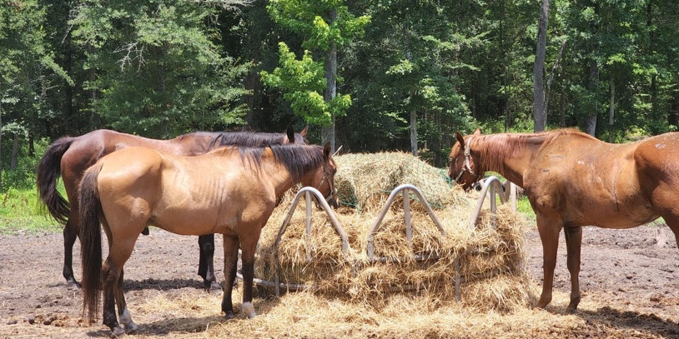

ALL VOLUNTEERS WILL BE REQUIRED TO ATTEND A NEW VOLUNTEER ORIENTATION.
Thank you for your interest in volunteering at 4 Steps Horse Rescue. Your help will enable us to rescue, rehabilitate, and retrain horses that have been abandoned, abused, neglected, and unwanted.
What Help Is Needed?

Volunteer hours are 8:00am-5:00pm every day and are divided into 3-hour shifts.
- 8:00am-11:00am
- 11:00am-2:00pm
- 2:00pm-5:00pm
Although these hours are our standard schedule, we are flexible with our volunteers’ time and understand that your time is valuable. If you can give an hour or two, we are extremely grateful. Just let us know and we can work with you. It is recommended however, to volunteer for each of these time slots as chores can be different for each shift. While we all love working with the horses, other duties are just as important in keeping the rescue running. We expect all our volunteers to complete the duties they are assigned during their hours of work.

Daily Chores
Volunteers will help in the daily care of our rescue horses. Daily chores include but are not limited to feeding, mucking (removing manure from pens and other areas), turning out horses, scrubbing water buckets, organizing supplies, cleaning helmets, removing cobwebs, and cleaning the bathroom.

Hands on Work with Horses
Volunteers will help by spending time with the horses in our care; brushing and loving on each resident is incredibly important to their recovery. Volunteers may be asked to groom horses along with other activities such as bathing, leading, and tacking for rides.

Ranch Operations
There is always a need for handy/maintenance work as we always have projects and repairs. Volunteers will help with fence, equipment, and other repairs, gardening/landscaping, building/construction, painting, etc.

Administrative Operations
We are always in need of volunteers who have special skills and experience with community outreach, grant writing, marketing, fundraising, accounting, social media, website design/maintenance, creating brochures, event planning, etc. Please let us know if you are interested in serving on a committee and helping out with any of these special needs.

Project Days and Special Work
On occasion special projects need to be done to keep 4 Steps Horse Rescue running smoothly. These projects range from repairing fencing to building horse stalls and everything in-between. This type of work is scheduled separately from the daily volunteer work.

Volunteer Guidelines, Policies, and Rules

Before Starting
- Every volunteer must read the Volunteer Handbook and commit to abiding by the rules. In addition, they must read and sign the Volunteer Release of Liability Contract. For minor volunteers, parents/guardians also need to sign.

Training Requirements
- All volunteers must attend a Volunteer Orientation. At the orientation, volunteers will be shown how to correctly perform different tasks. Volunteers are expected to follow the guidelines they are given when trained. It may take some time for you to feel comfortable completing each chore. We don’t want you to get frustrated. When in doubt—ask.

Commitment
- Since we depend solely on volunteers, it is imperative that you keep your volunteer commitments as scheduled. If you are unable to volunteer for your scheduled shift, please let us know as soon as possible. Please text us: 850 524-3484.

Sign In
- When you arrive at the ranch, all volunteers must sign the volunteer log sheet recording the date and time you arrived. Likewise, when you leave, please sign out by recording your departure time.
Check Chore Board
- Daily chores are listed on the Chore Board located by the bathroom. After you sign in, check the chore board to see which chores need completing. Once you have completed the chore, place your initials beside it indicating it has been completed and move on to the next chore on the list.

Return Supplies and Equipment
- All volunteers must put all wheelbarrows, manure forks, tools, buckets, tack, grooming supplies away properly after use. If you are painting, please wash the paint brushes and pans prior to returning them.

Age Requirements
- You must be at least 13 years old to volunteer. All volunteers under the age of 18 years old must have their parent/guardian sign the Release of Liability Contract.

Dress Code
- All volunteers must wear closed toed shoes (tennis shoes, hiking boots, cowboy boots, or riding boots, etc.). Dress comfortably for the weather and wear clothes you don’t mind getting wet and/or dirty. We work in the rain (we do not work in storms). Please limit jewelry-- nothing hanging or dangling that can get caught on things.

Cell Phones
- PLEASE do not use your cell phone when working around or with the horses. If it is an emergency, please leave the barn area to talk on the phone. Ringers on phones should be muted when around the horses.

Smoking
- No smoking is allowed in or around the barn, the hay bales, or near main house. Please do not throw your cigarette butts on the ground. Please place them in the trash cans after extinguishing them.

Mechanical Equipment and Golf Cart
- No volunteer is allowed to operate any mechanical equipment (including golf carts) without prior approval from the Lead Volunteer. There will be occasions when you will be asked to drive the carts to carry out chores. Unless directed, please do not operate the carts and other mechanical equipment without getting permission.

Alcohol and Other Drugs
- While on 4 Steps Horse Rescue at Crazy 8 Ranch, volunteers may not use, possess, distribute, sell, or be under the influence of alcohol or illegal drugs.

Task Limitations
- Volunteers will only perform tasks for which they are trained and qualified to perform. Our goal is to teach you new skills as you volunteer. Please be patient on doing new tasks until you are properly trained and prepared to do them.

Use of Force or Violence
- No volunteer may use force, hit, or use inhumane handling tactics with any animal housed at the rescue. Violence and/or inappropriate language/behavior (name calling, bullying, harassment, etc.) against other volunteers will not be tolerated.

Injuries
- Please notify the Lead Volunteer immediately in the event you receive any type of injury while working at the rescue.

Water and Food
- The rescue is located 16 miles outside of Tallahassee in a remote area with limited shopping/food options. Please bring a water bottle to hydrate while working. We have a refrigerator where volunteers can store drinks and food. If you forget your water, we sell bottled water and sodas for $1.00 each.

Volunteer Perks
We love and appreciate all of our dedicated volunteers and cannot thank you enough for your time, talents, and compassion. From all of us at 4 Steps Horse Rescue….we say “THANK YOU!”

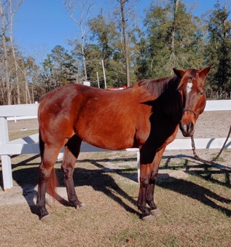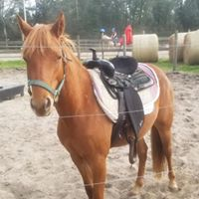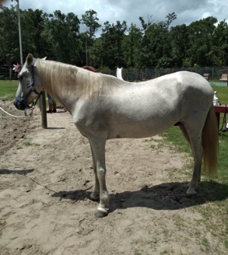

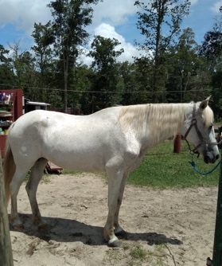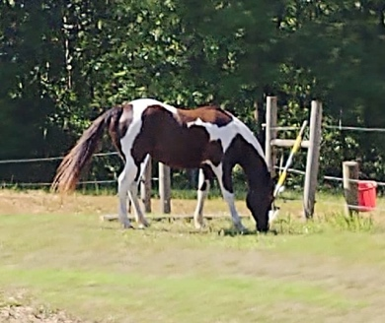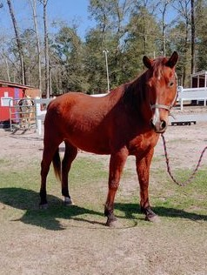
To express our appreciation, we are offering the following perks to our volunteers:

Trail Rides:
10 hours of volunteer time: Allows you to purchase a one-hour trail ride for $25.00 (1/2 off).
20 hours of volunteer time: Allows you to take a one-hour trail ride for free.

Trail Ride Guide
After volunteering for at least 30 days, you can ask to apply to be a Trail Ride Guide. A trail ride guide takes customers on rides through the Apalachicola National Forest. The majority of rides are booked on Saturdays and Sundays. In order to qualify as a guide, you need to demonstrate that you are dependable (showing up for all the days you agreed to volunteer, being on time, working while you are here, etc.). You will also need to demonstrate a level of horsemanship that is consistent with the task. If you are interested in becoming a Trail Ride Guide, please ask us for additional information.

Community Garden
We have a community garden where we plant vegetables during the spring. You are welcome to participate in the community garden by providing help weeding, watering, and other basic care. In return, you will be able to take home some of the fresh veggies.

Swimming Pool
We have a pool that is available for you to enjoy (after you complete your chores) . We just ask that you pitch in with the care of the pool (weeding, cleaning, treating, etc.).

