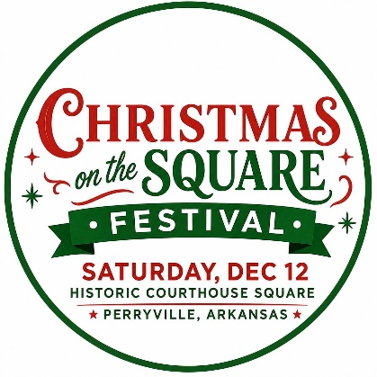
Christmas on the Square
Christmas Market
Perryville’s Historic Courthouse Square
11:00 am – 7:00 pm
December 12, 2026

Vendor Application
Deadline for Submission: November 13, 2026 * Juried Show
Acceptance Email will be sent on Nov 20, 2026

Business Name:__________________________________________________________________
Contact Person(s):____________________________________________________________________________
Daytime Phone:__________________________ Cell Phone:___________________________________
Email:_____________________________________________________________________________________
Website:________________________________ Facebook Link:________________________________
Address:____________________________________________________________________________________
City:________________________________ State:_______________ Zip:__________________________

Rules & fees are listed on the back of this form. Payment will be accepted at this time; however, check will be held until decision of acceptance or denial, at which time the check will either be deposited or returned. Invoices will be sent to those who have been accepted but have not paid. Vendor fees must be paid by November 30th. All vendors will be admitted at the discretion of the Christmas on the Square Committee. This is a juried festival. Photos of exhibited items will be required with ALL reservation forms.

Please list ALL items you will be displaying / selling. Use additional sheet if necessary. ___________________________________________________________________________________________ ___________________________________________________________________________________________
___________________________________________________________________________________________
___________________________________________________________________________________________
___________________________________________________________________________________________
Please provide the price range of your products (lowest to the highest):__________________________________
The committee makes every effort to avoid admitting duplicate items so it is very important to list all items sold in this space. *Note: We do allow multiple jewelry vendors but strive to provide diversity in styles and pricing as well as maintain good quality. Photos are important and required.

Please indicate the number of booth spaces you want to reserve: ___10x10

I, the exhibitor, agree to the terms on pages 1 & 2 of this form and acknowledge, if accepted as a vendor, I will receive the full written policy with additional terms, conditions, and regulations for the “2026 Christmas on the Square” and my acceptance to the event will not be finalized until I have read , initialed, and signed the full written policy and vendor agreement. I agree to abide by all of the terms set forth in this “Reservation Form” with no exceptions, and do hereby contract space for the 2026 event.

Signature:___________________________________________ Date:_____________________

Thank you for your interest in the 2026 Christmas on the Square event. Please return this form to:
Perry County Chamber of Commerce | 115 E Broadway | Morrilton, AR 72210
Amanda@MorriltonChamber.com
Questions/Comments? Contact us at 501-354-2393.
2026 Christmas on the Square
Christmas Market Vendor Rates & Fees

10x10 Booth Space:. . . . . . . . . . . . . . . . . ..… …… . . . . . . . . . . . $40 / space
Each Additional Space: . . . . . . . . . . . . . . . . . . . . . . . .. . . …….. . $25 / space

Guidelines & Regulations
•Christmas on the Square will be held rain or shine.
•The cost for vendors to participate is a non-refundable $40, which must be paid within one week of receiving confirmation from the committee. This includes one 10'x10' pre-assigned space. All spaces will be assigned by the Event Committee and are non-negotiable.
•Vendors must provide their own canopy, tables, chairs, and anything else needed for their booth. ALL canopies MUST be secured with sandbags or other weights that the vendor must provide. Vendors cannot drive stakes into the asphalt.
•All vendors must be on-site by 10:00 am and check in at the Information Tent. Booths must open at 11:00 am and remain open until 7:00 pm
.•Due to crowd safety, no vehicles may enter or leave the event area between 11:00 am and 7:00 pm.
•Vehicles cannot park inside the event area. However, you may drive into the area to unload from 9:00-11:00 am.
•The Christmas on the Square Event Committee is primarily seeking vendors who offer unique, hand-crafted, or local (Arkansas-made) items, though others may be considered.
•No electricity hook ups are available. Vendors will not be permitted to use electricity running from a downtown building or light pole. If you require electricity, you must bring your own generator and house it within your 10'x10' designated space.
•Wi-fi and other Internet hook-up will not be available.
•The vendor is responsible for paying all applicable taxes related to sales made at Christmas on the Square.
•Vendors who have any issues or concerns should report them to the Information Tent immediately. We will do our best to work with you. We want all our vendors and event patrons to have a great time at Christmas on the Square!
•All vendors must check in AND check out at the Information Tent to remain in good-standing with the event planning committee for future events. The committee will inspect your booth space to ensure trash and other items have been properly removed upon check out. Dumpsters will be located on-site for your convenience, and we thank you for your cooperation in keeping your event space clean and tidy.

Please acknowledge your agreement to these terms & regulations with your signature on page 1 of this form. Please initial ______

